Mahasambodhi Dharmasangha Guru Addresses Humanity 21 March, 2017 in Lalitpur, Nepal

August 31, 2017

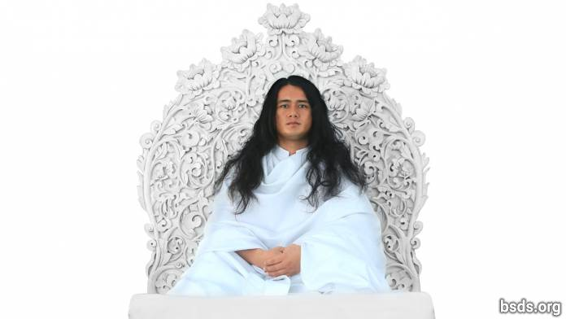

Dharma Sangha

Bodhi Shrawan Guru Sangaya

Mai Maitri Sarva Dharma Sangaya

Having maintained the purest state of pristine consciousness since ages upon ages past, abiding in the dharma standards and regulations vested in this authority, I came into this world to reveal the Bodhi Marghadarshan Maitri Dharma directly to this realm and to all living beings, dedicated solely to igniting the countless dharma truths for the entire sangha, all dharma lovers, all faithful devotees and followers.

But all humans of this human realm being alienated from intimate communion in Truth, bypassing the true Mārga, now act as if seeing nothing when it is plainly visible.

The main mission of the true Guru is for all living creatures to have all-dharma in one integrated maitribhav awareness without split or separation and to remove from humans the corruptions remaining in the depths of the soul, in order to bring out and unveil the true Dharma mārga long buried at the bottom of every heart.

Dharma is the invisible, living truth-reality that imparts the mukti-moksha mārgapath of ascension, the realm where all Paramātma Bhagawān dwell, the Paramātma Realm or the “all-Guru” state of divine consciousness..

The essence of dharma is empirical first-hand realisation of true wisdom, that is, having thoroughly searched for and found the true mārga, to live it. Dharma is light, the great brilliance that makes all lights shine; it is dharma essence that sustains all realms in the universe.

Not a self-serving path, the path-guidance of Dharma is the active mārga-process that uplifts all living beings into mukti-moksha transcendence. That is, dharma in the world is the true essence that remains forever untainted.

But to dispense disguised dharmas obliquely to the world, flaunting filthy assurances and self-serving charlatan margas in devious ways, being mired in delusion themselves, to pull all the world’s living beings into delusion is to trigger the marga of evil and annihilation.

Having thoroughly purified all poisonous substances remaining in the world within us to the most pristine, having absorbed true dharma, to awaken the great dharma marga for others including self, this is to bestow mukti-moksha release from this human realm.

True dharma is realised (by humans) gradually in measured increments. For the fruits of our karma actions therefore, we must rely solely on our own choices. The very meaning of this human realm is the punya karmafruit resulting from our choices between truth and untruth, wrongdoings and punya light.

After an interval of ages in time, all beings of the world doing true dharma and true marga darshan came blindly to follow artificial man-made traditions and rituals as if following true dharma, sinking their empirical cognition of pristine marga guidance deep into the whirlpool of confused delusion. Lost aimless in the material world without truth, pressured, they spin in search for true marga. But before, since the previous age, the world’s living beings themselves had been embracing true dharma on their own, and came into sublime purity having searched for truth, created maitribhav, living the laws and regulations of eternal dharma in infinite awe and reverence for the Gurus, releasing the bhavana of devotion and faith in mind and speech filled with full trust and hope. In the end it is from just this that dharma will be realised.

Dharma is not this: it never engenders behavioral traits like anger, greed, seduction, selfishness, exploitation, bias or separation, accusation and counter-accusation, mistrust, doubts and suspicion, or advocates mārgapaths of world destruction.

Dharma dwells only and solely in maitribhav and in true karma. That is why dharma does not have the least hint of separation or discord.

To know the realities of suffering of all the world’s living beings including self, exposing all disguises of evil poisons to erase them from the heart’s inner core, is to be in joyful divine blessing not only in this world but also in celestial spheres.

In order to establish dharma and maitribhav, giving maitri nectar-juice in full-hearted union, not only oneself, but the world must be awakened first-hand to dharma’s inner experiential realities. Now at last, the auspicious time for the world’s dharma-transformation is here.

The heart-thrust of dharma is marga without which mukti-moksha ascension is impossible.

Although dharma is laid down in the material physical world, its essentials are subtle, rare, invisible and hard to experience first-hand.

It is not that the Guru opposes dharma; it is rather that, arriving in the world at this present age when human beings themselves are entirely mired in self-serving mārgapaths of harmful seductive standards, glimpses of true Maitri Dharma mārgapath guidance can only be revealed only bit by bit.

The Guru’s manifest form exists in both human and suprahuman states, and the true Guru sighted in the world is the actual form of the Paramātma Gurus. In the world, only the dharma gurus who follow truth and abide in the laws of dharma are authorised to give the real dharma law. For those in falsehood, evidence of Truth is perceived as if looking at oneself in a trick mirror.

The Bhagawan marga, the marga guru, the guru marga guru and Paramatma gurus who had been dwelling in this world in the Satya Yug Age of Truth, have now come into this world. Although human nature is entirely nurtured by living, peace-giving plants, humans’ refusal to stop killing animals, to stop greed, pride, defilement, violence, commerce and exploitation has propelled them to rush toward world-annihilation in the end. In this present Age, even while dwelling in the ocean of truth, humans not following true dharma remain in a state of spiritual paralysis.

Not forsaking conceit, anger, greed, seduction, envy, violence, commerce and exploitation is making world-annihilation inevitable. Now in this end-time, humanity must wake up to this great challenge.

During the Pracin Kal Archaic Age after the Satya Yug Age of Truth, when the entire human race, rendered helpless by illness during the great plagues hungered in agony for remedies, the entirety of living healing herbs were bestowed onto the world through the Paramatma Bhagavan Gurus in the form of nectar to redeem the toxin-filled world and all its beings.

Now, abiding in all the standards and laws of Maitri Dharma, invoking invincible soul-consciousness, practicing true karma to gain mukti-moksha freedom for all beings, not only for oneself, with infinite awe and reverence for the Paramātma Gurus to create the heavenly realm flourishing like Paradise, in trust filled with faith, devotion and hope in direct, first-hand knowing and in light, building harmonious connections between human souls and Paramātma Bhagawān to their fullest, most glorious apotheosis – this is the Bodhi Mārgadarshan Maitridharma. It is possible to realise these unique essentials by living in truth and building dharma punya grace.

Whoever in the world still remains weighed down by evil thoughts, speech and harmful deeds, is doomed to certain perdition from which there is no recourse. Even Guru Himself and Dharma cannot help wherever the blessing light of punya karmafruit has been exhausted.

In fact, truth-essentials of dharma are realised to the exact extent that importance is given to them; human beings must urgently, seriously and full-heartedly undertake their own vital tasks.

It is not just for the Guru to be giving mārgapath directions and instructions, the journey of walking and living the Path is one’s own, and must be fostered with mercy, compassion, trust, faith and devotion, pure living, pure nourishment, pure views, pure speech, all the sacred precepts, samadhi, heartfelt reverence and wisdom.

Since all the world’s living beings are sustained by the plant kingdom, and since both the world’s living beings and the entire plant kingdom are creations of the Paramātma Bhagawān Gurus, in the end the chief sustainer of the world is Dharma.

May all the world’s living beings unerringly and swiftly absorb true dharma’s purest rudiments, precepts, dharma essentials and omniscience for the joyful inner transformations leading to supreme crowning revelations.

Sarva Maitri Mangalam, Asthu, Tathastu.

21 March 2017 Chunikel, Bungamati, Kathmandu Valley

https://bsds.org/en/news/199/mahasambodhi-dharmasangha-guru-message-2017

Mahasambodhi Dharmasangha Guru's Message in Lamjung of February 22, 2014

February 22, 2014

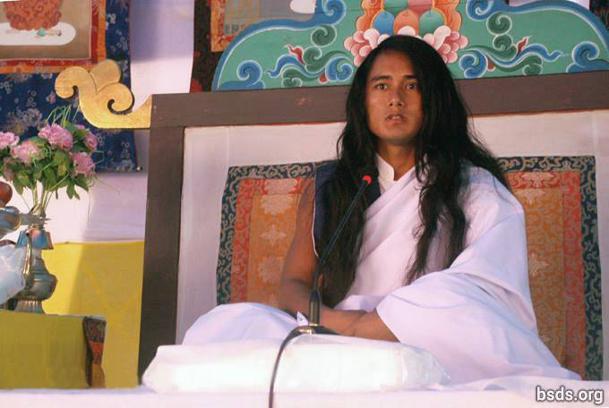

Dharma Sangha
Bodhi Shravan Guru Sanghaya
Namo Maitri Sarva Dharma Sanghaya

1. Following the Great Maitri Marga Guru, the GuruMarga and the Bhagvan Marga, absorbed in forgotten feelings, making Maitri Mangal (lovingly fulfilled) all Sangha friends, Dharma-lovers and followers that come and go; and, remembering this present Guru’s moment together, may all tormented souls on the Marga of the Maitri Dharma have refreshing realization. Dharma is the only element that can support a platform built to be directly with the Paramatma.

2. And, may the suffering wandering souls being without feeling or direction be free from bondage as soon as possible by heeding the fulfilling sound of Great Maitri.

3. Just as the value of water corresponds to the degree of thirst; the value of the Dharma is assessed by kindness, compassion, nonviolence, trust, belief, devotion, faith and an unwavering human life regarding the Marga.

4. To enter into the Dharma means to be absorbed in the path of mukti (freedom after death) and moksha (liberation from the cycle of rebirth).

5. That marga which does not have the element forming mukti and moksha can never even be accepted in the true Dharma as being called a marga, and the Dharma not being in divided civilisations, is obtained in the perfection of the Maitri knowledge, the bridge between the soul and the Paramatma.

6. It is impossible for humans remaining far from the knowledge of Maitri to attain true enlightenment no matter what one is practicing.

7. In the end, all that may have appeared to be beneficial in this transient world will prove futile.

8. There is no separation in the lifecycles of countless beings and their coming and going, in the order of the lokas (worlds), and in between the atma, anatma, and the Paramatma.

9. The Dharma is the rising and setting sun, the sky in which the stars shine, and the flowers blossoming in nature.

10. In the end, the Dharma is to understand the transience of the moment of this passing world as though waking up from a nightmare to find that in reality one is safe.

11. Rather than asking such questions as to what attributes a contemplative and intelligent person skillful in the Dharma has, and what the role of religion is in the Dharma; why doesn’t a person make the inquiry as to what one has given oneself through passion and attachments to worldly things?

12. Whether or not the way a person is following possesses the Tatva forming mukti and moksha is the person’s own very personal internal quest.

13. Guru is fulfilling the Dharma: He is giving the Marga to the world, but the person must make the journey on the Marga by oneself.

14. Whether or not one is enlightened and what one has to bear is justly determined according to the accumulated merit and other karma of the souls traveling on the Marga being shown by Guru.

15. Even though it is natural for various pains and sorrows to occur on the Path, the crucial matter is the reverence and faith towards the Guru Marga.

16. So be it, continue! The great realization of the omniscient wisdom of this Great Maitri Marga is perfect being filled with the precious jewels of the Dharma Tatva (essence).

17. However people store empty words used in their past life, otherwise the Path of Enlightenment would be realised very quickly by following the Guru Marga.

18. To stand on the Earth while resting in the sky remaining in human form together with the realisation of the Maitri Tatva of the pure appearance of the Paramatma’s own form – realizing including self all the mysteries of the universe – is to be freed from the mind’s countless oceans of illusion having evaporated like water into the open sky.

19. That which leads to the highest qualities of tatvas among all religions and Guru knowledge, having the ability to extinguish former confusion throughout the world, is called the Maitri Dharma. In this way, the primordial existence of all religions would all be on the Marga of Maitri Dharma itself.

20. On the Maitri Marga, only by doing true practice of the Dharma until the last moment of life does a person benefit the Dharma.

21. And with this Maitri message, I am giving (you) the 11 precepts to be free from all the defilements within the whole human world.

1) Never break oneness and equality on account of name, appearance, ethnicity, tribe, religion, colour, class, gender, belief, community, nation, power, position, ability and so forth; this means, give up all discord, be it worldly or spiritual.

2) Having found the eternal Dharma, Margapath and the Guru, remain respectful to all religions and beliefs.

3) Never cause rifts or doubts with untruths, accusations and counter-accusations, belittling or meaningless talk.

4) Resist all teachings and paths that lead to separation, rifts or boundaries; stay steadfast in the true marga-practice.

5) Resist doing even the least harmful karma-actions throughout life in true Gurumarga practice, melt totally into Guru’s truth-nature, becoming part of it.

6) Before being truly merged in the essential realities and practices of Gurunature and Dharmanature, refrain from expounding it with clever words; while still mired in hearsay, rumour, and propaganda, do not draw others into delusion.

7) Avoid any and all demonic behaviour: violence, killing, harming or hurting living beings; choose only pure wholesome nourishment.

8) Do not think less of people or countries on account of national identity.

9) Rooted in true Gurumarga practices, dedicate all karma-actions, thought and speech to the uplift of the whole world, including ourselves.

10) When searching for Truth, the Gurumarga path begins to take form within the heart and merges with Gurunature for the wellbeing of all life in the universe.

11) Remain always in the highest and deepest awareness, realising the various precepts in the soul, gaining freedom from all bygone bondage and constraints.

22. Together with these 11 precepts being internalized by all the Sanghas, liberate all living beings including self, and; may all realize this Satya Marga Gyan – the Wisdom of the True Path.

23. Never lingering in the ego, running after worldly name and fame; humans should stay resolute in the remembrance of the Paramatma always keeping the feeling of Maitri in the heart (atma).

24. The GuruMarga has descended to re-establish the true Dharma on the Earth after an interval of ages.

25. As this golden moment has been realized by beings and plant-life (the eco-system); may humans also be without defilements and take virtuous benefit from this Maha Maitri Marga at the earliest!

May all beings be lovingly fulfilled.
So be it!

https://bsds.org/en/news/170/dharmasangha-guru-lamjung-message-2014

Mahasambodhi Dharmasangha Guru's Message in Chitwan of June 8, 2013

June 8, 2013

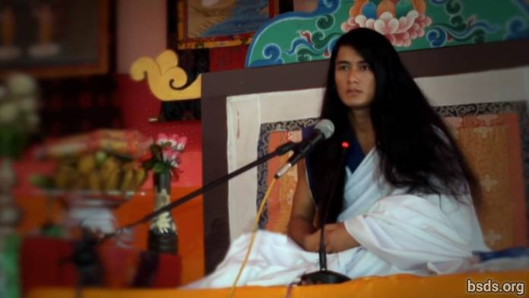

Dharma Sangha

Bodhi Shravan Guru Sanghaya

Namo Maitri Sarva Dharma Sanghaya

1. Being in unison with the True Dharma, Guru, and the Way; may the world realize the Dharma Tattva [1]. And, may all the world’s beings be contented by the Supreme Wisdom of this Great Maitri Way having the form of Mukti and Moksha.

2. The science of the Dharma Tattva is very deep and limitless.

3. In order to realise the True Dharma and Tattva, it is necessary to embody the Tattva oneself.

4. And the Dharma Tattva is not limited to this world alone, but resides in all existence.

5. May humans realise that this world is only one opportunity.

6. In order to realize the Tattva, in some trees, even though countless blossoms bud, only a limited number of fruit reach their natural form; thus only a few humans achieve the Dharma.

7. Even so, the flowers fallen on the Way of the True Dharma also have existence and greatness.

8. And each one of the fruit is being made to have its own distinct specialty and Dharma Virtue.

9. The main purpose of the human world and life is to be in adherence of the True Dharma and, achieving the Dharma Tattva, to be absorbed in Mukti and Moksha alone.

10. The Guru fulfills His own Dharma.

11. The Way is being given to the world, yet even so, the responsibility for taking each step forward on the way is the human’s own individual quest [2].

12. Whether or not the way one is following has the form of the Mukti and Moksha Tattva is another extremely personal quest of the human.

13. For a human remaining far from the wisdom of Maitri, no matter what kind of practice is done in one’s life in the name of Dharma, attainment of the True Tattva based in existence is impossible.

14. And those on a way not allowing the formation of Mukti and Moksha, can never call that "the Way."

15. That would be just a mere amusement of the temporary world.

16. In the worldly ways, the ego and desires of humans are upheld as usual, and the various paltry remedies being applied are distancing the desirous humans from the True Guru and the Way.

17. The Path which does not accept egoism and desires — that Path humans don’t want to walk.

18. But, ironically, each human has the understanding in the inner voice of the conscience [3] of which way is leading where.

19. Whether or not one is enlightened and what one has to bear is justly determined according to the accumulated merit of each soul traveling on the Way being shown by Guru.

20. Yet so be it, continue, the journey is yours alone.

21. Having been absorbed by the attributes of the Dharma Tattva; realising the defects of egoism and desires, one can be freed from the world. In order to do this, a human needs to strive continuously in the Dharma until the final moment of life.

22. May the whole world take this Maitri wisdom to heart and awaken.

Sarva Maitri Mangalam Astu Tathaastu (May all beings be lovingly peaceful. So be it.)

______________________

Notes:

[1] Tattva तत्व (n.)

[2] This word was written by Guru as "nirnaya," meaning "decision," however, in the speech, Guru says "khoj", meaning "search/quest."

[3] Nep. Chitta

https://bsds.org/en/news/158/mahasambodhi-dharmasangha-guru-s-message-in

Mahasambodhi Dharmasangha Guru's Message in Patharkot of April 9, 2013

April 9, 2013

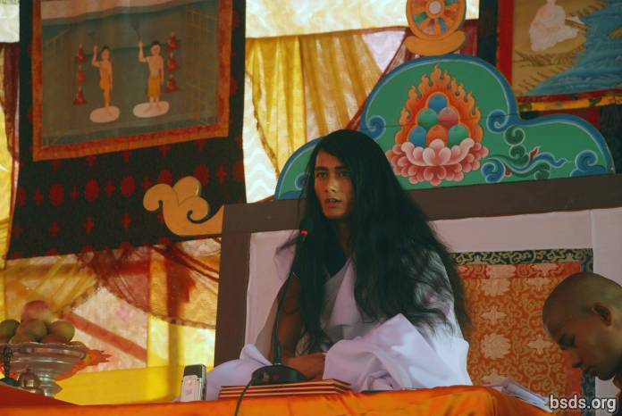

Dharma Sangha
Bodhi Shravan Guru Sanghaya
Namo Maitri Sarva Dharma Sanghaya [1]

1. Adhering to the Maha Maitriya Marga (the Great Loving Way), being Marga Guru (Guru of the Path), the Guru Marga (the Master Path) up until the Bhagwan Marga (the God Path), remaining in the presence of countless feelings, may the entire world of living beings take in the Amrita of Great Wisdom.

2. And may the blessings of the the Great Maitriya Guru and the Path always remain in the world.

3. Although countless stars are being seen, the sky is one; in the same way, the main source of all religions and paths seen in the world is ultimately one.

4. That is the wisdom that has been gained in the different ages of the world, moreover, the paths that have been rendered in auspicious times by the enlightened Gurus for the welfare of the world have been colored with the colors of various religions, teachings, paths and cultures in modern times.

5. I have been seeing humans, in the name of religion and path, gradually being separated from the True Essence, either unable or unwilling to distinguish right, wrong, sin, the Dharma, the Guru and the Path, carelessly moving towards darkness and lacking essence.

6. In the past, being of ek bhavana [2] (one focus/path) the enlightened Buddha is only a Marga Guru who points out the Path; however in the present time there is the illusion in the world that the previous Buddha did not have a teacher, nevertheless, the question of who the teacher of this Marga Guru is and the fact exist thus.

7. In this existence there are various thoughts, gurus, and paths that are still mysterious in this world.

8. According to the extreme importance of time, I have been showing the Guru Marga (the Master Path).

9. Even though the Path of all Gurus is the same, each one [Guru] makes their own rule and position, and in accordance with the rule the results are reaped.

10. The Guru Marga is that Path on which the whole world, living beings and plant life, by following Maitri Marga (the Path of Loving Kindness), achieve mukti (liberation after death) and moksha (Iiberation from rebirth).

11. In the human world, humans have freedom: they concentrate on the Path of Dharma or spend their lives in sinful acts.

12. The meaning of this world is to distinguish between Dharma and sin.

13. But the result is determined according to the good or bad karma of what humans have done on their own.

14. After ages, the Guru Marga has descended in the world.

15. Quenching the thirsty world by the nectar of understanding non-violence, kindness, compassion, love and Maitri Bhaav (the feeling of loving kindness) is the way to establish the Rule of Maitri, but, having feelings of omniscience, the egoistic humans cannot always properly accept the situation of the present Guru.

16. If humans take a moment to hold the soul in awareness and contemplate: why this penance of the Guru?

17. In the end it would only be for the sake of the mukti and moksha of the world, living beings and plant life.

18. There are those who have the hope to benefit from the Guru in another worldly way, but Guru can only give Dharma, Marga, Mukti, and Moksha.

19. But ironically since times past the polluted state of the human mind has instead been giving Guru accusations, disbelief, violence and obstructive behavior.

20. This human society, including the management, makes the need of Dharma and Marga for this entire world imperative.

21. Not just the Dharma, but may this truth be understood by humans.

22. And may life be spent in the search of the essence of Maitri Bhaav.

23. Also, in the coming days, Guru will definitely travel in order to give the darshan of the True Path throughout the world.

24. May all beings be lovingly peaceful. So be it.

______________________

Notes:

[1] To the Sangha of the Dharma Sangha Bodhi Shravan Guru (Wisdom Heeding Dharma Sangha Guru) I bow to all Loving Dharma Sanghas.

[2] Bhāvanā (Pali; Sanskrit, also bhāvana) literally means "development" or "cultivating" or "producing" in the sense of "calling into existence." The word bhavana normally appears in conjunction with another word forming a compound phrase such as citta-bhavana (the development or cultivation of the heart/mind) or metta/maitri-bhavana (the development/cultivation of lovingkindness). When used on its own bhavana signifies 'spiritual cultivation' generally. (Wikipedia)

https://bsds.org/en/news/148/mahasambodhi-dharmasangha-guru-s-message-in

Mahasambodhi Dharmasangha’s Message in Sindhuli of September 10, 2012

September 10, 2012

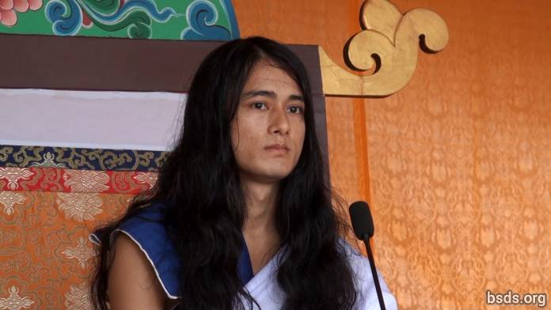

1. Following the True Dharma and the Guru in this current time, making all the meritorious souls present and absent here Maitri Mangalam (Lovingly Peaceful); remaining on this great Maitri Marga (Loving Way) of welfare and praanidhaan (prayers/life bestowing) for the world; atma (soul), body, and speech being under the witness of the Guru, I am proclaiming The Eternal Dharma.

2. Being Eternal Breath in order to know the Tattva (Essence) which is without decay, death, or destruction, one must have a life practice which single-mindedly takes up only the Dharma.

3. Moreover, the word Dharma is not sufficient in itself.

4. How can the Dharma come (be defined) in only one word when all Lokas (realms/worlds/universes) are in that Dharma Tattva (Essence)!

5. Dharma is not something to be understood but the truth to be realised.

6. If one is able to establish kindness, compassion, love, and friendship not only among human beings but also the world’s movable and immovable living beings and vegetation with unity; being able to drink the nectar of friendship; being able to keep one’s life routine in incomparable loving kindness; as a result, after this life, one attains Mukti (liberation after death) and Moksha (liberation from rebirth).

7. Murdering beings, displaying miraculous activities, and doing tantra-mantra (magic) in the name of the Dharma is only a way of temporary selfish fulfillment. Dharma is only that which provides the sentient beings the Path of freedom and liberation without discrimination according to karma (causes and conditions).

8. Since ancient times on Earth, human beings have been drifting about in the ocean of illusion. Having taken on a meaningful human life [1], one continues to wander on meaningless substances and paths, knowingly and unknowingly throughout the Kalpas (ages).

9. Blessed are these saintly souls, who are adhering to the Path of the Truth being in the refuge of the Guru. And also the Guru Himself, remaining under the Rule of Dharma of the highest of the Gurus beyond thousands of past Buddhas, has come.

10. In the coming days, I will be showing Teachings of the Guru and the Dharma. I am always doing so.

11. In order to eradicate karma accumulated under the influence of the passion of desires wandering into countless emotions; being in the Rule of the Dharma, one has to take up the Guru Marga, feeling reverence of mind in an undivided form, never being diverted in the least.

12. Sacrificing attachment, overcoming saying “me” and “mine,” greed and ego; only by living a life with an indestructible feeling for all living beings will human life be successful.

13. Finally what is the objective of coming to the world? Which essence is the search? What are the duties and the Dharma for oneself including the whole existence? What is the relationship between the atma (self/soul), anatma (non-self/non-soul), and Parmatma (the Great Soul)?

14. One must spend the Kalachakra (period of life) on life’s inner search for the boundless and minute, not just momentary sensual gratification and material bonds. Finally, establishing One Being, One World, One Dharma and the feeling of Maitri (Loving Kindness) without discrimination, having decorated the world in the sound of the Dharma, the Guru will travel satisfying the world’s countless perplexed beings throughout with the nectar of Maitri, giving Marga Darshan (guidance) in the coming time.

15. Guru is True since Guru is in the Dharma. It’s just that spreading the Rule of the Dharma by Guru has been misunderstood in a material world, though this is what it is, and it’s true.

16. May all beings be lovingly peaceful.

______________________

Notes:

[1] Tatvarupi manushya cholaa (meaningful human life) – note that cholaa means ‘cloth’ and has been used to indicate the human body. Manav chola means human body.

https://bsds.org/en/news/137/mahasambodhi-dharmasangha-s-message-in-sindhuli-of

Birthday Speech in Halkhoriya in 2012

April 11, 2012

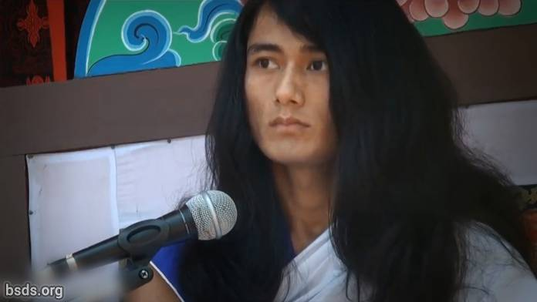

1. Benefiting all Sanghas and followers with Loving Kindness, today’s Yuga (age) is not only a time for festivity, it is for imparting the Path of Freedom and Liberation to the sentient beings of the world in following the Path of Truth and spreading the Law of Dharma, establishing Dharma, Peace, Understanding and the Maitri (Loving Kindness) feeling in the world.

2. It is difficult to find fulfillment unless one realizes the Tattva (Essence) of the True Guru in order to follow the Path of Truth.

3. The human life can be fruitful if one is able to search for and know the Tattvas (Elements) hidden in Guru’s words.

4. Guru, having been freed from worldly restraints, although seen in the world yet not being a worldly Guru, is the Pure Dharma Guru.

5. In order to establish the Law of the Dharma in the world, it is important to be completely faithful and dedicated to the Guru and equally so to the Sanghas as well.

6. And the fragrance of the moral excellence of the Sanghas must be in the spirit of mutual loving kindness and togetherness.

7. Interfering and placing obstacles in the work of the Guru means interfering with Dharma and the Path.

8. However, it is natural that many obstacles and interference occur in the spreading of the Law of Dharma.

9. But to face or overcome those Dharma-opposing Tattvas by being truthful with mind, body and speech is another personal dharma and duty of each of the Sanghas.

10. Guru, himself remaining, let all the Sanghas, absorbed in these invaluable moments by being engrossed in the Dharma-Sound, always utilize every Guru-Moment proving their own extreme intellectual abilities.

May all beings be loving and peaceful. So be it.

https://bsds.org/en/news/127/birthday-speech-in-halkhoriya-in-2012

Closing Speech for The World Loving Peace Puja on March 26, 2012

March 26, 2012

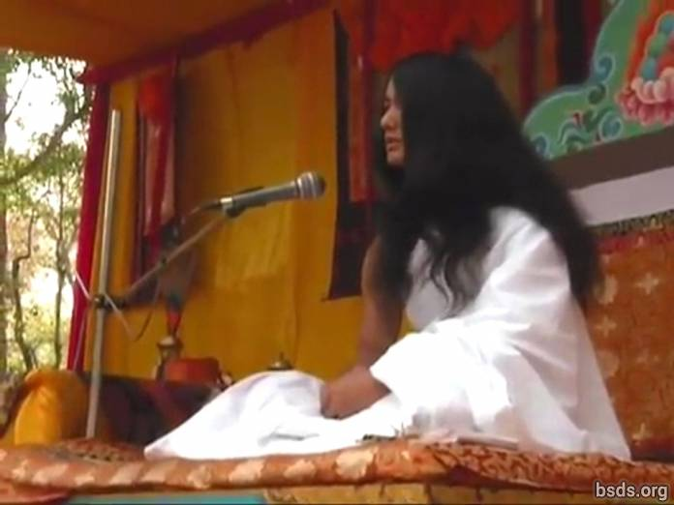

1. May all Sanghas [1] keeping the discipline of the Dharma [2] gathered at the World Loving Peace Puja [3] show unification to the world uniting all sentient beings within the perimeters of the power of the Dharma overcoming all illusions and obstacles of the past, present and coming days.

2. The way on the path of the True Dharma being followed, perfect enlightenment being accomplished, the understanding of world peace and the feeling of Maitri (Loving Kindness) being established, may the acquisition of the Dharma World be made manifest.

May all beings be happy. So be it.

________________________________

Notes:

1) Sangha – assembly/group with common goal, vision, purpose.

2) Dharma – Universal and Cosmic Truth, righteous duty, virtuous path, liberating law.

3) Puja – ritual, worship, ceremony, prayers.

https://bsds.org/en/news/125/closing-speech-for-the-world-loving-peace-puja-on

Opening Speech for The World Peace Maitri Puja on March 21, 2012

March 21, 2012

Dharma Sangha

Namo Bodhi Shravan Guru Sanghaya

Namo Maitri Sarva Dharma Sanghaya

1. I am giving the message of the eternal Dharma [1] to the Earth after many Yugas (eras), having followed the Path of the True Dharma in search of the purest path, lovingly benefitting all the Dharma-loving followers gathered at the World Peace Maitri Puja [2], liberating all sentient beings from suffering and pain by the form of the GuruMarga (GuruPath) having arrived (landed) 35000 years ago according to the Maitriyan Calendar, bringing Bodhi Shravan Dharma Sangha into being.

2. A flower`s existence lies only in its ceaseless form of offering and dedication of its own beauty and fragrance to the entire creation. Likewise, the fragrant flower, which is the meaning of the Dhamma (Dharma), cannot blossom unless humans, discarding from life desire, anger, greed, delusion, ego, murder, violence and other defilements, cultivate the ethic of the True Dharma.

3. Submitting to extreme penance and practices without deviation for a single moment from May 15, 2005 to May 16, 2011 for the path to true emancipation and freedom of the world, I have, with full determination, devoted myself entirely to the Maitri (Loving Kindness) Meditation having descended as the GuruMarga (GuruPath) Bodhi Shravan Dharma Sangha. Bodhi Shravan means to have the knowledge of the Tattva (Essence), of Satya (Truth) and Guru [3], to recognize the Astitvik Tattva (Existential Element), and to be endowed with all knowledge.

4. And the words “Dharma Sangha” refer to all Gurus of this world and other worlds. Bodhi Shravan Dharma Sangha means all the Gurus who, having comprehended the BodhiMarga (Path of Enlightenment) from the MargaGuru (PathGuru) and the GuruMarga (GuruPath) – or having received the Wisdom – has therefore been called Bodhi Shravan Dharma Sangha (The Wisdom-Heeding Dharma Sanghas).

5. The goal of the GuruMarga is to spread the feeling of Loving Kindness on Earth by rendering the paths of freedom and liberation of the True Dharma by releasing countless beings of the world suffering throughout the infinite ages.

6. On the path of Devotion, Trust and Faith, purifying body, speech and mind while following the precepts, one will attain complete gratification of divine joy within the human life.

7. In order to establish Dharma Peace, non-violence, mutual understanding and loving kindness, human beings should discard the lowly actions such as desires, anger, greed, delusion, jealousy, murder, violence, ego, disputes, hatred, insult, belittling, dissatisfaction, disbelief, doubts, illusion, false visions, selfishness, false words, addiction, bad company, unwholesome acts, misdeeds, devils and demons, obstacles, and making the false appear true and the true appear false.

8. Discard discrimination and rifts between Religions, castes, regions, communities, and sanghas [4].

9. Spreading wrong views is to profit by propaganda towards “my,” “mine,” “ours,” “villages,” “wards,” “municipalities,” “nations,” among nations and all over the world.

10. Murder, violence, unwholesome acts, misdeeds and unrest are accepted in the name of religion, spirituality, philosophy and wisdom, creating illusionary networks and boundaries that do not exist among human civilizations. This is indoctrination.

11. Being aware of those who have fostered illusions in the world since ages past, I am endorsing the True Dharma GuruMarga to follow and be followed by Sanghas, Dharma-loving followers and truth-seekers who have been confused in the past.

12. Following the True Dharma of the GuruMarga, abiding in Truth, by the power of the Truth one can eliminate the incoming obstacles corresponding to one's old karma, the congenital or postnatal side-effects which could have happened to oneself or one's descendents such as being handicapped, mute, deaf or blind.

13. I am giving these precepts eliminating and purifying the defilements in the very core of the heart of humans for the benefit of self and others and to spread the feeling of Loving Kindness [5].

*******************************************

1) Never break oneness and equality on account of name, appearance, ethnicity, tribe, religion, colour, class, gender, belief, community, nation, power, position, ability and so forth; this means, give up all discord, be it worldly or spiritual.

2) Having found the eternal Dharma, Margapath and the Guru, remain respectful to all religions and beliefs.

3) Never cause rifts or doubts with untruths, accusations and counter-accusations, belittling or meaningless talk.

4) Resist all teachings and paths that lead to separation, rifts or boundaries; stay steadfast in the true marga-practice [7].

5) Resist doing even the least harmful karma-actions throughout life in true Gurumarga practice [8], melt totally into Guru’s truth-nature [9], becoming part of it.

6) Before being truly merged in the essential realities and practices of Gurunature and Dharmanature, refrain from expounding it with clever words; while still mired in hearsay, rumour, and propaganda, do not draw others into delusion.

7) Avoid any and all demonic behaviour: violence, killing, harming or hurting living beings; choose only pure wholesome nourishment.

8) Do not think less of people or countries on account of national identity.

9) Rooted in true Gurumarga practices, dedicate all karma-actions, thought and speech to the uplift of the whole world, including ourselves.

10) When searching for Truth, the Gurumarga path begins to take form within the heart and merges with Gurunature for the wellbeing of all life in the universe.

11) Remain always in the highest and deepest awareness [10], realising the various precepts in the soul, gaining freedom from all bygone bondage and constraints.

*******************************************

14. Benefit self and all sentient beings by practicing these precepts being internalized by all Sanghas.

15. May all understand that these precepts are not to bind, rather they are the way to liberation from all bondage.

16. One who follows the GuruMarga in the right way with true belief, devotion and trust, that one, knowing one’s own intellect and the mysteries of this world and other worlds respectively one by one, by becoming omniscient, will lead a life in unprecedented bliss and Maitri (Loving Kindness) feeling.

17. It is equally necessary for humans to take wholesome food in order to achieve Enlightenment and in order to live a wholesome life.

18. Why do humans, who are above all beings eat those foods that harm self and other beings?

19. Forsake those foods that harm self and others and by taking wholesome food, treat others as you would yourself. From today I will take wholesome food.

20. Finally, I (Guru) will even travel the whole world to spread the feeling of loving kindness by linking the bridges of Faith, Trust, and Devotion through guiding devotees, Dharma-lovers, peace-lovers, and truth seekers of the whole world in the present times to come.

21. According to the suitability of time and your eligibility, I have been imparting the Essence of the True Dharma.

22. I am always remaining together (I am always with you/everywhere).

*** Sarva Maitri Mangalam Astu: Tathastu ***

(May all beings be loving and peaceful. So be it.)

________________________________

Notes:

[1] Dharma (Dhamma) – Universal and Cosmic Truth, and with a small “d” it is used to indicate religions and belief systems. Dhamma is Pali which is a dialect of Sanskrit.

[2] Puja – ritual, worship, ceremony, prayers.

[3] Guru – worthy, great, teacher, master; not a teacher who conveys any information, but guides and nourishes student's Awakening, not a dictator, but the advisor.

[4] Sangha – assembly/group with common goal, vision, purpose.

[5] Nep. Maitri bhaav

[6] Nep. Sheel – a precept or moral which although expressed in the imperative form are not quite as much a commandment as a continuous aim or goal for the focusing of one’s conscious behavior and habits.

[7] Nep. Satya Marga

[8] Nep. Satya GuruMarga

[9] Nep. Guru Tattva

[10] Nep. Chitta

https://bsds.org/en/news/124/opening-speech-for-the-world-peace-maitri-puja-on

Mahasambodhi Dharmasangha's Message of January 28, 2012

January 28, 2012
1. The Guru, accepting all the engaged Sanghas, Officers and surrounding disciples in Bodhi Shravan Dharma Sangha, and having taken refuge in this Truth, the Dharma, the GuruMarga’s (GuruPath)[1] sphere of ascetic practice; I, understanding the extreme urgency of the time, am conveying this message on today’s date to all the disciples.

2. First of all, the Sanghas must have a real understanding such as what is Truth, Dharma, and the Guru? What is meant by GuruMarga (The GuruPath)?

3. All Sanghas must join together with the essence of complete surrender being of one spirit within, keeping to the point, completely accepting the Guru, reciprocating the Maitri feeling; in other words, the connection between the Guru and disciple is joined together with faith, trust, and devotion acting as assimilating links.

4. For those who cannot be this way, questions (doubts) concerning Guru Dharma (the Guru’s teaching) keep on arising.

5. The Guru himself will take complete responsibility for all the formations of the Sangha from now on as these relationships are extremely sensitive and at times there are bad feelings.

6. As the Guru expands the Sangha, the Dharma will be spread, not a throng of people, otherwise the Guru Dharma cannot be assimilated and arising questions and doubts can never be resolved.

7. That which has been spoken today until this point, every second, every time, including this very speech and message from the Guru, was not steadily understood and assimilated.

8. Years having gone by, the True Guru is in front of you.

9. But I am seeing the irony.

10. There are states of mind indulging in defilement where behavior and sentiments are displayed with jealous feelings feeding the ego for the sake of status, name, fame, and reputation.

11. The Guru who comes embodied as the True GuruMarga is not even able to be seen, and, after ages, the preaching of the True Dhamma is not even heard.

12. Being called Sangha, one must be as a beacon of light, of one form and one feeling, without defilements, favoritism and discord.

13. The Guru has his own duty, towards the disciples, towards the Sanghas, towards all existence, towards the gurus; when a speech is given by the Guru it is a foundational moment: the intensity and complexity of understanding or not understanding depends upon one’s own interest.

14. When the Guru arrives nearby, what state of mind should one be in?

15. What purpose and aim must one have?

16. How must one hold onto the quest and hope of the Essence [3]?

17. The Sanghas have to be able to realise the Guru’s dignified, celestial, peaceful, calm and seemingly controversial presence.

18. With absolute dedication and faith, one has to completely accept and heed the Guru`s presence and eloquence by denying one`s own worldly logic, analysis, deceptiveness, sorrow, suffering, and mean intellect. There are hardly any true disciples or Sangha who are aware of the self and the value of the time at the moment of meeting with the Guru. But, as I see often, disciples or the Sanghas do not know themselves personally: where they are or which state and position they are in.

19. How is one to proceed, and what to do afterwards? What ought to be said? Which subject ought to be stressed and so forth.

20. But again, believe the Guru and you will follow the form of the Real Sangha in front of the True Guru, and you will be freed from the worldly ocean of illusion.

21. Otherwise there is no other alternative. The Sangha is expanded only on one out of two paths: is it the True Path or the False one? Only the highest standards will fulfill the Dharma.

22. But Purity and Essence are not with a quantifiable form, it is the quality of their form that keeps the Essence animated.

23. To this end, I have been giving all of you these precepts to assimilate and understand.

11 Maitri Sheel – Ekadasha Maitri Sila

***************************************************

1) Never break oneness and equality on account of name, appearance, ethnicity, tribe, religion, colour, class, gender, belief, community, nation, power, position, ability and so forth; this means, give up all discord, be it worldly or spiritual.

2) Having found the eternal Dharma, Margapath and the Guru, remain respectful to all religions and beliefs.

3) Never cause rifts or doubts with untruths, accusations and counter-accusations, belittling or meaningless talk.

4) Resist all teachings and paths that lead to separation, rifts or boundaries; stay steadfast in the true marga-practice.

5) Resist doing even the least harmful karma-actions throughout life in true Gurumarga practice, melt totally into Guru’s truth-nature, becoming part of it.

6) Before being truly merged in the essential realities and practices of Gurunature and Dharmanature, refrain from expounding it with clever words; while still mired in hearsay, rumour, and propaganda, do not draw others into delusion.

7) Avoid any and all demonic behaviour: violence, killing, harming or hurting living beings; choose only pure wholesome nourishment.

8) Do not think less of people or countries on account of national identity.

9) Rooted in true Gurumarga practices, dedicate all karma-actions, thought and speech to the uplift of the whole world, including ourselves.

10) When searching for Truth, the Gurumarga path begins to take form within the heart and merges with Gurunature for the wellbeing of all life in the universe.

11) Remain always in the highest and deepest awareness, realising the various precepts in the soul, gaining freedom from all bygone bondage and constraints.

***************************************************

24. For the Sangha finally to be called by this name, the essence of these precepts must be in the Sanghas, otherwise, the Sangha as such cannot be observed to be called by this name.

25. To cultivate the precepts of the GuruMarga, the Sanghas adhering to the path of True Dharma accomplish their responsibility and duty towards the Guru, the Dharma, and the Sangha with complete dedication. To expand the Sangha of Maitri free from defilement, one has to be determined; none other than by embracing this path will the Sangha be welcomed. For empowering the authorisation of the expansion of the Sangha and Dharma, the Guru is delivering the Dhamma Letter certified by himself.

26. The duration of this Dharma Letter must be re-certified every three months, and this Dhamma Letter has the powerful nature of bracing the extremely delicate – so much so that it can also be weak – bridge of faith, belief and devotion.

27. All Sanghas depend upon themselves. Just as by doing virtuous deeds by following the GuruMarga one is able to be freed from bondage, in the same way by doing the opposite, one experiences the exact opposite result.

28. Having said that, in the True Dhamma’s supremacy wrong words cannot be supported at all, but only because of the Guru Dharma is this opportunity obtained again today. Believe the Guru and the Sangha will get the complete benefit of this opportunity. Also, with this, I am informing all the Sanghas that from this date of 2068/10/14 (2012/1/28) onwards, reserving all the rights of the Sanghas’ present expansion of each Sangha, construction work, promotion and advertising, and spreading messages and notification in Halkhoria`s central office, all such works are to be performed by the workers of Halkhoria alone and only from the statement of the Guru.

May all be loving and calm, so be it.

________________________________

Notes:

[1] Here GuruMarga is put together in the original text, although devanagari letters used to write Nepali makes no distinction for capital letters. As the postposition "ko" indicating the genitive case is not present after Guru, the phrase has been translated as "Guru Path" over "Guru's Path." As it is without space in between, it has been translated as a compound noun. Compound nouns are written either with a hyphen in between or without a space. The translators have opted for capitalisation of Guru and Path to emphasize them, and for no space for easy reading.

[2] Adharmic means “outside of the Dharma” or “against the Dharma” as the prefix “a” in Sanskrit is the equivalent of “un” or “non.”

[3] Tattva तत्व (n.) base, center, centre, core, element, essence, gist, heart, heart and soul, inwardness, kernel, marrow, matter, substance, sum, the gist, metempirics (The concepts and relations, which are conceived as beyond, and yet as related to, the knowledge gained by experience) http://www.pelagiandictionary.com/roman/Aese%20tatvagyan%20se%20sambandhit

When Tattva is used with the verb “prapta garnu” (to achieve), it indicates Enlightenment.

[4] Sheel – a precept or moral which although expressed in the imperative form are not quite as much a commandment as a continuous aim or goal for the focusing of one’s conscious behavior and habits.

[5] Nep. Satya Marga

[6] Nep. Satya GuruMarga

[7] Nep. Guru Tattva

[8] Nep. Chitta

https://bsds.org/en/news/119/mahasambodhi-dharmasangha-s-message-of-january-28

Dharmasangha's Message in Ratanpur of June 4, 2011

June 4, 2011

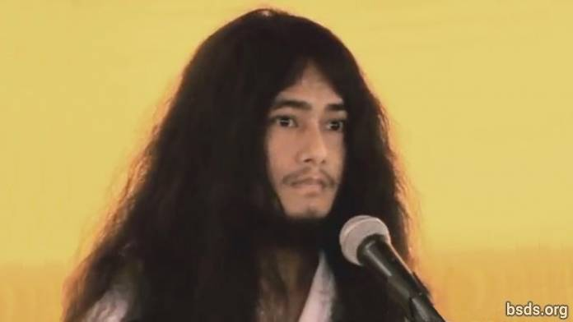

1. May the eternal sky acquire the form of the Earth, absorbing Sansara into the empty field of absolute potential (shunyata) and freedom (moksha).

2. Just as the Moon’s great illumined radiance may the world be enveloped by faith.

3. Just as the Sun’s glorious illumined radiance may the world be surrounded by perfect wisdom.

4. Just as the conch’s sound may the world resonate with the Dharma.

5. Just as the holder of the dorje (vajradhara), may the world be adamant with the love of the soul, the supreme soul (paratma) and the non-self (anatma).

6. Just as the eight-petalled lotus carries forms as the reflection, may the world be enveloped in morality, wisdom and meditation.

7. In search of this pure guidance (margadarshan), directly being steadfast in the precepts, meditational states, and wisdom (sheel, samadhi, pragya) of Noble Maitriya Nath and Noble Tara, I will be giving the guidance of freedom (mukti) and liberation (moksha) in the whole world.

8. If in the world Dharma guidance (margadarshan) for freedom and liberation (mukti and moksha) is given, (but) benefit for the earth and changes do not happen, not just the Dharma world (but) among each and every sentient being and human a storm of uncertain change will come.

9. In the impermanent world, when Dharma decays, then the world becomes unpeaceful, confrontational; a form of sectarianism is taken up among societies in the name of religion – mean behavior is practiced in the name of caste and creed – being deprived from the path of freedom. That is not Dharma to go about religions and peace in such a way.

10. By this communal form of religion, it is a religion made to fulfill personal interest.

11. Today we the Dharma Sanghas are in extreme happiness with the pious work.

12. Thus, let us keep the Maitriyan harmony. For this, I am assimilating and modifying in practice.

13. And, a splendid welcome and Khata may be tributed by the Namo Buddha Tapoban Samarakshyan Sangha and Bodhi Shravan Dharma Sangha’s Sangha Mitra and Kalyan Mitra.

14. In this way by the unification of the the sangha, let the Sangha Mitra and Kalyan Mitra of Dharma Sangha, maintain the Dharma having the same feeling. Also along with bidding a religious farewell, lets give religious thanks.

15. May all beings be tranquil. May they be happy. So be it...

https://bsds.org/en/news/103/speech-of-dharmasangha-on-june-4-2011

Message Given on The Completion of Tapas on May 20, 2011

May 20, 2011

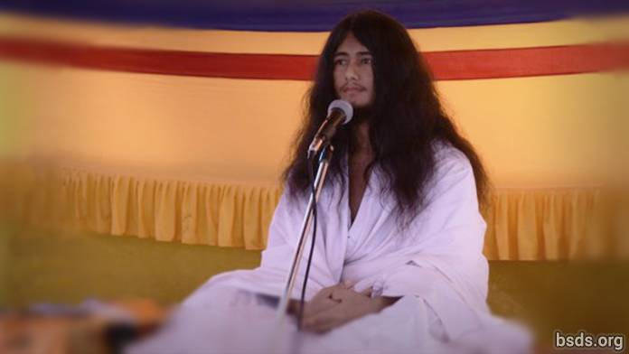

May the eternal sky acquire the form of the Earth absorbing Sansara into the empty field of absolute potential (shunyata) and freedom (moksha).

Just as the moon’s great illumined radiance may the world be enveloped by faith.

Just as the sun’s glorious illumined radiance may the world be surrounded by perfect wisdom.

Just as the conch’s sound may the world resonate with the Dharma.

Just as the holder of the dorje (vajradhara), may the world be adamant with the love of the soul (atma), the supreme soul (paratma) and the non-self (anatma).

Just as the eight-petalled lotus carries the fragrance of divine reminiscence, may the world be encircled in morality, wisdom and meditation.

I bow in homage to Lord Maitriya and to the followers of all religions.

The six year meditation has been accomplished in search of our purest way to world peace and the liberation of all living beings.

Today is an auspicious moment and also extremely difficult-to-reach blessed day.

In this Age of Kali the world is in the trap of the sansaric wheel and has changed into a world which is wandering about aimlessly.

I will be awakening the world which has been influenced by the circumstances of the ages with Maitri Nath’s Maitriful compassionate feeling.

This matter is unfathomable to the world.

The coming of Lord Maitriya has occurred in this world up to four times.

But he left, leaving only his voice for this world.

Thirty five thousand years before today, because of their morals, wisdom and meditational skills, thousands Bodhisattvas were able to become Arhants.

One thousand years later, two sisters were born.

That time, the elder sister took the form of a Bodhisattva.

The younger sister achieved the Miraculous Perfection and intended to destroy Sansara.

The names of those two sisters were Bodhi Shravan and Mohima.

Then, in the Sakya Clan, Siddhartha Gautama Buddha was born as the result of the previous meditation.

Siddhartha Gautama Buddha, in the search of the past meditation, to be able to concentrate again, renounced the home.

Due to the continuation of previous meditation (meditation of remembering past and previous lives); achieving Purva Gyan Siddhi (perfection in wisdom of knowing past lives), he re-established the system of morality, insight and Samadhi in the world.

At the time of obtaining the Final Nirvana, being absorbed in Samadhi, the darshan of Lord Maitriya was directly received.

Two thousand years ago from now, I was on this Earth. In that situation, I remained alone in meditation.

In that state, there was an extremely barbarous transitional occasion; in that situation (I) was murdered.

After 75 days I realized that I was dead.

In order to liberate such a world, wandering in that form of consciousness for up to 2000 years was painful.

Suddenly there was the sound of thunder, and I was able to achieve birth from my mother’s womb.

"Soon after birth, you will go into meditation".

This kind of thought overwhelmed my subconscious memory.

The world (my goal) that had been forgotten through Mother’s womb and the touch of love, was recalled after six or seven years.

One day a great person (colossus) clothed in a white robe delivered an oration.

Day by day, the information of the past meditation was revealed.

Meanwhile, at the age of about eight or nine years old, one miraculous vision appeared.

A small distance from the village of Ratanpur a Tharu family brought a dead body to be cremated.

At the time I was playing together with some friends.

Suddenly, I caught sight of the blazing funeral pyre.

There was a vision of one brilliant ray of light that was seen to pierce the sky.

The bright light was a green and yellow color.

From that time, day by day I was able to recall the past wisdom.

Because of that brilliant illumined radiance of the funeral pyre, I became more and more aware that just as after death, humans could attain liberation.

After that the past meditation was recalled.

Due to the occurrence of the brilliant light, it was necessary to have a place in order to relax alone and concentrate.

Due to the recollection of the previous meditation, starting from the seventh chakra reaching the Brahma Chakra, defilements (Klesha) and delusions (Mara) being destroyed, an invisible cluster of light entered the body.

In that state, being one with water, air, sky, Earth, and the Sun, I was able to obtain all sustenance through meditation.

Then the functions of the body at that time slowed down, and I was able to hibernate.

Having been in the same asana for ten months, due to the coldness of the Earth, the rain of storm clouds, the cold weather`s mist, the cloth on my body had become very thin.

When I looked behind, I saw that the termites had eaten my clothes.

I searched to move my body. The whole body was cramped and the body was neither able to feel hunger nor hot nor cold. My focused energy purification practice (tapasya charya) remained surrounded with the disbelief of the whole world.

This daily routine of mine was hard to be accepted by the world.

Even today, I am seeing many skeptical people.

The one who can reach the depth of the inner Maitriya will be optimistic and overwhelmed in truthfulness.

Those who acquire the wrong form will be overwhelmed with pessimism.

In the search of the Cosmic Body of the Great Vehicle (Mahayana Dharma Kaya), if my bodily-aggregates don`t stay, what message can I give to the world?

And while I was single-mindedly abiding in the meditation on the wisdom I had received for the sake of the world, in the evening there was a voice from heaven saying:

"Hey Tapasvi Muni, you are going to die, wake up, wake up, wake up!", the voice appeared to say.

At that time, I was face to face with the blessed one’s divine sight, the two eyes shining with green and yellow light.

That light entered the body manifesting the power of fire.

After that, some unsatisfied people were preparing to attack this emaciated body.

The recollecting thoughts of the emaciated body changed.

Heading southwards from the first site in the process to find a place to be alone, the old committee members were remembered.

So as not to cause worry, I waited from morning under the payer tree.

At eight or nine in the morning, with the sound of footsteps, a group of 7 people arrived to meet in the lonely forest with hearts washed with faith and devotion and eyes filled with tears.

These seven persons were Dharma Practitioners in their past lives.

With hearts bathed in faith and devotion and tears in their eyes, the seven people said, “What were we lacking?” thus expressing the feelings of Maitriya and compassion.

Leaving all matters behind after they had understood the explanation, I moved ahead in search of my own way.

From there, up to nine days, I proceeded forth on a long journey being in “Awakened-Meditation” (Jagrit Dhyan)

I crossed the open ravine in the jungle filled with elephants, tigers, deers, antelopes, leopards, rabbits, bear, wild horses, monkeys, peacocks and other beings, birds, plants (trees).

There is a river in Chitwan flowing in between with currents.

I crossed that river at night and head south in a state of meditation: “Hey, Child-Sage (Bal Muni), if you don’t take care of your body, you won’t exist to speak, then the forms of the Dharma will be lost.” Hearing this divine voice, I with my path headed once more towards Halkhoria.

After arriving in Halkhoria, I already said not to look for me up until six years, but being without shame, I found an odhar (a small sheltered place just big enough to hide the body, normally where animals hide during rain) inside a hill northeast of Halkhoria.

While spending three months in the cave without water, air or the heat of the Sun, a hunter in search of animals came.

The cave was seen by him.

The poor hunter, in greed of the animal’s flesh, was waiting outside.

“Who`s there, is it a man or animal?” he yelled up to three times. Then, I raised my hand outside the cave and showed my head too.

The poor hunter, being desirous and in greed of the flesh of the animal stood up.

For the happiness and well-being of the world, for the jungle, for conservation of plants, likewise for the hunter, I am doing Maitriya meditation (dhyan).

Staying at the base of the the wish-fulfilling tree of Halkhoria`s Banyan tree and under the Sindhuli tree at Baghjor, with soul, body, and speech applied to seeing Sansara for the world, thousands of revelations (darshan) of feelings (bhav), revelations of wisdom (gyan), and revelations of meditation (dhyan) at Halkhoria`s wish fulfilling tree and at the delightful Jungle of Baghjor, realization of the worldly cycle of existence, and joyous insights of various aspects (nana asana) of Dharma were received.

That time, being in this emaciated body, within the atmosphere of squalls proceeded by a dark cloudy secluded night alone in Halkhoria, being absorbed in between the soul (Atma) and the Super Soul (Parmatma) I received a direct vision face to face (darshan) with Maitriya Nath.

The directly witnessed revelation and his statements cannot be told to this Earth yet.

In the wisdom of enlightenment, our happening to be the same five-elemental body...

...as well as submerging in the feelings of love (Maitri Bhavna) that the whole world unite in the same feelings for the Earth to transform the worldly cycle of existence into love and compassion (Maitriya and Karuna) is the wish.

Seeing through the worldly vision to the soul, body and speech, spreading the World Peace Great Prayers throughout the world for the benefit and welfare of all beings and the conservation of flora, I will be giving the true understanding (satyagyan) of the entire universe through heeding the morals and meditational (samadhi) wisdom (pragya).

Perfect enlightenment (Samyak Sambodhi) is attained through wisdom (gyan), morals (sheel), and the meditative state (samadhi).

By material joy and comfort alone, in human life the path of liberation (Mukti) cannot be achieved.

If morals or rules are followed one may be released from worldly materialism as well as from the cycle of birth and death.

And, if in the name of religion spiritual opulence (riddhi) is shown, miracles are demonstrated, it is contrary to the rules of Dharma.

The rule of Dharma is to free those beings from the suffering of Sansara who are not able to do so; to show them the path of liberation is the rule of Dharma.

Suffering remaining, fear and terror, the practice of enlightenment, divine eye, extremely pure mind-exceeding knowledge, great compassion and enlightened mind are the revelation of the field of infinite potential (Sunyata).

Being dedicated for the sake of the sentient beings of the world, doing dedication...

wherever samadhi takes form, there is Dharma.

Whoever in this world reaches the conscience of Maitriya.

whoever, being in the union of the supreme soul (Parmatma), drinks the elixir of samadhi...

whoever up until the inner soul (antaratma) has the strength and light of the wisdom of Maitriya…

…opens the worldly gate of Matreya Nath`s loving understanding and feeling for the world (Sansara).

There is direct manifestation of the Truthful Being (purush), the Great Being (maha purush) and the Buddha Being (buddha purush).

Wherever there is the eternal existence of all human life; there, life’s perfection is Dharma.

In the perfection of Dharma, there is Shunyata (emptiness).

Encountering the feeling of Shunyata, there is enlightenment (Buddhatva).

Shunyata and Buddhatva are formless and unmanifested;

stronger than a rock of memories of material pleasure.

Inside the wisdom of buddhahood/enlightenment (buddhattva), there is peace, there is principle, gaining liberation for the world.

"so be it"; "may it be"

May all be tranquil/prosperous/happy.

https://bsds.org/en/news/91/message-given-on-the-completion-of-tapas-on-may-20

