Orações

Opening Invocation
— Opening Invocation
Twenty One Realms Prayers
— 21 Realms (Yungasito Gyunyuong)
— Swarga Realm (Dhgyanwa Gyunyong)
Blessing Prayer
— Blessing Prayer (Okulekshya)
Offering Prayers
— Water Offering Prayer (Shegya Nyendig Yupnrit)
— Flower Offering Prayer (Ngodhang Yupnrit)
— Fruit Offering Prayer (Nringyup Yupnrit)
— Light Offering Prayer (Krayop Nmuk Yupnrit Kshunya Yupnrit)
— Incense Offering Prayer (Drinmu Yupnrit)
Paramatma Guru Prayers
— Homage to Maha Maitri Marga Guru (Washu Suden Sepla Lopamweichi Lachu)
— Sei Seinyig Marga Gyawi (Sei Seinyig Sepla Gyawi)
— Yamtok Gyawi
— Yeshen Gyawi
— Homage to Layensiwi Gyawi
— Layensi Gyawi
— Homage to Nomyun Gyawi (Nomyun Gyawiweichi Fawoi)
Closing Prayer
— Closing Prayer

Opening Invocation
Nri-hi-tō ma-le-thō to-le-su nri-ho-tra shō
Gya-wi tra-ni-kshi gya-wi shō-a
Gya-wi da-kshi-thō nri-su nri-ho-tra shō-dhō

21 Realms (Yungasito Gyunyuong)
1. Sup-so wu-go-che-pa ye-wa-ga ye-go-wi-su chug-chep
2. Nur-pa num-yo oo-go-che-pa woz-na-so ney-yüng-ah-tum-pa ya-gu
3. Dai-gya bu-gyan-ah ah-nye-tre tik ah-nye-chi sep-ga se-dak
4. Oo-du-gya-ka yup-ke-fe-da wu-gyo-sa cha-wu-yey ya-gu

5. Tik-ah ah-nye-chi ka oo-ga-tru-wa-ye-se gu-su-ye gyu-yüng-ah-shey wu-teg
6. Oo-se-chi-cha gyu-yüng-ah-shey wu-wi-na lup-go
7. Ye-gong-ah-sha gyu-yüng-ah-shey wi-sa-se wu-te-ga la-fa-tro-da-ni
8. Ye-ku-cha sey-sa-si sey-sur-wa gey-shi-se-ya-gyo-gi gye-tün-ja lup-go-cha da-yo

Swarga Realm (Dhgyanwa Gyunyong)
1. Dri-yum-cha dai-gya dai-gey-wa gyu-yong-ah da-yu
2. Wi oo-ge-ngo-pa shu da-nyek-sel ma-sai-eh-gye wi
3. Wi oo-ge-ngo-pa shu ye-yu no-shey ma-shai-eh-gye wi
4. Da-wu-gya-ga wi shu oo-nem-fa da-yo-mey-ye wi

5. Wi neng-ah tra-tos-sa se-pla-sey oo-sna-fey
6. Bu-gyan-ah-sey gyo-shu wa-yu-na dey-gya-sey oo-sna-fey
7. Wi neng-ah sheh-da-ka gyün-yüng-da da-wi-pey-ga lung-sey
8. Cha-toh-fa ah-no-na wi neng-ah oo-gyu-sha da-yo-mey-ye wi

9. Sey-ka-sheh da-gya-pum-nya gyo-no-ka-cha cha-toh-fa pe-nga-ka wi ko-sha
10. Oom-na-pa-sey da-gya-pum-nya gyo-din-da cha-toh-fa pe-nga-ka wi ko-sha
11. In-nga-sey da-gya-pum-nya gyo-din-da cha-toh-fa pe-nga-ka wi ko-sha
12. Cha-toh-fa ah-no-na wi neng-ah eh-gyu-sha da-yo-mey-ye wi

13. Ye-ku-cha-pa oo-ge-ngo-pa wi neng-ah da-pai-ka-nyug-na
14. Cha-toh-fa nyu-nga pe-nga-ka wi ko-sha pa-ye eh-dey-cha dey-gya
15. Tra-tos-sa se-pla-sey oo-gyu-sha oo-gya-di-sey
16. Oo-nga-gyo tre-sha neng-ah oo-gyu-sha da-yo-mey-ye wi

17. Sa-se-cha ney-yüng-ah-tum-pa gyo-nye-pa sho-den che-pa lup-go
18. Lup-chu yo-doh-ga dai-chi-che cha-shya wi no-tra cha-toh-gya
19. Gyo-din-da da-nye-sel pa-ye ya-yu no-sheh ma-shai-eh-gye ga-toh
20. Sa-se-cha nul-ni-ga pa-ye dey-gha-wi wa-tro ti-aag

Blessing Prayer (Okulekshya)
1. No-tra cha-shyu-wi shyu-ka-na pung-ring-ah
2. Shi na-nig-gut-fa-no wi-ka-sa tra-tos-sa-sey
3. Gyo-no-ka-cha shep-la-se wu-ga da-toh
4. Su-den tra-tos-sa-sey gri-wo-ga ye-gey

5. Go-ta-sa ye-wa-gye no-tra cha-syu-wi
6. Tra-ka-ka-sey wu-ga-ye-sha shey-pa chey-gya-ta
7. Mey-ga lup-go cha-wi-yi-ga
8. Cha-toh-fa wa-chu-shya ney-yüng-ah tum-pa wi-ka-sa ye-se

9. Pa-tün gu-ka-le-cho pun-ring-shey su-den
10. Sep-la chep-na-ga-shey wu-go-na-pung-ah lup-cho yu-ngo
11. Toh-da-da-se meh-gu-ye ma-ye-sup-so lup-go

Water Offering Prayer (Shegya Nyendig Yupnrit)
1. Tra-num-wi che-ye na-pi-sa-ga-sa-wi duz-nyup-nga wa-chu-shya ney-yüng-ah-tum-pa sey gu-sui du-fa wa-ka chu-shya-sey nri-pum-ah sey pum-ring-ah sey-ye sa-gya tra-num-wi lup-go cha-wo-sey ya-pa-sey-ye-se lo-pum tum-pa tong-ah-wa oo-gya-pa tish-tu gu-ka-gya-wi te-che-ta che-pe ngo-yu-che-toh-pa lup-cho oo-tre-pa yeh-sai-eh lup-gu

2. Ya-pa-ye-sey lo-pum nga-yu-sa tum-pa se-nri-pung-ah shey-ye ma-che-dung-ah sey-gya-la pum-ring-ah shi-na-se tum-pa yo-ngo-ye pung-ring-ah shey-ye ney-ya-pa ma-che-dung da-ngu-nri-pum-ma sho-toh-le-gu-ma ya-lo-ba-wa tis-du ga-sa-ga lup-che-tro

Flower Offering Prayer (Ngodhang Yupnrit)
1. Wa-ka-chu shya-shey duz-nyup-nga wa-chu-shya ney-yüng-ah ta-pum
2. Wu-ga-ye-pa tis-du-sey shin-na tum-pa ye-ngo pum-nri
3. Ney-ya-fa-no wa-ka-sha tra-tos-sa-se sep-la-sey ngo-dung-ah
4. Jey-ga nga-tos-da-na gya-ge-ga cha-wu-ee-ga

5. Shri-yu-chey-pung-ah so-toh sey-ga-sey-ta-sa gu-ka-gya-wi nu-da-pa
6. Gya-ge-ga cha-wo-yi-ga shin-na so-shya nyo-pa gey-ka-yu-sa
7. Gyo-nga-cha ka-shna wo-nga cha-toh-fa wa-chu-shya ney-yu nga-sey
8. Tish-du ngo-dung-ah dey-ga

9. Dhri-yem-sey ye-trun-loh-ga tum-pa-sey gyum-ga lup-go
10. Ti-ga yem-ga dey-ga cha-wo-yi-ga ta-tu ngo-dung-ah
11. Chep-wi nyo-pa no-ka-chu lup-go cha-wu-ee-ga cha-toh-fa
12. Wa-chu-shya ney-yüng-ah-sey tish-du wa-ka-sha tra-tos-sa-sheh wu-ga da-toh

13. Gyo-nod-cha da-gya-pum-nya sho-toh pus-na-ta si-ga-si ta-sa ka-shna
14. Ngo-dung-ah gya-chu-shey dey-ga-gya-gu-ma cha-toh-fa wa-chu-shya
15. Ney-yüng-ah-sey tish-du wa-ka-sha tra-tos-sa-sey gye-chu-sey
16. Yo-nga-ka gri-wo-ga yo-nga-ka tre-shu-ye dey-ga gya-go-ma

17. Su-den-na-se nul-ni-da nga-dong-ah pa-go-ta dey-ga
18. Gya-mo-pa pa-toh-ga wa-chu-shya-sheh wa-ka-sa
19. Tra-tos-sa-se tra-go dri-yum-sey-ye trun-lo-ga tum-pa-sey
20. Ni-pa-nga-sey ye-yu-nga-ka tish-du chep-ee ngo-dung-ah oo-ro-pung-ah lup-che-tro

Fruit Offering Prayer (Nringyup Yupnrit)
Tra-num-wi sa-yüng-ah na-pi-sa-ga sha-wi che-ye du-pa wa-ka-chu shya-sey cha-toh-fa ney-yüng-ah tey-ye sey-gu-su-ye tra-num-wi lup-go cha-wu-sey nri-nga-yu-pa oo-gu ta-ge-pa tum-pa tong-ah-wa nri-nga-yu-pa dey-gya-pum-nya ngo-yu che-toh-pa lup-gu yi-yo-nga güz-bu-sey mey-go ye-nge-ka tish-du che-pe cha-toh-fa ye-go-ma ga-sha-ga lup-che-tro

Light Offering Prayer (Krayop Nmuk Yupnrit Kshunya Yupnrit)
1. Cha-toh-fa wa-chu-shya ney-yüng-ah tum-pa gi-ga tra-toh-sa-oo-wa oo-ga-sey-pa-so-toh nul-ni-ga sey se-pla gyo-toh-ga da-toh trey-ye-pu pa-tu-sey cha-toh-fa mey-ga-la tish-du mey-gu-ye tey-ma chu-ya des-mi-gya-wa lup-gu-chu-ye sey ees-sna-sep-ah chep-en da-toh nul-ni-ga sey-gyo-na-ga-ta pum-ring-ah shey-ye oo-gyo-pa-wa tre-wu-ma

2. Nye-ma-wu-wa nye-ma met-ah-oo-wa met-ah tra-tos-sa-wu-wa tra-tos-ah ge-te-ta-oo-wa wi-chi ge-te-ta ee-sna-sey yu-ngo pum-ring-ah te-ma mey-ga-la tar-da-ni-yeng-ah na-tu-pey wo-pa shey-ye-pa-tu-ma-ya tra-gu ya-pa-ye-se lo-pum nga-yu-sa tum-pa ye-nge-ka tish-du chep-eh ga-sha-ga lup-che-na-tro

Incense Offering Prayer (Drinmu Yupnrit)
1. Wa-ka-chu-shya-sey gyo-na-che-(sha)-pung-ah sey gu-su-ye tra-num-wi lup-go-cha-wu-sey gye-ma-ga pum-ring-ah mi-na ga-chu-ye-ta gye-ma-ga drin-mu wa-mey-eh-pa ta-so-pa tum-pa sey ni-pung-ah-shey-ye tra-tos-sa ka-shna-sey ki-ye-ma-ge jey-ye-pa oo-ngu tra-gu nri-pung-ah sheh-ye ga-sha-ga lup-che-tra

2. Cha-toh-fa lo-pum tum-pa tüng-ah-wa cha-toh-fa mi-na-ga-chu-ye-ta

3. Drin-mu sey gye-ma-ge wi-chi gyo-ney-cha sha-pung-ah cha-wo-pa

4. Che-gu-ma tra-gu sha-ye-ge-ka wu-sheh-ka-ta shey-ka-shna tum-pa sey da-lo mi-na-ga-chu-ye-ta drin-mu sey gye-ma-ge wi-chi-tra-nga cha-wo-pa chey-gu-ma

5. Da-ngu wa-ka-chu-shya-shey wu-che-ka-ta pum-ring-ah shey-ye ma-ge-yu-ra-pa tey-ge cha-wa-se ye-pe-ye-sheh nga-yu-sha tum-pa tong-ah-wa cha-toh-fa min-ga-chu-ye-ta gye-ma-ge pum-ring-ah oo-ga-sey-wu-wi gya-gak-chey-gey ye-sa-ye lup-che-tro

Homage to Maha Maitri Marga Guru (Washu Suden Sepla Lopamweichi Lachu)

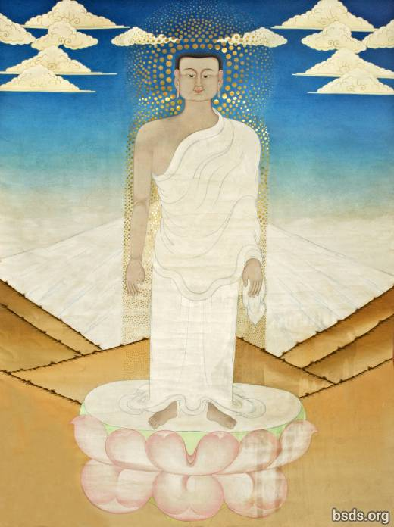

1. Dum-yu-ga ta-khe-pa pa-go wu-doh-sey ye-ga-ga sey-wa-sey
2. Du-ye sa-tu-ge wu-cha lay cha-wa-fa-gyi-ya
3. Wa-chu-shya ney-yong-ah-se gu-su-ye ka-ka-da-pa-ye ga-toh
4. Ye-ku-cha wa-chu-shya-sey wu-leh-pu-ye su-den se-pla lo-pum-wi-chi ye-nge-sha lup-che-tra

5. Nul-ni-ga pa-yey gya-wi tra-tos-sa wi-chi wi-nya lup-cho
6. Tish-du ka-wi-se sheh-weh dhün-gya-gu nyu-fa-sey khe-yung-ah wi-chi
7. Su-den sep-la lo-pum sey ye-fa-sey ees-shna-sa wi lo-nyi-na-ya-ra lup-go
8. Gyo-nyim-chi-la toh-wi ga-toh yu-nye chu-ne cha-dong-ah yep-gya gyap-so-go cha-wu-sey

9. Oong-ah ying-ah-wi da chin-eh-chey wo-ga dey-gya-fa-ye gyu-yüng-ah-sheh tu-wi cha wu-sey sep-la lo-pum wi-chi gi-ta-gya lum-wi
10. Cha-toh-fa wa-chu-shya ney-yüng-ah tum-pa wo-nga cha-se-ga ye-gyu da-ya
11. Ye-deh-cha su-den pa-ye sha-pa-nye-wi no-tre ya-bi ney-pug
12. Oo-wi-so da-gyup-nga sey-wa-se su-den tra-tos-sa dhi-ta-sho-yo wa-nyi-ah-gyo tey-go

13. Cha-toh-fa tra-num-wi-pey-ga su-den se-pla lo-pum-wi-chi ga-sa-ga lup-che-tra
14. Güp-so-wa gye ya-dri ku-shya ga-ta-chi-da-na gye-nyi
15. Gyo-trum-mo-na nga-gyu-ka mre-wi-da ni-yu-ra ni-pung-ah lup-cho cha-wu-sey
16. Ye-dhun-gya pum gya-sho-toh ye-doh-wi cha-wu-sey te-ma-ye ye-ah-pa wo-nga cha-sey-ga-wi

17. Dai-gya ney-gyu-sey ees-sna-sey ye-sha-no-ya su-den se-pla lo-pum-wi-chi gi-ta-gya lum-wi
18. Nul-ni-ga-sha ul-na ney-ye ge-da-pa lup-go ye-ta-ye-da lup-cho
19. Mey-ba-pa ees-sna-sey cha-toh-pa wa-chu-shya-shey gyu-wi-oo-sey
20. Dey-tu chu-ne gün-du-ye pum-ri-wi ya-ta-ye-da lup-cho

21. Noh-sey se-pla se-pla lo-pum pa-yey
22. Lo-pum se-pla lo-pum wi-chi ga-sha-ga lup-che-tra
23. Su-den se-pla lo-pum na-pi-sa-ga yen-sa ye-ngo na-wi-doh-ba-wi ko-shya
24. Dai-gya pa-ye chuss-ye-cha ma-sa-ge-pa tre-sha ye-yu-ya-che-ti-wi-ee-sa-gna

25. Wa-yu-na-sey gha-chi-tri ye-non-na gyo-tu-sey yi-sa-no-yey
26. Oo-gyo-sa no-yar-gyi-la se-pla lo-pum-wi-chi ga-sha-ga lup-che-tra
27. Su-den se-pa-nye wa-shu da-yi-nga-gi-shey gyo-tu wo-yin-tro nen-mo
28. Yum-pa-toh-ka yon-da ye-nung-ah pa-ye ba-wi ka-mey tu-wa-pa wa-yu-na

29. Lo-pum se-pla pa-ye tra-tos-sa-shey ni-wa-yin-tru su-den sa-wi
30. Wa-su su-den se-pla lo-pum-wi-chi sha-pa-nge-sha-ka ga-sha-ga lup-che-tra
31. Sheh-ka gyi-na gu-yey-ye-sheh nye-gya gyo-din-da pa-yey
32. Doh-da cha-wa-sey wu-gya-gye-te-ga so-shya

33. Yey-nye-tre da-chi-ta chuss-pung-ah ye-sha da-chi-ney ye-chu-sey
34. Cha-toh-gya wu-nge-yi-pa shey-da-ka-sey wong-ah ing-ah-ga-toh gyo-nyim-chi-la
35. Kot-wa ney-gya nul-ni-ga-shey wu-gye tik-shu-ga ye-ta ney-gya
36. Bu-gya-na-sey chi-la-pa-sey gyum-du-sey ney-yüng-ah-tum-pa-sey gu-shu-yey

37. Gya-ta-fo lup-go-ga tu-ya-sha tra-yu ta-wong-ah la-doh jey-ko-wi
38. Gye-ya yu-trun-ah sheh-ga-wi-chi ga-sa-ga lup-che-tra
39. Ti-chang-ah ko-sya no-ye-jun ney-yüng-ah-tum-pa-sey yu-tra-na-che-ye
40. Cha-sey-cha no-ma tra-yu-su nri-nga ne-shyu wi

41. Oor-ta-ser-sha-dhi dha-chi-ko-dha-pa cha-shey-cha shey-pa-ta-pum
42. Tra-yu-su chu-da-nge-pa lup-chu-wi-chi ga-sha-ga lup-che-tra
43. Gyo-sup-so ga-glar wi gyu-yüng-ah-sey gyo-gya-ka ga-toh tro-ye-pu cha-wu-sey
44. Ya-nge-ka-sey wu-che-fa wi tra-tos-sa lo-pum ye-ga pa-du-ye cha-wu-sey

45. Tra-tos-sa gyi-dep-na gyo-toh-ga cha-wu-sey tu-ga-tu-ye ney-yüng-ah tum-pa wi-chi
46. Cha-toh-fa lo-nyi-shya-ya-ngu ni-pum-ah sho-toh tra-tos-sa yen-di-wo-yi oo-ngu
47. Gyu-yüng-ah-sey gyung-ah-chi yu-no gya-sey ya-gu tra-go-se nyu-fa-tum-pa
48. Ye-ku-cha-pa güng-ah su-wa wu-su-wa-sey lup-gu-sey cha-wu ya-go

49. Chu-yi-ngu ya-ka-dey-ka wi ye-ngo ma-di-ye ga-toh
50. Lup-tro chi-fa-ga wu-nge wong-ah lup-go dey-tey wa-chu-shya sha-ge-ba-wi-chi
51. Ye-nye-ka ma-sa-ge-pa ga-toh ye-yu sa chi-la-gya mey-gya-la
52. Dri-yum-cha dai-gya tru-wi tra-yu-sa ga-pa-sheh-ni-na gyo-no-na yüng-ah-shey wi-chi

53. Ye-na-pu-su-ye so-shyu gyu-du-tra nga-yu-pa yep-gya
54. Ti-si-gyo wu-ngu su-den-ah tra-tos-sa-sey ba-ngo pa-ye sha-pa-nge-wi
55. Oo-sey-ah-cha gyu-yüng-ah-shey yüng-ah-shey ney-yüng-ah-tum-pa-sey gu-su-yey
56. Wey-gu wa-tey-gi cha-wu-sey wu-yo güp-ge-ye-pa no-tra

57. Cha-toh-fa chu-wi-se su-den se-pla lo-pum-tum-pa-sey
58. Lup-tro wu-nye-pa yup-ni-ta gya-gu-tum-pa yey-yu ya-go
59. Tru-da-tri-gya ka-shey-wi wa-ka-sha tra-tos-sa-wi-chi da-chi-la lup-gi
60. Oo-yün-da da-chi-kish-yu-da ye-wi ga-gey pa-ye tru-shna ka-sheh-wi

61. Doh-nung-ah yin-sa no-ga-sho-du-ye tra-tos-sa pa-ye se-pla cho-fu
62. Sa-gyo-pa-sa la-ah-ga-ge-chi wa-ka-sa se-pla oo-yeh-ge-ah-gi
63. Mey-gya-la pa-toh-so-gya wa-ka-sa se-pla-sey
64. Oo-go-na-pung-ah lup-chu gyo-sup-so ni-gut-fa

65. Lo-pum ka-sna-sey da-chi-wa-da-sey
66. No-tra da-chi-nri-shey sheh-gyi-wa oo-ga wa-tey-gi
67. Nring-ah-pa ye-ye-yu lup-gu-se ka-shna-wi-chi ye-gyo wi
68. Ka-tey-cha kem-tu-wa-sey gye-tün-ja wi wo-yin-tra lup-gi

69. Ya-ngo yung-ah-sha ka-meh ti-la-gye-sha wu-da-pung-ah
70. Dey-tu ka-sheh-weh meh-sha-ka-sha wu-te-ye chi-pa-ga lup-gi
71. Se-weh-sha pe-cha-na ye-tu dey-la-shey ye-gyo-cha-sey
72. Yo-dra doh-ga sho-gyi-dep-pa pa-ye ye-ta-sa-ya ga-pem-go

73. Wa-ka-sha su-den tra-tos-sa-sey wu-go-na-pung-ah lup-chu
74. Na-gyun-da pa-ye wu-ge wi-chi fi-chi-trul-gyo-ka teh-gu shep-ka lup-gi
75. Ney-yüng-ah ah-ta-che-pa-sey yu-tra-na-sey gu-shu-ye ka-shna nring-ah lup-gi
76. Ying-ah-sey ah-no-na-ye-sha pe pa-ta-wa-shung-ah-sey

77. No-tra wu-ga ga-toh
78. Gri-ya-tum-pa-sey tish-gu nring-ah lup-go ma-sai-yen-ah ja-gye-pa-ye-ga sho-shya-tu-wi
79. Tu-pe-na che-pa wi ley-ta-ga na-wa lup-gu-sey gri-yo
80. No-ka-cha ying-ah-wi wa-yu-ga-sheh-pa ah-ga-gey-chi

81. Dai-gyun-da ri-pa-ga du-gya-ga yin-sa che-pa-ge-che-wi
82. Su-den tra-tos-sa gye-wi-ya-ga cha-toh-fa wa-chu-shya-shey
83. Ah-wa-gya ney-yüng-ah tum-pa bu-gya-na-shey cha-te-gya-ye-ga
84. So-sya ga-toh wu-ge-ye-pa no-sey se-pla gyu-kay

85. Ye-ba grin-ta nen-mu-sey gu-su-ye ye-ku-che da-chi-ko da-pa
86. Wo-se-ying-ah ga-toh nri-pum-ah ni-yur-ra wa-gya

87. SON-WA NE-HI NIG-MA GYA-WI GYA-TE GYA-WI YEN-DIG NYEN-DE NIG-MA

-------------------------------------------------------------------------
Final Prayer:
88. Sey ya-nge-ka da-tri-ya ye-gyo pa-wi-sa-ka ma-sha-ye-ngo ne-yüng-ah tum-pa
89. Oo-ge-cha-ye-fa ti-chu-ga nri-pum-ah-sho-toh su-den tra-tos-sa gyi-dep-na lup-go
90. Tish-du-se gyo-nge-pa ba-ngo gyesh-pa-nge ye-wa-ga ga-toh
91. Ma-sai-ye-ge ti-ah-ga cha-toh-fa su-den tra-tos-sa-sey lo-pum tum-pa
-------------------------------------------------------------------------

92. Ka-chu chi-shi-gye ne-yum-ah mey-ba-pa tik-shu-ga ye-cha
93. Ye-ka-chu dey-toh wa-tri-da ah-lo-ka-sha tog-tra-ga
94. Ka-cha-pa nul-ni-ga tra-tos-sa lo-pum-wi-chi wi-ya lup-chu nyu-fa-wi düng-ah-nai yu-wu-pa wu-sui oog-shu-ye cha-wu dey-ga
95. Oo-su-ye ga-toh ye-ku-cha-pa gu-nga tra-tos-sa-sey ka-shna nring-ah ney-pug

96. Oo-sheh-da-ta chi-la-gya mey-gya-la nen-mu cha-wu-ye da-lo
97. Da-sri gyo-din-da su-den tra-tos-sa-sey yo-du-ga ga-cha-wo
98. Ti-ka un-nye-chi-ka pu-pi-da-ge-shey wu-lem-pa gya-toh-ga te-gu-wi-chi
99. Wa-ka-sha su-den tra-tos-sa-sey yo-du-ga wa-nyi-ah-gyo wo-ngu

100. Oo-gya-ta ye-gyo-ni ul-na-ni-ya-sey ngat-na-si yui-no
101. Nul-ni-ga-sha dey-gya-sey yui-no ya-sha-pa-pe cha-wu-sey
102. Gyot-wa gyo-chu-go ah-lyo-pa ne-yüng-ah-tum-pa wi-chi
103. Su-den tra-tos-sa ka-shna-sey yui-pa ees-sna-sey fu-cha-ma lup-gi wo-ngu

104. Nul-ni-ga-sha dey-gya ye-yu sho-toh-ga ne-yüng-ah-tum-pa
105. Dai-gya-sey da-te-ge-wi dai-gya-sey ah-nye-ka mi-ku lup-che
106. Küng-ah dai-gya ya-yu tru-ye-ga ga-gyum-gu ya-na
107. Ya-no-na-sey ba-se-ga se-ga-sey wu-ne-gyu ga-toh

108. Ye-ku-cha-pa ye-gu-wi-su wu-gyo-sha bu-gya-na tru-yi-ka ya-go
109. Oo-ga-trey ye-wi-ga-toh nga-yu-pa-tum-pa nem-mu lup-gi-shey tresh-ah wu-yu sha-du-ga
110. Tresh-ah dog-da gyu-ka ye-sho-ton-wa nen-mu-sey gu-su-ye
111. No-sey se-pla chep-na-ga su-den tra-tos-sa-sey

112. Gyo-yüng-ah wa-yu-na tik-chu-ga sey-sur-wa ya-du-ga ne-pa
113. Kong-ah tra-yu-sa nen-mu wa-gri-na ma-sa-ra-yu-sey
114. Oo-ga-tre wu-go-che-pa gya-sey gi-dep-na wa-yu-ye da-loh
115. Kot-wa gu-ge-du-ye kün-nyu chri-sho wu-ye-cha

116. Ye-ta tik-chu-ga ye-cha ngi-da dey-tu gyi-dey-sha-pa gyu-ku shi-güng-ah
117. Ye-na-pu-bo nul-ni-ga-sha ah-nye-tre na-pa-da-wi
118. Oo-gyo-ta pa-ye pu-ga-shi-da gya-wa-ta ka-shey-wi
119. Ya-no-na pa-ye tish-du cho-fu-wi-chi no-tra wa-yu-na tey-gu gyu-kay

120. Ye-ku-da seng-ah-ye su-den tra-tos-sa-sey oo-tey-ga oo-no-na
121. Chi-la-gya gyu-yüng-ah-sey gya-sey ya-gu tra-num-wi ga-toh
122. Nir-ga-sha ga-wi kün-nyu pa-ye bu-gya-na dey-gya
123. Tra-tos-sa tra-num-wi-shey nga-yu-pa toh-ga

124. Tra-tos-sa wo-yin-tra tra-num-wi-shey che-la-pa-sey
125. Nyo-pa wi-chi tra-tos-sa tru-wi chai-su-ye cha-wu-sey
126. Gyu-yüng-ah-wi jey-su-wu-sheh du-ga pu-ge-pa shüb-ke che-gu-na
127. Ye-ya-da-sey wa-pa-te-na grin-ta tu-pe-nu ye-wa-ga ga-toh

128. Ah-lo-ka-sha nul-ni-ga-sha bu-gya-na nir-ga-sha
129. No-sey se-pla chep-na-ga su-den tra-tos-sa nring-ah lup-go
130. Nul-ni-ga sha-wa-shu cha-te-gya-ye-ga sho-chya ti-aag
131. Wa-no-bung-ah nul-ni-ga bu-gya-na-sey cha-ti-gya-ye-ga

132. Yeg-yo pa-wi-sha-ka ma-sha-ye-ngo ne-yüng-ah-tum-pa-se gu-shu-ye
133. Ri-pa-ga lup-chu wu-gyo-sha no-ga-wi pa-ye
134. Su-den se-pla pu-pi-da-ge-shey ye-pa ees-sna-sey ye-wa-ga ti-aag
135. Cha-toh-fa tin-ku nyu-ga-wi-chi wu-yu-da da-chi-ki-shyu-da pa-ye

136. Aas-yu-da ngup-ni ye-ngup-ni ka-meh dey-tu ka-sheh-wi
137. Sey-sir-wa da-chi-gya-ngu-ka nyu-ga da-chi-gya-pa lup-go
138. Da-wa-wi-na nyu-ga wong-ah ying-ah-wi nu-ga-wi ne-pug
139. Kot-wa-su chi-shen-na-ngu ne-ye-meh-shey che-gyu tog-tra

140. Ye-ta gi-pa nul-ni-ga-sha tu-wi-shi sho-tru-ga-tra
141. Da-sa nge-da cho-pu gu-yep-ba da-chu-na yu-tro da-gu
142. So-sya nu-gye-nu grin-ta nul-ni-ga-sha bu-gya-na-ye-ga
143. Nri-pung-ah ta-ka wu-cha-te-ka wa-chu-shya ne-yüng-ah-tum-pa

144. Oo-gyo-sa bu-gya-na shed-na-wi yu-hu-ga wu-nyem-pa wu-gya-di-shey
145. Nri-pung-ah-se ga-toh neng-ah dey-tu su-den se-pla lo-pum-wi
146. Wa-su su-den tra-tos-sa se-pla chep-na-ga-sey yu-doh-ga wa-nyi-ah-gyo wu-ngu
147. Da-chi-se-se met-pa lo-pum se-pla-sey yo-du-ga cha-wu-sey wu-gya-di-sey

148. Ool-ne-si-pa-so-toh wu-nyu-ga-ye-sey se-pung-ah-wi ye-wa-ga gyo-bu-ga-ra pa-ye
149. Se-pa-sey ye-yu-pum-ye ye-bey ah-cha-lo-ka wu-tra-tey-di num-da
150. Sa-pa-ge-na dey-tu tra-yu-su gyo-wu-ga ti-aag
151. No-tra yu-te-ga-nge-wa oo-ngu wi-gu yup-gi pa-ye

152. Ley-yi-ga wa-yu-na gyo-gyu-na-ngo-fa ye-ngo di-ba-dey pa-ye da-nye-trung-ah-chep-wi
153. Gya-shey tre-sha tra-tos-sa-sey ning-ah ne-pa-ga wu-cho-da-pa ye-wi-ga-toh
154. Ye-ku-cha lup-go ye-ba grin-ta shu-yi-dep-na lup-ga cha-shog
155. Ya-no-na wum-na-pa ying-ah ya-gu no-ka-cha ga-toh

156. Chi-ge-dep-pa wa-yu-na gyo-din-da wu-da-pung-ah wi ko-shya
157. Pa-ye ye-ku-cha-pa güng-ah da-fai-ka-nyug-na cha-toh-fa pe-nga-ka-tum-pa-sey
158. Ah-no-na se-pla chep-na-ga gyu-wi-ah-ga su-den tra-tos-sa-sey
159. Cha-toh-fa no-sey nyu-ga mi-ku pa-ye oo-lung-ah-na-wa-sey sey-sa-sey

160. Ley-yi-ga ah-lyu-chu shu-sep-ba ga-toh-ga
161. Gyo-din-da wu-da-pung-ah na-wi-doh-ba ko-shya
162. Su-be-ga ga-toh tra-ba-chi-dra-wa ba-wi wa-yu-na su-den nyu-ga gi-dep-na ney-pug
163. Neng-ah dey-tu su-den nyu-ga-te-na

164. Güp-gey-ye-pa su-den wa-da-pung-ah sey wu-ga ga-toh
165. Dri-yum-cha ri-pa-ga da-chi-gya-pa da-chi-ne-shey dey-tu sep-ka
166. Gyo-che-pa ti-ah-ga ba-wi wa-yu-na tu-ya-sha chu-gya chu-gya-sey
167. Yey-teng-ah-sey gu-shu-ye ka-ka-da-pa gi-nush-ah lung-ah-tum-pa wi-chi

168. Un-nye-tre pa-ye yu-te-ga cha-ko-wi wo-yin-tra te-go
169. Yong-ah-sho no-ma pa-ye sey-wi-ta-wa wa-yu-na
170. Sa-ti-gya-ka ta-yu-pa nu-da-fa gyi-ye-pa-pung-ah no-tra
171. Yu-ngo ya-nye-ka ma-sa-ge-pa-wi nen-mu shu ye-no-na

172. Gyi-ge-na ga-toh khe-ga-tra ye-ma-sheh-da-la tre-sha neng-ah gyi-pa
173. Ti-yeng-ah trey-sha nga-yu-pa dri-gu sha-ya-gya cha-wu-ye ya-gu
174. Ti-ah-ga ye-nge-ka wa-tro lup-ga su-den tra-tos-sa ka-shna ye-ku-cha-shey tre-sha
175. Dri-yum-cha ko-shyu wo-yin-tra su-den tra-tos-sa-sey

176. Sha-ge-da-ka lung-ah-shey cha-toh-fa nu-ri-sha ying-ah ye-wa-ga ga-toh
177. Oo-gyo-toh lo-nyi-shya-ya-ngu ye-gu-wi-shu su-den tra-tos-sa chep-wi
178. Nu-wi-se cha-toh-fa chu-wi pe-wong-ah pe-wong-ah-shey
179. Gya-sey cha-wu-se bhe-wi se-gi ne-yüng-ah-tum-pa

180. Gop-sum-wa ga-toh wu-te-ye ye-ke-cha wo-nga oo-ra-ma-shey
181. Su-den sha-pa-nge so-chu-ye pa-ye ah-nye-tre wi
182. Ya-pu-pa-yo-ga ti-ah-ga ying-ah pa-yum-sey
183. Cha-toh-fa ne-yüng-ah-tum-pa na-pi-sa-ga-se-pa su-den se-pla lo-pum-shey

184. Yo-doh-ga wa-nyi-chi no-tra ya-bi lup-go
185. Ye-wi-ba-wa-ka fu-ye-yu ning-ah-sha dey-tu wey-gyi-da-pa lup-chu
186. Ti-sey-gyo tai-cha cha-toh-fa ne-yüng-ah-tum-pa dey-gya-pa-ye ya-pa-sey-ye-shey gyu-yüng-ah-shey
187. Shey-da ge-pung-ah ka-te-cha lo-yey-ye-na tra-tos-sa tum-pa-sey

188. Sho-shya ga-toh chey-su-ye la-doh dha-chi-cheh wu-tra-tos-sa sa-ge-da-ga tum-pa
189. Ka-te-che-sey che-la-pa pa-ye nri-pum-ma oop-ba-sey
190. Chep-na-ga ti-ah-ga no-tra tra-ba-chi su-den tra-tos-sa un-jey-ye-shu
191. Tra-tos-sa-sey bhe-wi ye-ni-tre pej-gu-tum-pa wi-chi

192. Shüb-ye tra-tos-sa se-pla lo-pum wu-gu-na süb-ke num-da-yi-ga
193. Gya-sey tre-sha dey-tu su-sya ga-toh ye-ba grin-toh
194. Da-chi-wa-da ti-ah-ga no-tra tra-ba-chi se-pla yep-nong-ah-sur-wa
195. Nul-ni-ga-sey gya-sey ya-gu bo-wi sheh-gi tra-num-wi ye-wa-ga cha-wu-sey-seh

196. Pe-wong-ah wi gyu-yüng-ah-sheh ki-wa ya-pu-pa-yo-ga wa-yu-ya da-lo
197. Ye-ni-tre nyi-sey cha-toh-fa su-den tra-tos-sa-se no-se se-pla chep-na-ga-ta-pum
198. Nir-ga-sha ti-ah-ga cha-toh-pa-wa-nye ya-bi pa-ye mi-ku lup-cho
199. No-tra nüg-cha wu-ne-gye te-gu sheh-wi-sha-ta-pum-sey pa-ye

200. Yüng-ah pa-ye ye-nge-ka wu-che-pa te-gu chi-se-wa-chi pa-ye
201. Tra-tos-sa-sey ka-te-cha da-lo gyo-no-ga te-gu chu-gya chu-gya-sey
202. Ti-chang-ah ti-ah-ga no-tra wa-ka-sa su-den tra-tos-sha yir-na-pu
203. Su gyu-yüng-ah-yi-ga ku-nyu ya-ka-dey-ye

204. Ye-ba grin-ta güng-ah dey-gya-pa-ye gyu-yüng-ah-shey
205. Nar-pu su-den se-pla ne-ye-nge-sha ga-to
206. Oo-se-no-ta no-sey se-pla chep-na-ga ri-pa-ga lup-ga nye-aag
207. Ye-ku-cha-pa yüp-nri-ta lup-gu-sey ye-nong-ah-chi-la wi

208. Wa-ka-sha su-den tra-tos-sa-sey ge-pung-ah ka-shna ye-wa-ga ga-toh
209. Yo-du-go lup-go gyo-din-da no-sey se-pla chep-na-ga-shey da-chi-shi cha-shyu wi
210. Nen-mu ti-ah-ga ye-ba grin-ta no-sey se-pla cha-se-chi-ye ne-yüng-ah-tum-pa wi
211. Cha-se-chya nul-ni-da-sey tish-ne-yum-gya tra-tos-sa se-pla cho-fu oo-gyo-pa ne-gya-pa lup-gi wo-ngu

212. Se-pla chep-na-ga wa-nyi-ah-gyo tai-ch

Sei Seinyig Marga Gyawi (Sei Seinyig Sepla Gyawi)

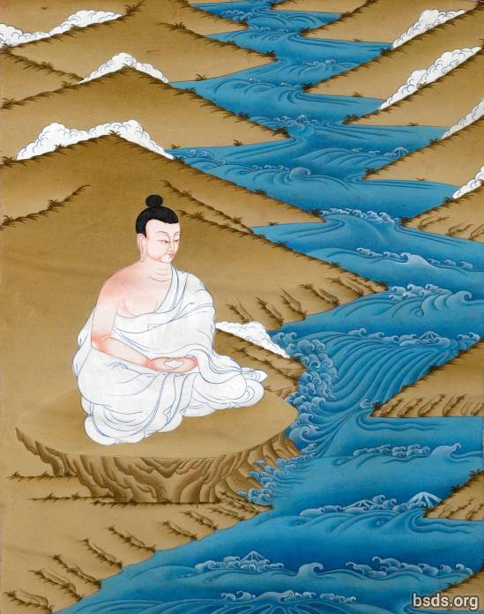

1. Nyu-nga pa-ye yen-di-ga-sey gyo-gyo-na cho-te-ga cha-wu-sey gyo-din-da sed-wa-sey
2. Dug-na-yi-ga wu-cha pe-na-ka cha-wu-sey-ka-wi ye-wi-yüng-ah-sey
3. Ong-ah-sa gyum-du-gya sey yu-nu-fa wi-pa-tum-pa-shey bo-gri-na
4. Sei sei-nyi-ga lo-pum-wi-chi ko-tra-na met-pa ga-sha-ga lup-che-tra

5. Ong-ah cho-te-pa chi-wa la-wa-gya gri-wing-ah nri-yung-ah-po cha-wu-sey
6. Ye-dun-gya nga-gyu-ka mre-wi-da gya-ya-la lup-gi cha-wu-sey
7. Ya-li chu-ne gyup-su-wo-pa da-chi-nog-na ni-da cha-wu-sey
8. Shey shey-nyi-ga lo-pum-wi-chi ga-sa-ga lup-che-tra

9. Yot-go wu-ngu ye-ku-cha sey-da-ka sey ba-ngo pa-ye sha-pa-nge-wi
10. Da-gey-nip-chu ya-ngu-na ku-wa sra-wa-ma lup-go-wu-sey
11. Da-ngu ba-gya yu-wa yum-gu güp-sum-wa rum-wi
12. Lup-gi wu-ngu yum-pyu ye-ser-chu-sheh pa-ye su-lu-wo-wi wong-oh wel-ke-sa ye-che-bo-su

13. Tre-sha mut-ga-pu ye-ye-chi-sey wum-li nrim-la-yin da-yum lung-sey
14. Nir-ga-sa chi-ma ye-ku-cha gyu-yong-ah-sheh su su-gya pe-wong-ah ney-gya
15. Si-güng-ah ne-yüng-ah pa-wi-sha-ka wi-pa wi-pa da-ka sey
16. Sho-wa-gya-da pa-chri-na na-gyum-du-sey cha-wu chi-fa-ga lup-che-tra

17. Sha-ba-wi pum-nya ye-gyo wi shu-wa up-su-wa sey
18. Ye-gye-na dai-shi-gya-ya-ra ya-bey gyi-pa-la-na-sha cho-du-ye lup-gu-sey
19. Da-du wi-chi trung-ah dey-tu sey-nüht-pa pa-ye ji-ru-na-pa lup-gu-sey
20. Dem-pa ye-ya-ma ba-wu-du ye-chu ye-gyum-du-sey gi-wa-fa chi-fa-ga lup-che-tra

21. Lo-pum-wi-chi dey-pa pe-wong-ah shey ah-chi-shi pa-ye cha-shyu wi
22. No-tra nring-ah ye-ngu-na oo-nying-ah-sha lup-gu-sey
23. Tu-wi ney-ye-ah-toh mo-gya pa-ye bo-gri-na wi-pa-sey
24. Tu-wi-tum-pa-yi-ga ye-ba grin-ta ga-gya sho-shya te-gu-tra

25. Oo-ge-pa ya-gu ye-ku-cha sheh-da-ka sey ngu-la lup-gu-sey
26. Bo-gri-na wi-pa bo-gri-na ni-na-wa-tum-pa pa-wi-sha-ka yi-ga-ye-tum-pa wi
27. Pe-chi-ney-yeng-ah rum-wi dey-toh ti-du-sung-ah sey cha-wu-sey dey-tu ne-gya ga-toh
28. Na-na-da-pa su dey-gya-sho-toh ti-aag

Yamtok Gyawi

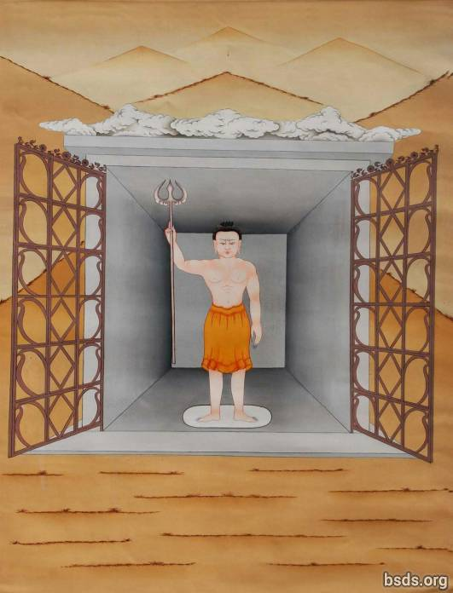

1. Oo-ga-sa-ga-ne-pa lo-gye-sey nga-gyu-ka gyum-du-gye ge-ne
2. Cho-pu pum-nya tra-ne-ah-go cha-wu-ye da-lo oong-oh-sha pum-nya ni-da cha-wu-sey
3. Gyo-gyo-na pum-nri-wi lung-ah-pa-sheh wu-ga ni-da cha-wu-sey
4. Yam-tok gya-wi-sey nri-pung-ah-sey ga-sha-ga lup-che-tra

5. Bo-wi yip-gya cho-yu-pa ye-ah-pa sha-wa-ngu-toh pa-gye-da-na-sheh chu-wi cha-wu-sey
6. Te-ye-ma yep-gya mem-wa pum-ring-ah-sheh gya-sho-da wa-te-gi cha-wu-sey
7. Cho-fu-wi cho-yu-pa te-ye-sey ye-sen pa-ye-nu-sey da-yi-ga ni-yu-ra lup-gi cha-wu-sey
8. Ye-pa yey-ah-pa-se lum-sha-wi mre-wi-da chi-nri-ye yam-tok gya-wi-sey

9. Sheh-ka gyi-na pa-ye ying-ah-ye-ga ye-wa-ga tre-sha ya-ma-ra-tum-pa
10. Dhüm-sa lum-sa-wi mre-wi-da ni-ya-ra lup-gi cha-wu-sey
11. No-tra wu-no-na da-chin-ri-sey
12. Dha-chi-nog-na cha-wu-sey wi-chi da-lo ga-sha-ga lup-che-tra

13. YANG-CHYA-SYU YANG-CHYA-SYU YANG-CHYA-SYU YEN-TA DO-WAN-SO

14. Ga-chi-tri-gya-ngi-pe su su-gye gya-che-da wi-chi no-tra ma-du-chi
15. Se-ka gyi-na ying-ah-sey ye-gu-da-ba ja-gye-pa-yi-ga shu-shya ga-toh
16. Se-ka gyi-na dai-gya-so-toh pa-ye wu-gyo-sa-no nen-mu wi
17. Oo-yu-da da-chi-ki-syu-da ne-doh ge-da-pa lup-cho tish-du gya-wing-ah nen-mu wi

18. Sep-ka-tum-pa wo-in-tra toh-ga-sey gu-su-ye weh-gu yep-gi tra-yu-sey
19. Gya-wey wu-de-ga-sha de-pa ka-shna-sey pa-shrin-ah sho-shya-ga pa-ye
20. Ne-doh de-mu-yi cha-wu-sey
21. Gya-na-tum-pa wi-chi duz-wa chu-ra-ga ye-nga-kyu lup-gu-sey da-lo so-shya tog-tra

22. Ye-gyo wi-chi ya-da lup-cho ne-doh-sey de-toh wa-li-na pa-ye
23. Nüg-cha-yi-ga gyo-ma-sey ye-nya lup-gu-sey gu-su-ye gyum-na-sey ye-yu-shey chi-sho
24. Oo-ge-ye ga-toh tik-shar-ga cha-wi-na du sep-ka-se wi-gu da-yu-sey
25. Nga-ta-la-ta ye-gyo gyo-ma-sha tey-gu-tra

26. Gyum-na-sey ga-chi-tri-gye-ni-pe gya-che-da ma-du-sey wa-ka-sa yu-da-pa wi
27. Ne-doh pa-chri-na so-shya-ga se-pa gey-ni gyo-ma-sa yi-nya lup-go
28. Wa-ka-sha tra-tos-sa pa-ye tra-tos-sa wu-pa-chi-nu-tum-pa de-tu chu-wi-sey gyu-wi-oo-pa
29. Ye-ba grin-ta yam-tok gya-wi-shey ka-shna nen-mu lup-ga cha-shog

Yeshen Gyawi

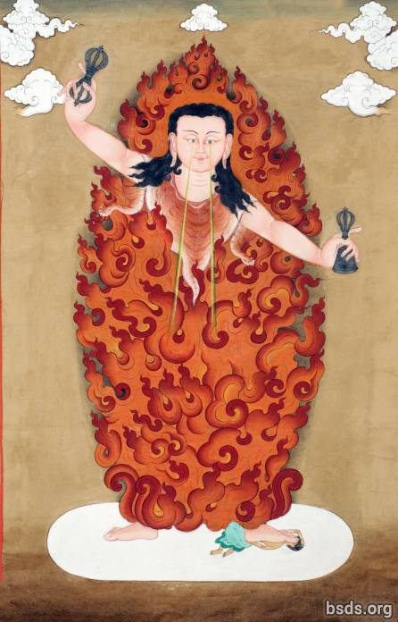

1. Nga-gyu-ka gyum-du-gya-se gya-so-da ye-sen gya-wi
2. Oo-nga cho-te-pa chi-wa te-ma-ye-sheh duz-yup-nga te-wi gya-yu-la lup-gi cha-wu-sey
3. Nri-ga-yi-ga dhüm-sa lum-sha-wi nga-wa-nu gye-wa-pa num-ga-cha-nu-sey ees-sna-sey lush-reng-ah cha-wu-sey
4. Se-wi yüp-da gyu-mi nu-gri-ti ye-ga-wi-oo-sey

5. Cha-ngo-ka la-wa-gya-wi lum-sha-wi ye-ma-chi wu-ni-ga yep-ge ti-tra-wu-sey
6. Pa-shring-ah la-wa-gye sha-wa-ngu-toh se-ye-nga ni-yu-ra lup-gi cha-wu-sey
7. Shrun-ring-ah-sey gye-ya-da-sey chi-wi dhüm-sa nga-gyu-ka gye-yi chi-wa yey-up
8. Chi-wa yu-pa sha-wa ngu-toh pa-shring-ah wi yu-nge-pa yo-song-ah

9. Di-gyi-wi-sho-toh ye-sen gya-wi da-yo
10. Gu-na-wi-sho-toh ye-no-na-shey nri-yüng-ah-wi
11. So-se-pla-sey tin-sha-wo-wi yu-nge-pa-shey wa-li-na wi-chi te-ma-pa lup-gi
12. Ye-sen gya-wi wi-chi da-yu-pa lup-che-tro

13. Dee-gyi-wi-sho-toh ye-sen gya-wi da-yo
14. Gu-na-wi-sho-toh gyi-yu-sey nri-yüng-ah-wi
15. Oom-na-pa-sey nyu-pa-tum-pa ge-da-pa lup-gi
16. Ye-sen gya-wi-wi-du da-yu-pa lup-che-tro

17. Dee-gyi-wi-sho-toh ye-sen gya-wi da-yu
18. Gu-na-wi-sho-toh ying-ah-sey nri-yüng-ah-wi
19. Ying-ah-sey nyu-pa tum-pa ge-da-pa lup-gi
20. Ye-sen gya-wi-wi-chi da-yu-pa lup-che-tro

21. Cha-se-chya ni-fa-sey se-pla lo-pum tum-pa-sey se-ka gyi-na ying-ah-yi-ga lush-ring-ah cha-wu-sey
22. Gya-da-bo-gri-na gya-che-da dey-tu gya-nye ye-no-da-se cha-wu-sey
23. Doh-gyu-yüng-ah-sey ye-gu-da-ba tro-ma-fa tum-pa wi-gyi-da-pa lup-gi
24. Ye-sen gya-wi-wi-du da-yu-pa lup-che-tro

25. Ni-yu-ra lup-gi cha-wu-sey wu-yu ne-shyu-sho-toh ye-ma-chi
26. Sheh-da gye-wa la-gye-na ye-shong-ah-nri-wi
27. Ye-gu-da-ba bo-gri-na-sey wa-li-na wey-gyi-da-pa lup-gi
28. Ye-sen gya-wi-wi-chi da-yu-pa lup-che-tro

29. Che-gu-na cha-wu-sey cha-sheh-chya chu-ne-sey du-sna-sey yep-gi toh-nyi-du
30. Ne-gya pum-nri-wi nri-sha-pa ga-te-gu oom-na-pa gyu-no-pe-ba-sey
31. Da-yi-gya wa-li-na wi-chi lo-krig-da-pa lup-gi
32. Ye-sen gya-wi-wi-du da-yu-fa lup-che-tro

33. Sa-se-chya ni-pa gish-nu se-pla lo-pum-tum-pa-sey ye-toh
34. Ah-nye-ka pa-ye nyu-ga wong-ah pum-nri-wi ne-yüng-ah yu-tra-na cha-wi-na
35. Sa-se-chya gyan-gu se-pla lo-pum-tum-pa ne-shyu pa-ye gya-wing-ah dup-wa-nu-yum
36. Ye-sen gya-wi da-yu-pa lup-che-tro

37. Nu-pa-de-pa nyüng-ah-sey la-ngo-pa-se wu-ga cha-wo-sey wi-chi no-tre ya-bi pa-ye
38. Dum-cha-pai-ga-shey de-tu tro-ma-pa na-sho-gya lup-ga-sey gu-su-ye
39. Sa-pa-nge un-ye-ka-wi nga-du-ga-sa-ka pum-nya tra-ne-ah-go cha-wu-sey
40. Ye-sen gya-wi-wi-chi da-yu-fa lup-che-tro

Homage to Layensiwi Gyawi

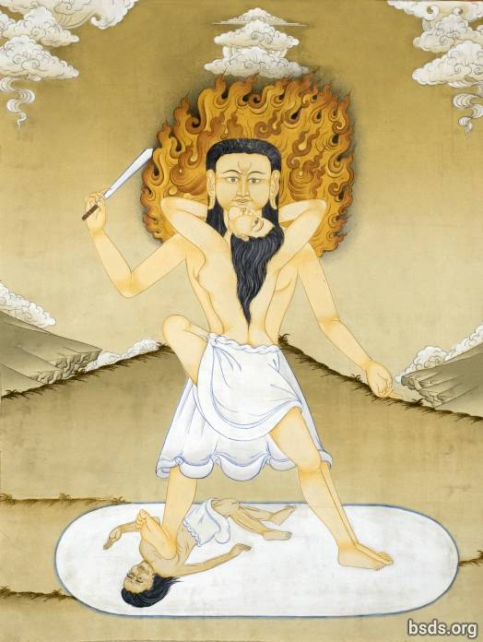

1. Ngo-da-sey gu-na la-shreng-ah naw-ba yum-nu-pa pa-gya-da-na-sey da-chlo-yu-sey
2. Dum-gyo-chi-wu-sey se-wi nu-gri-ti nga-du-ga-sa-ka pum-nri-wi
3. Cho-yu-pa la-wa-gya-wi nga-gyu-ka pu-ne-ka wo-ni-ga-yu-pa ti-tro-na
4. Pa-shri-nga la-wa-gya sha-wa-ngu-toh ngya-pa-gye sok-sheh-se yu-nu-pa ni-da ga-toh

5. Ye-wa nga-gyu-ka nga-gyu-ka pa-ye gya-ye-ti nga-gyu-ka wa-yu-na
6. Cha-ngo-ka ye-ya-pa-wi yop-da ne-yu yu-ne-pa lo-krig-da-pa lup-go
7. Nga-gyu-ka gyum-du-ga-shey shu-chyu-nga pun-ri-wi yu-nu-fa ni-da cha-wu-sey
8. Cha-toh-fa yi-ye-na la-yen-si-wi gya-wi-wi-du ye-nge-sha lup-che-tro

9. Nu-gya-ga pum-nya tra-gya-ta ye-doh-wi cha-wu-sey la-yen-si-wi gya-wi wi-chi
10. Gya-ye-ti nga-gyu-ka wa-yu-na ye-wa lum-ngi nga-gyu-ka nyi-pum-nu bo-grin-reng-ah wi
11. Pa-shri-nga ye-ye-pa se-sa-pa de-ya chi-wa la-wa-gya-wi ye-wül-wa lup-gu-sey
12. Ya-da ya-ka-de-ya la-yen-si-wi gya-wi chi-wa chom-pa-wi-du ga-sa-ga lup-che-tro

13. Sha-du-ga se-pa-tum-pa wi-gyi-da-pa lup-gi la-yen-si-wi gya-wi-sey
14. Nga-du-ga-sa-ka la-yen-si-wi gya-wi se-ka-wi
15. Pe-wong-ah se-da-ka de-tu ye-wi-ga-toh da-chi-ko-da-pa wi
16. Lup-gi wo-ngu wi-gyi-da-pa ye-ku-cha pum-nri-wi

17. Men-gya sa-tu-ge chu-ga pa-wi-sa-ka de-tu ley-ta-tum-pa
18. Pa-shri-na so-shya-ga pi-du-wi ya-bey yi-gya-ye de-tu
19. Teh-ma-pa ti-ah-ga ge-da-pa ti-aag
20. Ko-gyo-yin-ga ti-ah-ga wa-gyo-yim-cha ti-aag

Layensi Gyawi

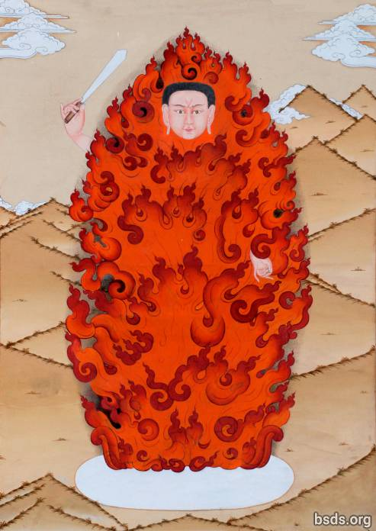

1. Dhüm-sa lum-sa-wi cho-te-pa pa-gya-da-na-se no-ba yum-no-pa mos-di-chi
2. Na-du-ga-sa-ka se-wi num-gri-tri-cha ye-ga-wi-oo-sey
3. Cho-yu-pa te-ma-ye-wi nga-gyu-ka pu-ne-ka ye-sen yep-gya ye-che-oo-ee cha-wu-sey
4. Pa-shring-ah te-ma-ye sha-wung-ah-toh no-ga so-chey sey yu-no-pa toh-wi ga-toh

5. Nga-gyu-ka gyum-du-gya-sheh na-du-ga-sa-ka yu-nu-pa tu-wi cha-wu-sey
6. Ye-no-na-yi-ga ye-ghung-ah-ye gu-na la-shreng-ah cha-wu-sey wi
7. Ne-doh te-ma-pa lup-ga wong-ah pum-nya tu-wi cha-wu-sey
8. Gu-na-wi-sho-toh la-yen-si gya-wi wi-chi ga-sa-ga lup-che-tro

9. Se-pa-tum-pa wi-gyi-da-pa lup-cho tra-si-gya-ba pum-nya
10. Ye-ku-cha-yi-ga ye-wa-ga dhüm-sa se-wi kha-nye-nga wi
11. Sha-ge-da-ka pa-ye ee-gya-ye-shey wet-ma in-sha toh ye-ke-cha pa-ye
12. Ye-gu-da-ba lup-cho pa-shrin-na de-tu tu-wa-pa da-ya-ba te-ma-pa ti-aag

13. Sheh-pa-tum-pa wi-gyi-da-pa lup-gi tra-shi-gya-ba pum-ya
14. Oom-na-pa-yi-ga ye-wa-ga dhüm-sa se-wi ka-nye-nga wi
15. Sha-ge-da-ka pa-ye yi-gya-ye-sheh toh ye-ke-cha pa-ye
16. Trüs-na no-ma de-tu so-shya ti-aag

17. Se-pa-tum-pa wi-gyi-da-pa lup-cho tra-shi-gya-ba pum-nya
18. Ying-ah-ye-gya ye-wa-ga dhüm-sa se-wi ka-nye-nga wi
19. Toh-da-gya-gwa yin-sa toh da-ri-sheh pa-ye
20. Ye-gu-da-ba gya-da-pa pa-ye ni-toh-wa-pa wu-pa-wa-sre-ye-ga wu-gyo-yim-cha tum-pa

21. Ye-ba grin-ta wi-gi-da-pa ga-toh ngi-da de-tu yir-na-po
22. Ye-go-sho-wa de-toh-dyo-nu de-tu ye-ba cha-ah grin-ta wa-tro ti-aag

Homage to Nomyun Gyawi (Nomyun Gyawiweichi Fawoi)

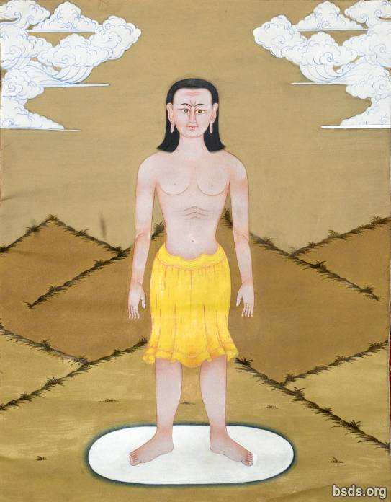

1. Sey-wi-ta-wa wa-yu-na ne-gya-yu gyün-ah-sey tri-ah-sey
2. Lum-sha-wi mre-wi-da sey pa-ye nga-gyu-ka gyün-du-ga-sheh gyu-yim-chi-la ni-da cha-wu-sey
3. Ye-ma-ra-tum-pa wi-chi no-ma ga-ti-ga sey gu-su-yey
4. Ne-gya pum-nya tra-gya-toh ye-doh-wi cha-wu-sey

5. Ye-gyo wi-chi yo-da lup-go pa-shri-na wu-ye-du-ga lup cho
6. Tro-ma-pa-sey wa-li-na-tum-pa grin-ta wi-gyi-da-pa lup-gi-sey gu-shu-yey
7. Shey-wi yop-da gyu-me-yo-sey
8. Naw-ba yim-nu-pa mos-de-chi nüm-gri tri-cha ye-ga-wi-oh-sey

9. Gya-ye-ti oo-la-na-sey mre-wi-da wa-yu-na
10. Ya-pa-ye ye-pa-sey lum-sha-wi mre-wi-da ni-yur-ra lup-go
11. Nga-du-ga pa-ye ne-gu-sey pum-ya tra-gya-toh yu-no-pa ni-da cha-wu-sey
12. Nom-yün gya-wi-wi-chi sheh-ka gyi-na ying-ah-wi ko-tra-na tra-po-sha ga-sha-ga lup-che-tro

13. Nul-ni-ga-sha sup-so pa-ye bu-gya-na-yi-ga ye-pa toh-ga-sey gu-shu-ye
14. Wa-ka-sha tra-tos-sa pa-ye wa-ka-sa se-pla ne-gya-pa lup-gi wo-ngu
15. Oo-go-na-pung-ah lup-cho ga-te-ge pa-ye lup-go wa-te-gi cha-wu-sey wi-chi
16. Sha-pa-nge-wi du-gyi wu-no-na met-pa ne-gya-pa lup-gi wo-ngu

17. Fu-da-wi-na ne-yüng-ah-tum-pa-sey tra-yu-sa-sey pa-shri-na so-shya-ga
18. Wi-gyi-da-pa nen-mu ga-ga-toh-ke-wa ye-nga-yo pa-shri-na pa-ye sho-shya-ga-sey
19. Shi-wa nun-ga-chya-nu-sey ye-gyi-da-pa-yi-ga sho-shya toh-ga-sey gu-shu-ye
20. Oo-nga ying-ah-wi ye-ku-cha sey wu-ga ti-aag

21. SON-WA YEN-GYE YEN-GYE NIG-MA NIG-MA DEN-PO DEN-PO DO-WAN-SO

22. Ye-ku-cha-pa la-ngo-pa doh-ya yüp-nri-ta lup-gu-sey ne-shyu wi
23. Nir-gha-sa te-ne-cha yu-wa ku-nyu-sey cho-ma-yi-ga so-shya ga-toh
24. Dey-tu ye-sho-pa-tra-ye-tum-pa ye-ba grin-ta ye-ngo ga-toh
25. Chi-wa ye-gyi-da-pa-yi-ga sho-shya ga-toh chi-wa ye-nge-ka ye-ngo ti-aag

26. Shey-da-ka pe-wong-ah ni-pa pa-ye cha-sheh-chya chu-ne-tum-pa-sey
27. No-tra wa-ka-sha tra-tos-sa-sey wu-lo-na-pung-ah lup-cho ne-yüng-ah-tum-pa wi-chi
28. Nom-yün gya-wi wi wo-nga tra-yu ka-sheh-wi
29. No-tra ya-bi lup-go wu-yin-tra ne-gya-pa lup-gi wo-ngu

30. Ye-wüt-chey-ye de-tu sep-ka-tum-pa yum-pa se-wi ka-chyu
31. Nu-wa-fa nu-wa-toh-shna-pa pun-nri-wi de-tu ye-ngo ti-aag
32. Nom-yün gya-wi-sey la-ngo-pa doh-ya-se yo-du-ga lup-go
33. Bo-gri-na lo-pum-sey wu-yin-tra ye-ba grin-ta wa-tro ti-aag

Closing Prayer
1. Sey ya-nge-ka da-tri-ya ye-gyo pa-wi-sa-ka ma-sha-ye-ngo ne-yüng-ah tum-pa
2. Oo-ge-cha-ye-fa ti-chu-ga nri-pum-ah-sho-toh su-den tra-tos-sa gyi-dep-na lup-go
3. Tish-du-se gyo-nge-pa ba-ngo gyesh-pa-nge ye-wa-ga ga-toh
4. Ma-sai-ye-ge ti-ah-ga cha-toh-fa su-den tra-tos-sa-sey lo-pum tum-pa

https://bsds.org/pt_BR/prayers

