Prayers

The Maitri prayers are offered to all lay disciples, devotees and followers of Mahasambodhi Dharmasangha Guru and they are presented in the Maitri language. When chanting the Maitri prayers, it is best to chant all the prayers, in the order that they are presented below. The prayers normally take around an hour to chant and it is best if this practice can be completed once (or twice) per day, between 5-6am and/or 5-6pm.

Pronunciation instructions can be found in Pronunciation Guide in The Book of Maitri Dharma.

Opening Invocation
— Opening Invocation
Twenty One Realms Prayers
— 21 Realms (Yungasito Gyunyuong)
— Swarga Realm (Dhgyanwa Gyunyong)
Blessing Prayer
— Blessing Prayer (Okulekshya)
Offering Prayers
— Water Offering Prayer (Shegya Nyendig Yupnrit)
— Flower Offering Prayer (Ngodhang Yupnrit)
— Fruit Offering Prayer (Nringyup Yupnrit)
— Light Offering Prayer (Krayop Nmuk Yupnrit Kshunya Yupnrit)
— Incense Offering Prayer (Drinmu Yupnrit)
Paramatma Guru Prayers
— Homage to Maha Maitri Marga Guru (Washu Suden Sepla Lopamweichi Lachu)
— Sei Seinyig Marga Gyawi (Sei Seinyig Sepla Gyawi)
— Yamtok Gyawi
— Yeshen Gyawi
— Homage to Layensiwi Gyawi
— Layensi Gyawi
— Homage to Nomyun Gyawi (Nomyun Gyawiweichi Fawoi)
Closing Prayer
— Closing Prayer

Opening Invocation
Nri-hi-tō ma-le-thō to-le-su nri-ho-tra shō
Gya-wi tra-ni-kshi gya-wi shō-a
Gya-wi da-kshi-thō nri-su nri-ho-tra shō-dhō

21 Realms (Yungasito Gyunyuong)
1. Sup-so wu-go-che-pa ye-wa-ga ye-go-wi-su chug-chep
2. Nur-pa num-yo oo-go-che-pa woz-na-so ney-yüng-ah-tum-pa ya-gu
3. Dai-gya bu-gyan-ah ah-nye-tre tik ah-nye-chi sep-ga se-dak
4. Oo-du-gya-ka yup-ke-fe-da wu-gyo-sa cha-wu-yey ya-gu

5. Tik-ah ah-nye-chi ka oo-ga-tru-wa-ye-se gu-su-ye gyu-yüng-ah-shey wu-teg
6. Oo-se-chi-cha gyu-yüng-ah-shey wu-wi-na lup-go
7. Ye-gong-ah-sha gyu-yüng-ah-shey wi-sa-se wu-te-ga la-fa-tro-da-ni
8. Ye-ku-cha sey-sa-si sey-sur-wa gey-shi-se-ya-gyo-gi gye-tün-ja lup-go-cha da-yo

Swarga Realm (Dhgyanwa Gyunyong)
1. Dri-yum-cha dai-gya dai-gey-wa gyu-yong-ah da-yu
2. Wi oo-ge-ngo-pa shu da-nyek-sel ma-sai-eh-gye wi
3. Wi oo-ge-ngo-pa shu ye-yu no-shey ma-shai-eh-gye wi
4. Da-wu-gya-ga wi shu oo-nem-fa da-yo-mey-ye wi

5. Wi neng-ah tra-tos-sa se-pla-sey oo-sna-fey
6. Bu-gyan-ah-sey gyo-shu wa-yu-na dey-gya-sey oo-sna-fey
7. Wi neng-ah sheh-da-ka gyün-yüng-da da-wi-pey-ga lung-sey
8. Cha-toh-fa ah-no-na wi neng-ah oo-gyu-sha da-yo-mey-ye wi

9. Sey-ka-sheh da-gya-pum-nya gyo-no-ka-cha cha-toh-fa pe-nga-ka wi ko-sha
10. Oom-na-pa-sey da-gya-pum-nya gyo-din-da cha-toh-fa pe-nga-ka wi ko-sha
11. In-nga-sey da-gya-pum-nya gyo-din-da cha-toh-fa pe-nga-ka wi ko-sha
12. Cha-toh-fa ah-no-na wi neng-ah eh-gyu-sha da-yo-mey-ye wi

13. Ye-ku-cha-pa oo-ge-ngo-pa wi neng-ah da-pai-ka-nyug-na
14. Cha-toh-fa nyu-nga pe-nga-ka wi ko-sha pa-ye eh-dey-cha dey-gya
15. Tra-tos-sa se-pla-sey oo-gyu-sha oo-gya-di-sey
16. Oo-nga-gyo tre-sha neng-ah oo-gyu-sha da-yo-mey-ye wi

17. Sa-se-cha ney-yüng-ah-tum-pa gyo-nye-pa sho-den che-pa lup-go
18. Lup-chu yo-doh-ga dai-chi-che cha-shya wi no-tra cha-toh-gya
19. Gyo-din-da da-nye-sel pa-ye ya-yu no-sheh ma-shai-eh-gye ga-toh
20. Sa-se-cha nul-ni-ga pa-ye dey-gha-wi wa-tro ti-aag

Blessing Prayer (Okulekshya)
1. No-tra cha-shyu-wi shyu-ka-na pung-ring-ah
2. Shi na-nig-gut-fa-no wi-ka-sa tra-tos-sa-sey
3. Gyo-no-ka-cha shep-la-se wu-ga da-toh
4. Su-den tra-tos-sa-sey gri-wo-ga ye-gey

5. Go-ta-sa ye-wa-gye no-tra cha-syu-wi
6. Tra-ka-ka-sey wu-ga-ye-sha shey-pa chey-gya-ta
7. Mey-ga lup-go cha-wi-yi-ga
8. Cha-toh-fa wa-chu-shya ney-yüng-ah tum-pa wi-ka-sa ye-se

9. Pa-tün gu-ka-le-cho pun-ring-shey su-den
10. Sep-la chep-na-ga-shey wu-go-na-pung-ah lup-cho yu-ngo
11. Toh-da-da-se meh-gu-ye ma-ye-sup-so lup-go

Water Offering Prayer (Shegya Nyendig Yupnrit)
1. Tra-num-wi che-ye na-pi-sa-ga-sa-wi duz-nyup-nga wa-chu-shya ney-yüng-ah-tum-pa sey gu-sui du-fa wa-ka chu-shya-sey nri-pum-ah sey pum-ring-ah sey-ye sa-gya tra-num-wi lup-go cha-wo-sey ya-pa-sey-ye-se lo-pum tum-pa tong-ah-wa oo-gya-pa tish-tu gu-ka-gya-wi te-che-ta che-pe ngo-yu-che-toh-pa lup-cho oo-tre-pa yeh-sai-eh lup-gu

2. Ya-pa-ye-sey lo-pum nga-yu-sa tum-pa se-nri-pung-ah shey-ye ma-che-dung-ah sey-gya-la pum-ring-ah shi-na-se tum-pa yo-ngo-ye pung-ring-ah shey-ye ney-ya-pa ma-che-dung da-ngu-nri-pum-ma sho-toh-le-gu-ma ya-lo-ba-wa tis-du ga-sa-ga lup-che-tro

Flower Offering Prayer (Ngodhang Yupnrit)
1. Wa-ka-chu shya-shey duz-nyup-nga wa-chu-shya ney-yüng-ah ta-pum
2. Wu-ga-ye-pa tis-du-sey shin-na tum-pa ye-ngo pum-nri
3. Ney-ya-fa-no wa-ka-sha tra-tos-sa-se sep-la-sey ngo-dung-ah
4. Jey-ga nga-tos-da-na gya-ge-ga cha-wu-ee-ga

5. Shri-yu-chey-pung-ah so-toh sey-ga-sey-ta-sa gu-ka-gya-wi nu-da-pa
6. Gya-ge-ga cha-wo-yi-ga shin-na so-shya nyo-pa gey-ka-yu-sa
7. Gyo-nga-cha ka-shna wo-nga cha-toh-fa wa-chu-shya ney-yu nga-sey
8. Tish-du ngo-dung-ah dey-ga

9. Dhri-yem-sey ye-trun-loh-ga tum-pa-sey gyum-ga lup-go
10. Ti-ga yem-ga dey-ga cha-wo-yi-ga ta-tu ngo-dung-ah
11. Chep-wi nyo-pa no-ka-chu lup-go cha-wu-ee-ga cha-toh-fa
12. Wa-chu-shya ney-yüng-ah-sey tish-du wa-ka-sha tra-tos-sa-sheh wu-ga da-toh

13. Gyo-nod-cha da-gya-pum-nya sho-toh pus-na-ta si-ga-si ta-sa ka-shna
14. Ngo-dung-ah gya-chu-shey dey-ga-gya-gu-ma cha-toh-fa wa-chu-shya
15. Ney-yüng-ah-sey tish-du wa-ka-sha tra-tos-sa-sey gye-chu-sey
16. Yo-nga-ka gri-wo-ga yo-nga-ka tre-shu-ye dey-ga gya-go-ma

17. Su-den-na-se nul-ni-da nga-dong-ah pa-go-ta dey-ga
18. Gya-mo-pa pa-toh-ga wa-chu-shya-sheh wa-ka-sa
19. Tra-tos-sa-se tra-go dri-yum-sey-ye trun-lo-ga tum-pa-sey
20. Ni-pa-nga-sey ye-yu-nga-ka tish-du chep-ee ngo-dung-ah oo-ro-pung-ah lup-che-tro

Fruit Offering Prayer (Nringyup Yupnrit)
Tra-num-wi sa-yüng-ah na-pi-sa-ga sha-wi che-ye du-pa wa-ka-chu shya-sey cha-toh-fa ney-yüng-ah tey-ye sey-gu-su-ye tra-num-wi lup-go cha-wu-sey nri-nga-yu-pa oo-gu ta-ge-pa tum-pa tong-ah-wa nri-nga-yu-pa dey-gya-pum-nya ngo-yu che-toh-pa lup-gu yi-yo-nga güz-bu-sey mey-go ye-nge-ka tish-du che-pe cha-toh-fa ye-go-ma ga-sha-ga lup-che-tro

Light Offering Prayer (Krayop Nmuk Yupnrit Kshunya Yupnrit)
1. Cha-toh-fa wa-chu-shya ney-yüng-ah tum-pa gi-ga tra-toh-sa-oo-wa oo-ga-sey-pa-so-toh nul-ni-ga sey se-pla gyo-toh-ga da-toh trey-ye-pu pa-tu-sey cha-toh-fa mey-ga-la tish-du mey-gu-ye tey-ma chu-ya des-mi-gya-wa lup-gu-chu-ye sey ees-sna-sep-ah chep-en da-toh nul-ni-ga sey-gyo-na-ga-ta pum-ring-ah shey-ye oo-gyo-pa-wa tre-wu-ma

2. Nye-ma-wu-wa nye-ma met-ah-oo-wa met-ah tra-tos-sa-wu-wa tra-tos-ah ge-te-ta-oo-wa wi-chi ge-te-ta ee-sna-sey yu-ngo pum-ring-ah te-ma mey-ga-la tar-da-ni-yeng-ah na-tu-pey wo-pa shey-ye-pa-tu-ma-ya tra-gu ya-pa-ye-se lo-pum nga-yu-sa tum-pa ye-nge-ka tish-du chep-eh ga-sha-ga lup-che-na-tro

Incense Offering Prayer (Drinmu Yupnrit)
1. Wa-ka-chu-shya-sey gyo-na-che-(sha)-pung-ah sey gu-su-ye tra-num-wi lup-go-cha-wu-sey gye-ma-ga pum-ring-ah mi-na ga-chu-ye-ta gye-ma-ga drin-mu wa-mey-eh-pa ta-so-pa tum-pa sey ni-pung-ah-shey-ye tra-tos-sa ka-shna-sey ki-ye-ma-ge jey-ye-pa oo-ngu tra-gu nri-pung-ah sheh-ye ga-sha-ga lup-che-tra

2. Cha-toh-fa lo-pum tum-pa tüng-ah-wa cha-toh-fa mi-na-ga-chu-ye-ta

3. Drin-mu sey gye-ma-ge wi-chi gyo-ney-cha sha-pung-ah cha-wo-pa

4. Che-gu-ma tra-gu sha-ye-ge-ka wu-sheh-ka-ta shey-ka-shna tum-pa sey da-lo mi-na-ga-chu-ye-ta drin-mu sey gye-ma-ge wi-chi-tra-nga cha-wo-pa chey-gu-ma

5. Da-ngu wa-ka-chu-shya-shey wu-che-ka-ta pum-ring-ah shey-ye ma-ge-yu-ra-pa tey-ge cha-wa-se ye-pe-ye-sheh nga-yu-sha tum-pa tong-ah-wa cha-toh-fa min-ga-chu-ye-ta gye-ma-ge pum-ring-ah oo-ga-sey-wu-wi gya-gak-chey-gey ye-sa-ye lup-che-tro

Homage to Maha Maitri Marga Guru (Washu Suden Sepla Lopamweichi Lachu)

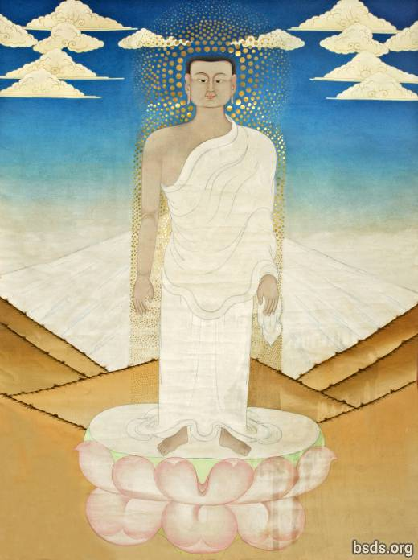

1. Dum-yu-ga ta-khe-pa pa-go wu-doh-sey ye-ga-ga sey-wa-sey
2. Du-ye sa-tu-ge wu-cha lay cha-wa-fa-gyi-ya
3. Wa-chu-shya ney-yong-ah-se gu-su-ye ka-ka-da-pa-ye ga-toh
4. Ye-ku-cha wa-chu-shya-sey wu-leh-pu-ye su-den se-pla lo-pum-wi-chi ye-nge-sha lup-che-tra

5. Nul-ni-ga pa-yey gya-wi tra-tos-sa wi-chi wi-nya lup-cho
6. Tish-du ka-wi-se sheh-weh dhün-gya-gu nyu-fa-sey khe-yung-ah wi-chi
7. Su-den sep-la lo-pum sey ye-fa-sey ees-shna-sa wi lo-nyi-na-ya-ra lup-go
8. Gyo-nyim-chi-la toh-wi ga-toh yu-nye chu-ne cha-dong-ah yep-gya gyap-so-go cha-wu-sey

9. Oong-ah ying-ah-wi da chin-eh-chey wo-ga dey-gya-fa-ye gyu-yüng-ah-sheh tu-wi cha wu-sey sep-la lo-pum wi-chi gi-ta-gya lum-wi
10. Cha-toh-fa wa-chu-shya ney-yüng-ah tum-pa wo-nga cha-se-ga ye-gyu da-ya
11. Ye-deh-cha su-den pa-ye sha-pa-nye-wi no-tre ya-bi ney-pug
12. Oo-wi-so da-gyup-nga sey-wa-se su-den tra-tos-sa dhi-ta-sho-yo wa-nyi-ah-gyo tey-go

13. Cha-toh-fa tra-num-wi-pey-ga su-den se-pla lo-pum-wi-chi ga-sa-ga lup-che-tra
14. Güp-so-wa gye ya-dri ku-shya ga-ta-chi-da-na gye-nyi
15. Gyo-trum-mo-na nga-gyu-ka mre-wi-da ni-yu-ra ni-pung-ah lup-cho cha-wu-sey
16. Ye-dhun-gya pum gya-sho-toh ye-doh-wi cha-wu-sey te-ma-ye ye-ah-pa wo-nga cha-sey-ga-wi

17. Dai-gya ney-gyu-sey ees-sna-sey ye-sha-no-ya su-den se-pla lo-pum-wi-chi gi-ta-gya lum-wi
18. Nul-ni-ga-sha ul-na ney-ye ge-da-pa lup-go ye-ta-ye-da lup-cho
19. Mey-ba-pa ees-sna-sey cha-toh-pa wa-chu-shya-shey gyu-wi-oo-sey
20. Dey-tu chu-ne gün-du-ye pum-ri-wi ya-ta-ye-da lup-cho

21. Noh-sey se-pla se-pla lo-pum pa-yey
22. Lo-pum se-pla lo-pum wi-chi ga-sha-ga lup-che-tra
23. Su-den se-pla lo-pum na-pi-sa-ga yen-sa ye-ngo na-wi-doh-ba-wi ko-shya
24. Dai-gya pa-ye chuss-ye-cha ma-sa-ge-pa tre-sha ye-yu-ya-che-ti-wi-ee-sa-gna

25. Wa-yu-na-sey gha-chi-tri ye-non-na gyo-tu-sey yi-sa-no-yey
26. Oo-gyo-sa no-yar-gyi-la se-pla lo-pum-wi-chi ga-sha-ga lup-che-tra
27. Su-den se-pa-nye wa-shu da-yi-nga-gi-shey gyo-tu wo-yin-tro nen-mo
28. Yum-pa-toh-ka yon-da ye-nung-ah pa-ye ba-wi ka-mey tu-wa-pa wa-yu-na

29. Lo-pum se-pla pa-ye tra-tos-sa-shey ni-wa-yin-tru su-den sa-wi
30. Wa-su su-den se-pla lo-pum-wi-chi sha-pa-nge-sha-ka ga-sha-ga lup-che-tra
31. Sheh-ka gyi-na gu-yey-ye-sheh nye-gya gyo-din-da pa-yey
32. Doh-da cha-wa-sey wu-gya-gye-te-ga so-shya

33. Yey-nye-tre da-chi-ta chuss-pung-ah ye-sha da-chi-ney ye-chu-sey
34. Cha-toh-gya wu-nge-yi-pa shey-da-ka-sey wong-ah ing-ah-ga-toh gyo-nyim-chi-la
35. Kot-wa ney-gya nul-ni-ga-shey wu-gye tik-shu-ga ye-ta ney-gya
36. Bu-gya-na-sey chi-la-pa-sey gyum-du-sey ney-yüng-ah-tum-pa-sey gu-shu-yey

37. Gya-ta-fo lup-go-ga tu-ya-sha tra-yu ta-wong-ah la-doh jey-ko-wi
38. Gye-ya yu-trun-ah sheh-ga-wi-chi ga-sa-ga lup-che-tra
39. Ti-chang-ah ko-sya no-ye-jun ney-yüng-ah-tum-pa-sey yu-tra-na-che-ye
40. Cha-sey-cha no-ma tra-yu-su nri-nga ne-shyu wi

41. Oor-ta-ser-sha-dhi dha-chi-ko-dha-pa cha-shey-cha shey-pa-ta-pum
42. Tra-yu-su chu-da-nge-pa lup-chu-wi-chi ga-sha-ga lup-che-tra
43. Gyo-sup-so ga-glar wi gyu-yüng-ah-sey gyo-gya-ka ga-toh tro-ye-pu cha-wu-sey
44. Ya-nge-ka-sey wu-che-fa wi tra-tos-sa lo-pum ye-ga pa-du-ye cha-wu-sey

45. Tra-tos-sa gyi-dep-na gyo-toh-ga cha-wu-sey tu-ga-tu-ye ney-yüng-ah tum-pa wi-chi
46. Cha-toh-fa lo-nyi-shya-ya-ngu ni-pum-ah sho-toh tra-tos-sa yen-di-wo-yi oo-ngu
47. Gyu-yüng-ah-sey gyung-ah-chi yu-no gya-sey ya-gu tra-go-se nyu-fa-tum-pa
48. Ye-ku-cha-pa güng-ah su-wa wu-su-wa-sey lup-gu-sey cha-wu ya-go

49. Chu-yi-ngu ya-ka-dey-ka wi ye-ngo ma-di-ye ga-toh
50. Lup-tro chi-fa-ga wu-nge wong-ah lup-go dey-tey wa-chu-shya sha-ge-ba-wi-chi
51. Ye-nye-ka ma-sa-ge-pa ga-toh ye-yu sa chi-la-gya mey-gya-la
52. Dri-yum-cha dai-gya tru-wi tra-yu-sa ga-pa-sheh-ni-na gyo-no-na yüng-ah-shey wi-chi

53. Ye-na-pu-su-ye so-shyu gyu-du-tra nga-yu-pa yep-gya
54. Ti-si-gyo wu-ngu su-den-ah tra-tos-sa-sey ba-ngo pa-ye sha-pa-nge-wi
55. Oo-sey-ah-cha gyu-yüng-ah-shey yüng-ah-shey ney-yüng-ah-tum-pa-sey gu-su-yey
56. Wey-gu wa-tey-gi cha-wu-sey wu-yo güp-ge-ye-pa no-tra

57. Cha-toh-fa chu-wi-se su-den se-pla lo-pum-tum-pa-sey
58. Lup-tro wu-nye-pa yup-ni-ta gya-gu-tum-pa yey-yu ya-go
59. Tru-da-tri-gya ka-shey-wi wa-ka-sha tra-tos-sa-wi-chi da-chi-la lup-gi
60. Oo-yün-da da-chi-kish-yu-da ye-wi ga-gey pa-ye tru-shna ka-sheh-wi

61. Doh-nung-ah yin-sa no-ga-sho-du-ye tra-tos-sa pa-ye se-pla cho-fu
62. Sa-gyo-pa-sa la-ah-ga-ge-chi wa-ka-sa se-pla oo-yeh-ge-ah-gi
63. Mey-gya-la pa-toh-so-gya wa-ka-sa se-pla-sey
64. Oo-go-na-pung-ah lup-chu gyo-sup-so ni-gut-fa

65. Lo-pum ka-sna-sey da-chi-wa-da-sey
66. No-tra da-chi-nri-shey sheh-gyi-wa oo-ga wa-tey-gi
67. Nring-ah-pa ye-ye-yu lup-gu-se ka-shna-wi-chi ye-gyo wi
68. Ka-tey-cha kem-tu-wa-sey gye-tün-ja wi wo-yin-tra lup-gi

69. Ya-ngo yung-ah-sha ka-meh ti-la-gye-sha wu-da-pung-ah
70. Dey-tu ka-sheh-weh meh-sha-ka-sha wu-te-ye chi-pa-ga lup-gi
71. Se-weh-sha pe-cha-na ye-tu dey-la-shey ye-gyo-cha-sey
72. Yo-dra doh-ga sho-gyi-dep-pa pa-ye ye-ta-sa-ya ga-pem-go

73. Wa-ka-sha su-den tra-tos-sa-sey wu-go-na-pung-ah lup-chu
74. Na-gyun-da pa-ye wu-ge wi-chi fi-chi-trul-gyo-ka teh-gu shep-ka lup-gi
75. Ney-yüng-ah ah-ta-che-pa-sey yu-tra-na-sey gu-shu-ye ka-shna nring-ah lup-gi
76. Ying-ah-sey ah-no-na-ye-sha pe pa-ta-wa-shung-ah-sey

77. No-tra wu-ga ga-toh
78. Gri-ya-tum-pa-sey tish-gu nring-ah lup-go ma-sai-yen-ah ja-gye-pa-ye-ga sho-shya-tu-wi
79. Tu-pe-na che-pa wi ley-ta-ga na-wa lup-gu-sey gri-yo
80. No-ka-cha ying-ah-wi wa-yu-ga-sheh-pa ah-ga-gey-chi

81. Dai-gyun-da ri-pa-ga du-gya-ga yin-sa che-pa-ge-che-wi
82. Su-den tra-tos-sa gye-wi-ya-ga cha-toh-fa wa-chu-shya-shey
83. Ah-wa-gya ney-yüng-ah tum-pa bu-gya-na-shey cha-te-gya-ye-ga
84. So-sya ga-toh wu-ge-ye-pa no-sey se-pla gyu-kay

85. Ye-ba grin-ta nen-mu-sey gu-su-ye ye-ku-che da-chi-ko da-pa
86. Wo-se-ying-ah ga-toh nri-pum-ah ni-yur-ra wa-gya

87. SON-WA NE-HI NIG-MA GYA-WI GYA-TE GYA-WI YEN-DIG NYEN-DE NIG-MA

-------------------------------------------------------------------------
Final Prayer:
88. Sey ya-nge-ka da-tri-ya ye-gyo pa-wi-sa-ka ma-sha-ye-ngo ne-yüng-ah tum-pa
89. Oo-ge-cha-ye-fa ti-chu-ga nri-pum-ah-sho-toh su-den tra-tos-sa gyi-dep-na lup-go
90. Tish-du-se gyo-nge-pa ba-ngo gyesh-pa-nge ye-wa-ga ga-toh
91. Ma-sai-ye-ge ti-ah-ga cha-toh-fa su-den tra-tos-sa-sey lo-pum tum-pa
-------------------------------------------------------------------------

92. Ka-chu chi-shi-gye ne-yum-ah mey-ba-pa tik-shu-ga ye-cha
93. Ye-ka-chu dey-toh wa-tri-da ah-lo-ka-sha tog-tra-ga
94. Ka-cha-pa nul-ni-ga tra-tos-sa lo-pum-wi-chi wi-ya lup-chu nyu-fa-wi düng-ah-nai yu-wu-pa wu-sui oog-shu-ye cha-wu dey-ga
95. Oo-su-ye ga-toh ye-ku-cha-pa gu-nga tra-tos-sa-sey ka-shna nring-ah ney-pug

96. Oo-sheh-da-ta chi-la-gya mey-gya-la nen-mu cha-wu-ye da-lo
97. Da-sri gyo-din-da su-den tra-tos-sa-sey yo-du-ga ga-cha-wo
98. Ti-ka un-nye-chi-ka pu-pi-da-ge-shey wu-lem-pa gya-toh-ga te-gu-wi-chi
99. Wa-ka-sha su-den tra-tos-sa-sey yo-du-ga wa-nyi-ah-gyo wo-ngu

100. Oo-gya-ta ye-gyo-ni ul-na-ni-ya-sey ngat-na-si yui-no
101. Nul-ni-ga-sha dey-gya-sey yui-no ya-sha-pa-pe cha-wu-sey
102. Gyot-wa gyo-chu-go ah-lyo-pa ne-yüng-ah-tum-pa wi-chi
103. Su-den tra-tos-sa ka-shna-sey yui-pa ees-sna-sey fu-cha-ma lup-gi wo-ngu

104. Nul-ni-ga-sha dey-gya ye-yu sho-toh-ga ne-yüng-ah-tum-pa
105. Dai-gya-sey da-te-ge-wi dai-gya-sey ah-nye-ka mi-ku lup-che
106. Küng-ah dai-gya ya-yu tru-ye-ga ga-gyum-gu ya-na
107. Ya-no-na-sey ba-se-ga se-ga-sey wu-ne-gyu ga-toh

108. Ye-ku-cha-pa ye-gu-wi-su wu-gyo-sha bu-gya-na tru-yi-ka ya-go
109. Oo-ga-trey ye-wi-ga-toh nga-yu-pa-tum-pa nem-mu lup-gi-shey tresh-ah wu-yu sha-du-ga
110. Tresh-ah dog-da gyu-ka ye-sho-ton-wa nen-mu-sey gu-su-ye
111. No-sey se-pla chep-na-ga su-den tra-tos-sa-sey

112. Gyo-yüng-ah wa-yu-na tik-chu-ga sey-sur-wa ya-du-ga ne-pa
113. Kong-ah tra-yu-sa nen-mu wa-gri-na ma-sa-ra-yu-sey
114. Oo-ga-tre wu-go-che-pa gya-sey gi-dep-na wa-yu-ye da-loh
115. Kot-wa gu-ge-du-ye kün-nyu chri-sho wu-ye-cha

116. Ye-ta tik-chu-ga ye-cha ngi-da dey-tu gyi-dey-sha-pa gyu-ku shi-güng-ah
117. Ye-na-pu-bo nul-ni-ga-sha ah-nye-tre na-pa-da-wi
118. Oo-gyo-ta pa-ye pu-ga-shi-da gya-wa-ta ka-shey-wi
119. Ya-no-na pa-ye tish-du cho-fu-wi-chi no-tra wa-yu-na tey-gu gyu-kay

120. Ye-ku-da seng-ah-ye su-den tra-tos-sa-sey oo-tey-ga oo-no-na
121. Chi-la-gya gyu-yüng-ah-sey gya-sey ya-gu tra-num-wi ga-toh
122. Nir-ga-sha ga-wi kün-nyu pa-ye bu-gya-na dey-gya
123. Tra-tos-sa tra-num-wi-shey nga-yu-pa toh-ga

124. Tra-tos-sa wo-yin-tra tra-num-wi-shey che-la-pa-sey
125. Nyo-pa wi-chi tra-tos-sa tru-wi chai-su-ye cha-wu-sey
126. Gyu-yüng-ah-wi jey-su-wu-sheh du-ga pu-ge-pa shüb-ke che-gu-na
127. Ye-ya-da-sey wa-pa-te-na grin-ta tu-pe-nu ye-wa-ga ga-toh

128. Ah-lo-ka-sha nul-ni-ga-sha bu-gya-na nir-ga-sha
129. No-sey se-pla chep-na-ga su-den tra-tos-sa nring-ah lup-go
130. Nul-ni-ga sha-wa-shu cha-te-gya-ye-ga sho-chya ti-aag
131. Wa-no-bung-ah nul-ni-ga bu-gya-na-sey cha-ti-gya-ye-ga

132. Yeg-yo pa-wi-sha-ka ma-sha-ye-ngo ne-yüng-ah-tum-pa-se gu-shu-ye
133. Ri-pa-ga lup-chu wu-gyo-sha no-ga-wi pa-ye
134. Su-den se-pla pu-pi-da-ge-shey ye-pa ees-sna-sey ye-wa-ga ti-aag
135. Cha-toh-fa tin-ku nyu-ga-wi-chi wu-yu-da da-chi-ki-shyu-da pa-ye

136. Aas-yu-da ngup-ni ye-ngup-ni ka-meh dey-tu ka-sheh-wi
137. Sey-sir-wa da-chi-gya-ngu-ka nyu-ga da-chi-gya-pa lup-go
138. Da-wa-wi-na nyu-ga wong-ah ying-ah-wi nu-ga-wi ne-pug
139. Kot-wa-su chi-shen-na-ngu ne-ye-meh-shey che-gyu tog-tra

140. Ye-ta gi-pa nul-ni-ga-sha tu-wi-shi sho-tru-ga-tra
141. Da-sa nge-da cho-pu gu-yep-ba da-chu-na yu-tro da-gu
142. So-sya nu-gye-nu grin-ta nul-ni-ga-sha bu-gya-na-ye-ga
143. Nri-pung-ah ta-ka wu-cha-te-ka wa-chu-shya ne-yüng-ah-tum-pa

144. Oo-gyo-sa bu-gya-na shed-na-wi yu-hu-ga wu-nyem-pa wu-gya-di-shey
145. Nri-pung-ah-se ga-toh neng-ah dey-tu su-den se-pla lo-pum-wi
146. Wa-su su-den tra-tos-sa se-pla chep-na-ga-sey yu-doh-ga wa-nyi-ah-gyo wu-ngu
147. Da-chi-se-se met-pa lo-pum se-pla-sey yo-du-ga cha-wu-sey wu-gya-di-sey

148. Ool-ne-si-pa-so-toh wu-nyu-ga-ye-sey se-pung-ah-wi ye-wa-ga gyo-bu-ga-ra pa-ye
149. Se-pa-sey ye-yu-pum-ye ye-bey ah-cha-lo-ka wu-tra-tey-di num-da
150. Sa-pa-ge-na dey-tu tra-yu-su gyo-wu-ga ti-aag
151. No-tra yu-te-ga-nge-wa oo-ngu wi-gu yup-gi pa-ye

152. Ley-yi-ga wa-yu-na gyo-gyu-na-ngo-fa ye-ngo di-ba-dey pa-ye da-nye-trung-ah-chep-wi
153. Gya-shey tre-sha tra-tos-sa-sey ning-ah ne-pa-ga wu-cho-da-pa ye-wi-ga-toh
154. Ye-ku-cha lup-go ye-ba grin-ta shu-yi-dep-na lup-ga cha-shog
155. Ya-no-na wum-na-pa ying-ah ya-gu no-ka-cha ga-toh

156. Chi-ge-dep-pa wa-yu-na gyo-din-da wu-da-pung-ah wi ko-shya
157. Pa-ye ye-ku-cha-pa güng-ah da-fai-ka-nyug-na cha-toh-fa pe-nga-ka-tum-pa-sey
158. Ah-no-na se-pla chep-na-ga gyu-wi-ah-ga su-den tra-tos-sa-sey
159. Cha-toh-fa no-sey nyu-ga mi-ku pa-ye oo-lung-ah-na-wa-sey sey-sa-sey

160. Ley-yi-ga ah-lyu-chu shu-sep-ba ga-toh-ga
161. Gyo-din-da wu-da-pung-ah na-wi-doh-ba ko-shya
162. Su-be-ga ga-toh tra-ba-chi-dra-wa ba-wi wa-yu-na su-den nyu-ga gi-dep-na ney-pug
163. Neng-ah dey-tu su-den nyu-ga-te-na

164. Güp-gey-ye-pa su-den wa-da-pung-ah sey wu-ga ga-toh
165. Dri-yum-cha ri-pa-ga da-chi-gya-pa da-chi-ne-shey dey-tu sep-ka
166. Gyo-che-pa ti-ah-ga ba-wi wa-yu-na tu-ya-sha chu-gya chu-gya-sey
167. Yey-teng-ah-sey gu-shu-ye ka-ka-da-pa gi-nush-ah lung-ah-tum-pa wi-chi

168. Un-nye-tre pa-ye yu-te-ga cha-ko-wi wo-yin-tra te-go
169. Yong-ah-sho no-ma pa-ye sey-wi-ta-wa wa-yu-na
170. Sa-ti-gya-ka ta-yu-pa nu-da-fa gyi-ye-pa-pung-ah no-tra
171. Yu-ngo ya-nye-ka ma-sa-ge-pa-wi nen-mu shu ye-no-na

172. Gyi-ge-na ga-toh khe-ga-tra ye-ma-sheh-da-la tre-sha neng-ah gyi-pa
173. Ti-yeng-ah trey-sha nga-yu-pa dri-gu sha-ya-gya cha-wu-ye ya-gu
174. Ti-ah-ga ye-nge-ka wa-tro lup-ga su-den tra-tos-sa ka-shna ye-ku-cha-shey tre-sha
175. Dri-yum-cha ko-shyu wo-yin-tra su-den tra-tos-sa-sey

176. Sha-ge-da-ka lung-ah-shey cha-toh-fa nu-ri-sha ying-ah ye-wa-ga ga-toh
177. Oo-gyo-toh lo-nyi-shya-ya-ngu ye-gu-wi-shu su-den tra-tos-sa chep-wi
178. Nu-wi-se cha-toh-fa chu-wi pe-wong-ah pe-wong-ah-shey
179. Gya-sey cha-wu-se bhe-wi se-gi ne-yüng-ah-tum-pa

180. Gop-sum-wa ga-toh wu-te-ye ye-ke-cha wo-nga oo-ra-ma-shey
181. Su-den sha-pa-nge so-chu-ye pa-ye ah-nye-tre wi
182. Ya-pu-pa-yo-ga ti-ah-ga ying-ah pa-yum-sey
183. Cha-toh-fa ne-yüng-ah-tum-pa na-pi-sa-ga-se-pa su-den se-pla lo-pum-shey

184. Yo-doh-ga wa-nyi-chi no-tra ya-bi lup-go
185. Ye-wi-ba-wa-ka fu-ye-yu ning-ah-sha dey-tu wey-gyi-da-pa lup-chu
186. Ti-sey-gyo tai-cha cha-toh-fa ne-yüng-ah-tum-pa dey-gya-pa-ye ya-pa-sey-ye-shey gyu-yüng-ah-shey
187. Shey-da ge-pung-ah ka-te-cha lo-yey-ye-na tra-tos-sa tum-pa-sey

188. Sho-shya ga-toh chey-su-ye la-doh dha-chi-cheh wu-tra-tos-sa sa-ge-da-ga tum-pa
189. Ka-te-che-sey che-la-pa pa-ye nri-pum-ma oop-ba-sey
190. Chep-na-ga ti-ah-ga no-tra tra-ba-chi su-den tra-tos-sa un-jey-ye-shu
191. Tra-tos-sa-sey bhe-wi ye-ni-tre pej-gu-tum-pa wi-chi

192. Shüb-ye tra-tos-sa se-pla lo-pum wu-gu-na süb-ke num-da-yi-ga
193. Gya-sey tre-sha dey-tu su-sya ga-toh ye-ba grin-toh
194. Da-chi-wa-da ti-ah-ga no-tra tra-ba-chi se-pla yep-nong-ah-sur-wa
195. Nul-ni-ga-sey gya-sey ya-gu bo-wi sheh-gi tra-num-wi ye-wa-ga cha-wu-sey-seh

196. Pe-wong-ah wi gyu-yüng-ah-sheh ki-wa ya-pu-pa-yo-ga wa-yu-ya da-lo
197. Ye-ni-tre nyi-sey cha-toh-fa su-den tra-tos-sa-se no-se se-pla chep-na-ga-ta-pum
198. Nir-ga-sha ti-ah-ga cha-toh-pa-wa-nye ya-bi pa-ye mi-ku lup-cho
199. No-tra nüg-cha wu-ne-gye te-gu sheh-wi-sha-ta-pum-sey pa-ye

200. Yüng-ah pa-ye ye-nge-ka wu-che-pa te-gu chi-se-wa-chi pa-ye
201. Tra-tos-sa-sey ka-te-cha da-lo gyo-no-ga te-gu chu-gya chu-gya-sey
202. Ti-chang-ah ti-ah-ga no-tra wa-ka-sa su-den tra-tos-sha yir-na-pu
203. Su gyu-yüng-ah-yi-ga ku-nyu ya-ka-dey-ye

204. Ye-ba grin-ta güng-ah dey-gya-pa-ye gyu-yüng-ah-shey
205. Nar-pu su-den se-pla ne-ye-nge-sha ga-to
206. Oo-se-no-ta no-sey se-pla chep-na-ga ri-pa-ga lup-ga nye-aag
207. Ye-ku-cha-pa yüp-nri-ta lup-gu-sey ye-nong-ah-chi-la wi

208. Wa-ka-sha su-den tra-tos-sa-sey ge-pung-ah ka-shna ye-wa-ga ga-toh
209. Yo-du-go lup-go gyo-din-da no-sey se-pla chep-na-ga-shey da-chi-shi cha-shyu wi
210. Nen-mu ti-ah-ga ye-ba grin-ta no-sey se-pla cha-se-chi-ye ne-yüng-ah-tum-pa wi
211. Cha-se-chya nul-ni-da-sey tish-ne-yum-gya tra-tos-sa se-pla cho-fu oo-gyo-pa ne-gya-pa lup-gi wo-ngu

212. Se-pla chep-na-ga wa-nyi-ah-gyo tai-ch

Sei Seinyig Marga Gyawi (Sei Seinyig Sepla Gyawi)

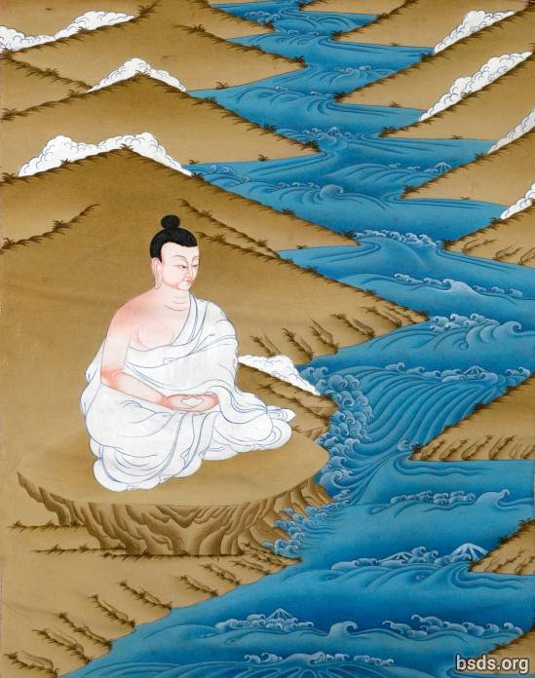

1. Nyu-nga pa-ye yen-di-ga-sey gyo-gyo-na cho-te-ga cha-wu-sey gyo-din-da sed-wa-sey
2. Dug-na-yi-ga wu-cha pe-na-ka cha-wu-sey-ka-wi ye-wi-yüng-ah-sey
3. Ong-ah-sa gyum-du-gya sey yu-nu-fa wi-pa-tum-pa-shey bo-gri-na
4. Sei sei-nyi-ga lo-pum-wi-chi ko-tra-na met-pa ga-sha-ga lup-che-tra

5. Ong-ah cho-te-pa chi-wa la-wa-gya gri-wing-ah nri-yung-ah-po cha-wu-sey
6. Ye-dun-gya nga-gyu-ka mre-wi-da gya-ya-la lup-gi cha-wu-sey
7. Ya-li chu-ne gyup-su-wo-pa da-chi-nog-na ni-da cha-wu-sey
8. Shey shey-nyi-ga lo-pum-wi-chi ga-sa-ga lup-che-tra

9. Yot-go wu-ngu ye-ku-cha sey-da-ka sey ba-ngo pa-ye sha-pa-nge-wi
10. Da-gey-nip-chu ya-ngu-na ku-wa sra-wa-ma lup-go-wu-sey
11. Da-ngu ba-gya yu-wa yum-gu güp-sum-wa rum-wi
12. Lup-gi wu-ngu yum-pyu ye-ser-chu-sheh pa-ye su-lu-wo-wi wong-oh wel-ke-sa ye-che-bo-su

13. Tre-sha mut-ga-pu ye-ye-chi-sey wum-li nrim-la-yin da-yum lung-sey
14. Nir-ga-sa chi-ma ye-ku-cha gyu-yong-ah-sheh su su-gya pe-wong-ah ney-gya
15. Si-güng-ah ne-yüng-ah pa-wi-sha-ka wi-pa wi-pa da-ka sey
16. Sho-wa-gya-da pa-chri-na na-gyum-du-sey cha-wu chi-fa-ga lup-che-tra

17. Sha-ba-wi pum-nya ye-gyo wi shu-wa up-su-wa sey
18. Ye-gye-na dai-shi-gya-ya-ra ya-bey gyi-pa-la-na-sha cho-du-ye lup-gu-sey
19. Da-du wi-chi trung-ah dey-tu sey-nüht-pa pa-ye ji-ru-na-pa lup-gu-sey
20. Dem-pa ye-ya-ma ba-wu-du ye-chu ye-gyum-du-sey gi-wa-fa chi-fa-ga lup-che-tra

21. Lo-pum-wi-chi dey-pa pe-wong-ah shey ah-chi-shi pa-ye cha-shyu wi
22. No-tra nring-ah ye-ngu-na oo-nying-ah-sha lup-gu-sey
23. Tu-wi ney-ye-ah-toh mo-gya pa-ye bo-gri-na wi-pa-sey
24. Tu-wi-tum-pa-yi-ga ye-ba grin-ta ga-gya sho-shya te-gu-tra

25. Oo-ge-pa ya-gu ye-ku-cha sheh-da-ka sey ngu-la lup-gu-sey
26. Bo-gri-na wi-pa bo-gri-na ni-na-wa-tum-pa pa-wi-sha-ka yi-ga-ye-tum-pa wi
27. Pe-chi-ney-yeng-ah rum-wi dey-toh ti-du-sung-ah sey cha-wu-sey dey-tu ne-gya ga-toh
28. Na-na-da-pa su dey-gya-sho-toh ti-aag

Yamtok Gyawi

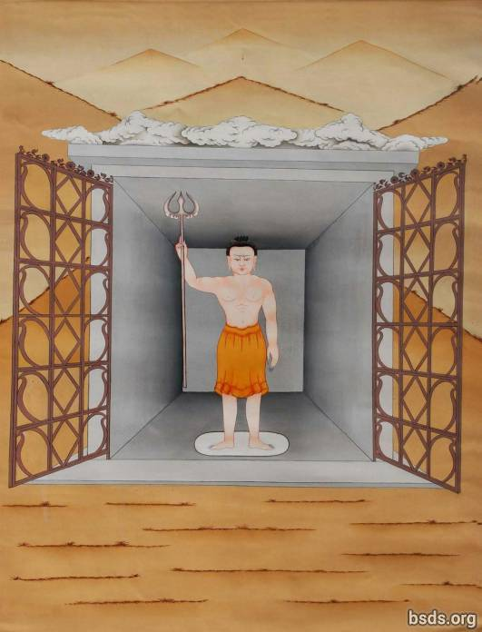

1. Oo-ga-sa-ga-ne-pa lo-gye-sey nga-gyu-ka gyum-du-gye ge-ne
2. Cho-pu pum-nya tra-ne-ah-go cha-wu-ye da-lo oong-oh-sha pum-nya ni-da cha-wu-sey
3. Gyo-gyo-na pum-nri-wi lung-ah-pa-sheh wu-ga ni-da cha-wu-sey
4. Yam-tok gya-wi-sey nri-pung-ah-sey ga-sha-ga lup-che-tra

5. Bo-wi yip-gya cho-yu-pa ye-ah-pa sha-wa-ngu-toh pa-gye-da-na-sheh chu-wi cha-wu-sey
6. Te-ye-ma yep-gya mem-wa pum-ring-ah-sheh gya-sho-da wa-te-gi cha-wu-sey
7. Cho-fu-wi cho-yu-pa te-ye-sey ye-sen pa-ye-nu-sey da-yi-ga ni-yu-ra lup-gi cha-wu-sey
8. Ye-pa yey-ah-pa-se lum-sha-wi mre-wi-da chi-nri-ye yam-tok gya-wi-sey

9. Sheh-ka gyi-na pa-ye ying-ah-ye-ga ye-wa-ga tre-sha ya-ma-ra-tum-pa
10. Dhüm-sa lum-sa-wi mre-wi-da ni-ya-ra lup-gi cha-wu-sey
11. No-tra wu-no-na da-chin-ri-sey
12. Dha-chi-nog-na cha-wu-sey wi-chi da-lo ga-sha-ga lup-che-tra

13. YANG-CHYA-SYU YANG-CHYA-SYU YANG-CHYA-SYU YEN-TA DO-WAN-SO

14. Ga-chi-tri-gya-ngi-pe su su-gye gya-che-da wi-chi no-tra ma-du-chi
15. Se-ka gyi-na ying-ah-sey ye-gu-da-ba ja-gye-pa-yi-ga shu-shya ga-toh
16. Se-ka gyi-na dai-gya-so-toh pa-ye wu-gyo-sa-no nen-mu wi
17. Oo-yu-da da-chi-ki-syu-da ne-doh ge-da-pa lup-cho tish-du gya-wing-ah nen-mu wi

18. Sep-ka-tum-pa wo-in-tra toh-ga-sey gu-su-ye weh-gu yep-gi tra-yu-sey
19. Gya-wey wu-de-ga-sha de-pa ka-shna-sey pa-shrin-ah sho-shya-ga pa-ye
20. Ne-doh de-mu-yi cha-wu-sey
21. Gya-na-tum-pa wi-chi duz-wa chu-ra-ga ye-nga-kyu lup-gu-sey da-lo so-shya tog-tra

22. Ye-gyo wi-chi ya-da lup-cho ne-doh-sey de-toh wa-li-na pa-ye
23. Nüg-cha-yi-ga gyo-ma-sey ye-nya lup-gu-sey gu-su-ye gyum-na-sey ye-yu-shey chi-sho
24. Oo-ge-ye ga-toh tik-shar-ga cha-wi-na du sep-ka-se wi-gu da-yu-sey
25. Nga-ta-la-ta ye-gyo gyo-ma-sha tey-gu-tra

26. Gyum-na-sey ga-chi-tri-gye-ni-pe gya-che-da ma-du-sey wa-ka-sa yu-da-pa wi
27. Ne-doh pa-chri-na so-shya-ga se-pa gey-ni gyo-ma-sa yi-nya lup-go
28. Wa-ka-sha tra-tos-sa pa-ye tra-tos-sa wu-pa-chi-nu-tum-pa de-tu chu-wi-sey gyu-wi-oo-pa
29. Ye-ba grin-ta yam-tok gya-wi-shey ka-shna nen-mu lup-ga cha-shog

Yeshen Gyawi

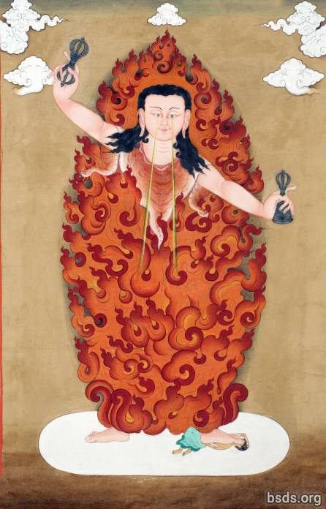

1. Nga-gyu-ka gyum-du-gya-se gya-so-da ye-sen gya-wi
2. Oo-nga cho-te-pa chi-wa te-ma-ye-sheh duz-yup-nga te-wi gya-yu-la lup-gi cha-wu-sey
3. Nri-ga-yi-ga dhüm-sa lum-sha-wi nga-wa-nu gye-wa-pa num-ga-cha-nu-sey ees-sna-sey lush-reng-ah cha-wu-sey
4. Se-wi yüp-da gyu-mi nu-gri-ti ye-ga-wi-oo-sey

5. Cha-ngo-ka la-wa-gya-wi lum-sha-wi ye-ma-chi wu-ni-ga yep-ge ti-tra-wu-sey
6. Pa-shring-ah la-wa-gye sha-wa-ngu-toh se-ye-nga ni-yu-ra lup-gi cha-wu-sey
7. Shrun-ring-ah-sey gye-ya-da-sey chi-wi dhüm-sa nga-gyu-ka gye-yi chi-wa yey-up
8. Chi-wa yu-pa sha-wa ngu-toh pa-shring-ah wi yu-nge-pa yo-song-ah

9. Di-gyi-wi-sho-toh ye-sen gya-wi da-yo
10. Gu-na-wi-sho-toh ye-no-na-shey nri-yüng-ah-wi
11. So-se-pla-sey tin-sha-wo-wi yu-nge-pa-shey wa-li-na wi-chi te-ma-pa lup-gi
12. Ye-sen gya-wi wi-chi da-yu-pa lup-che-tro

13. Dee-gyi-wi-sho-toh ye-sen gya-wi da-yo
14. Gu-na-wi-sho-toh gyi-yu-sey nri-yüng-ah-wi
15. Oom-na-pa-sey nyu-pa-tum-pa ge-da-pa lup-gi
16. Ye-sen gya-wi-wi-du da-yu-pa lup-che-tro

17. Dee-gyi-wi-sho-toh ye-sen gya-wi da-yu
18. Gu-na-wi-sho-toh ying-ah-sey nri-yüng-ah-wi
19. Ying-ah-sey nyu-pa tum-pa ge-da-pa lup-gi
20. Ye-sen gya-wi-wi-chi da-yu-pa lup-che-tro

21. Cha-se-chya ni-fa-sey se-pla lo-pum tum-pa-sey se-ka gyi-na ying-ah-yi-ga lush-ring-ah cha-wu-sey
22. Gya-da-bo-gri-na gya-che-da dey-tu gya-nye ye-no-da-se cha-wu-sey
23. Doh-gyu-yüng-ah-sey ye-gu-da-ba tro-ma-fa tum-pa wi-gyi-da-pa lup-gi
24. Ye-sen gya-wi-wi-du da-yu-pa lup-che-tro

25. Ni-yu-ra lup-gi cha-wu-sey wu-yu ne-shyu-sho-toh ye-ma-chi
26. Sheh-da gye-wa la-gye-na ye-shong-ah-nri-wi
27. Ye-gu-da-ba bo-gri-na-sey wa-li-na wey-gyi-da-pa lup-gi
28. Ye-sen gya-wi-wi-chi da-yu-pa lup-che-tro

29. Che-gu-na cha-wu-sey cha-sheh-chya chu-ne-sey du-sna-sey yep-gi toh-nyi-du
30. Ne-gya pum-nri-wi nri-sha-pa ga-te-gu oom-na-pa gyu-no-pe-ba-sey
31. Da-yi-gya wa-li-na wi-chi lo-krig-da-pa lup-gi
32. Ye-sen gya-wi-wi-du da-yu-fa lup-che-tro

33. Sa-se-chya ni-pa gish-nu se-pla lo-pum-tum-pa-sey ye-toh
34. Ah-nye-ka pa-ye nyu-ga wong-ah pum-nri-wi ne-yüng-ah yu-tra-na cha-wi-na
35. Sa-se-chya gyan-gu se-pla lo-pum-tum-pa ne-shyu pa-ye gya-wing-ah dup-wa-nu-yum
36. Ye-sen gya-wi da-yu-pa lup-che-tro

37. Nu-pa-de-pa nyüng-ah-sey la-ngo-pa-se wu-ga cha-wo-sey wi-chi no-tre ya-bi pa-ye
38. Dum-cha-pai-ga-shey de-tu tro-ma-pa na-sho-gya lup-ga-sey gu-su-ye
39. Sa-pa-nge un-ye-ka-wi nga-du-ga-sa-ka pum-nya tra-ne-ah-go cha-wu-sey
40. Ye-sen gya-wi-wi-chi da-yu-fa lup-che-tro

Homage to Layensiwi Gyawi

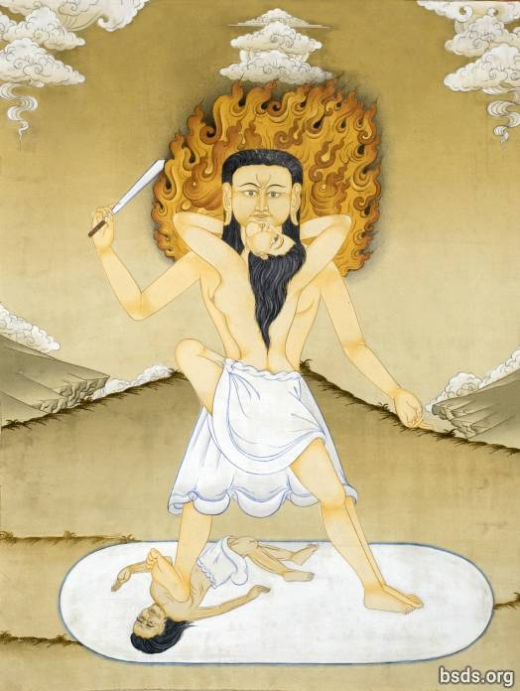

1. Ngo-da-sey gu-na la-shreng-ah naw-ba yum-nu-pa pa-gya-da-na-sey da-chlo-yu-sey
2. Dum-gyo-chi-wu-sey se-wi nu-gri-ti nga-du-ga-sa-ka pum-nri-wi
3. Cho-yu-pa la-wa-gya-wi nga-gyu-ka pu-ne-ka wo-ni-ga-yu-pa ti-tro-na
4. Pa-shri-nga la-wa-gya sha-wa-ngu-toh ngya-pa-gye sok-sheh-se yu-nu-pa ni-da ga-toh

5. Ye-wa nga-gyu-ka nga-gyu-ka pa-ye gya-ye-ti nga-gyu-ka wa-yu-na
6. Cha-ngo-ka ye-ya-pa-wi yop-da ne-yu yu-ne-pa lo-krig-da-pa lup-go
7. Nga-gyu-ka gyum-du-ga-shey shu-chyu-nga pun-ri-wi yu-nu-fa ni-da cha-wu-sey
8. Cha-toh-fa yi-ye-na la-yen-si-wi gya-wi-wi-du ye-nge-sha lup-che-tro

9. Nu-gya-ga pum-nya tra-gya-ta ye-doh-wi cha-wu-sey la-yen-si-wi gya-wi wi-chi
10. Gya-ye-ti nga-gyu-ka wa-yu-na ye-wa lum-ngi nga-gyu-ka nyi-pum-nu bo-grin-reng-ah wi
11. Pa-shri-nga ye-ye-pa se-sa-pa de-ya chi-wa la-wa-gya-wi ye-wül-wa lup-gu-sey
12. Ya-da ya-ka-de-ya la-yen-si-wi gya-wi chi-wa chom-pa-wi-du ga-sa-ga lup-che-tro

13. Sha-du-ga se-pa-tum-pa wi-gyi-da-pa lup-gi la-yen-si-wi gya-wi-sey
14. Nga-du-ga-sa-ka la-yen-si-wi gya-wi se-ka-wi
15. Pe-wong-ah se-da-ka de-tu ye-wi-ga-toh da-chi-ko-da-pa wi
16. Lup-gi wo-ngu wi-gyi-da-pa ye-ku-cha pum-nri-wi

17. Men-gya sa-tu-ge chu-ga pa-wi-sa-ka de-tu ley-ta-tum-pa
18. Pa-shri-na so-shya-ga pi-du-wi ya-bey yi-gya-ye de-tu
19. Teh-ma-pa ti-ah-ga ge-da-pa ti-aag
20. Ko-gyo-yin-ga ti-ah-ga wa-gyo-yim-cha ti-aag

Layensi Gyawi

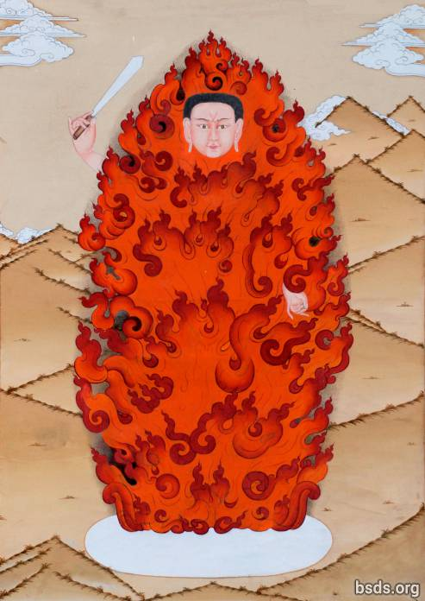

1. Dhüm-sa lum-sa-wi cho-te-pa pa-gya-da-na-se no-ba yum-no-pa mos-di-chi
2. Na-du-ga-sa-ka se-wi num-gri-tri-cha ye-ga-wi-oo-sey
3. Cho-yu-pa te-ma-ye-wi nga-gyu-ka pu-ne-ka ye-sen yep-gya ye-che-oo-ee cha-wu-sey
4. Pa-shring-ah te-ma-ye sha-wung-ah-toh no-ga so-chey sey yu-no-pa toh-wi ga-toh

5. Nga-gyu-ka gyum-du-gya-sheh na-du-ga-sa-ka yu-nu-pa tu-wi cha-wu-sey
6. Ye-no-na-yi-ga ye-ghung-ah-ye gu-na la-shreng-ah cha-wu-sey wi
7. Ne-doh te-ma-pa lup-ga wong-ah pum-nya tu-wi cha-wu-sey
8. Gu-na-wi-sho-toh la-yen-si gya-wi wi-chi ga-sa-ga lup-che-tro

9. Se-pa-tum-pa wi-gyi-da-pa lup-cho tra-si-gya-ba pum-nya
10. Ye-ku-cha-yi-ga ye-wa-ga dhüm-sa se-wi kha-nye-nga wi
11. Sha-ge-da-ka pa-ye ee-gya-ye-shey wet-ma in-sha toh ye-ke-cha pa-ye
12. Ye-gu-da-ba lup-cho pa-shrin-na de-tu tu-wa-pa da-ya-ba te-ma-pa ti-aag

13. Sheh-pa-tum-pa wi-gyi-da-pa lup-gi tra-shi-gya-ba pum-ya
14. Oom-na-pa-yi-ga ye-wa-ga dhüm-sa se-wi ka-nye-nga wi
15. Sha-ge-da-ka pa-ye yi-gya-ye-sheh toh ye-ke-cha pa-ye
16. Trüs-na no-ma de-tu so-shya ti-aag

17. Se-pa-tum-pa wi-gyi-da-pa lup-cho tra-shi-gya-ba pum-nya
18. Ying-ah-ye-gya ye-wa-ga dhüm-sa se-wi ka-nye-nga wi
19. Toh-da-gya-gwa yin-sa toh da-ri-sheh pa-ye
20. Ye-gu-da-ba gya-da-pa pa-ye ni-toh-wa-pa wu-pa-wa-sre-ye-ga wu-gyo-yim-cha tum-pa

21. Ye-ba grin-ta wi-gi-da-pa ga-toh ngi-da de-tu yir-na-po
22. Ye-go-sho-wa de-toh-dyo-nu de-tu ye-ba cha-ah grin-ta wa-tro ti-aag

Homage to Nomyun Gyawi (Nomyun Gyawiweichi Fawoi)

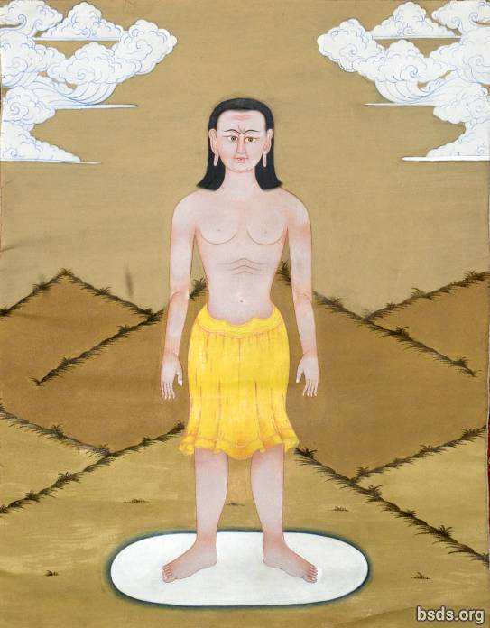

1. Sey-wi-ta-wa wa-yu-na ne-gya-yu gyün-ah-sey tri-ah-sey
2. Lum-sha-wi mre-wi-da sey pa-ye nga-gyu-ka gyün-du-ga-sheh gyu-yim-chi-la ni-da cha-wu-sey
3. Ye-ma-ra-tum-pa wi-chi no-ma ga-ti-ga sey gu-su-yey
4. Ne-gya pum-nya tra-gya-toh ye-doh-wi cha-wu-sey

5. Ye-gyo wi-chi yo-da lup-go pa-shri-na wu-ye-du-ga lup cho
6. Tro-ma-pa-sey wa-li-na-tum-pa grin-ta wi-gyi-da-pa lup-gi-sey gu-shu-yey
7. Shey-wi yop-da gyu-me-yo-sey
8. Naw-ba yim-nu-pa mos-de-chi nüm-gri tri-cha ye-ga-wi-oh-sey

9. Gya-ye-ti oo-la-na-sey mre-wi-da wa-yu-na
10. Ya-pa-ye ye-pa-sey lum-sha-wi mre-wi-da ni-yur-ra lup-go
11. Nga-du-ga pa-ye ne-gu-sey pum-ya tra-gya-toh yu-no-pa ni-da cha-wu-sey
12. Nom-yün gya-wi-wi-chi sheh-ka gyi-na ying-ah-wi ko-tra-na tra-po-sha ga-sha-ga lup-che-tro

13. Nul-ni-ga-sha sup-so pa-ye bu-gya-na-yi-ga ye-pa toh-ga-sey gu-shu-ye
14. Wa-ka-sha tra-tos-sa pa-ye wa-ka-sa se-pla ne-gya-pa lup-gi wo-ngu
15. Oo-go-na-pung-ah lup-cho ga-te-ge pa-ye lup-go wa-te-gi cha-wu-sey wi-chi
16. Sha-pa-nge-wi du-gyi wu-no-na met-pa ne-gya-pa lup-gi wo-ngu

17. Fu-da-wi-na ne-yüng-ah-tum-pa-sey tra-yu-sa-sey pa-shri-na so-shya-ga
18. Wi-gyi-da-pa nen-mu ga-ga-toh-ke-wa ye-nga-yo pa-shri-na pa-ye sho-shya-ga-sey
19. Shi-wa nun-ga-chya-nu-sey ye-gyi-da-pa-yi-ga sho-shya toh-ga-sey gu-shu-ye
20. Oo-nga ying-ah-wi ye-ku-cha sey wu-ga ti-aag

21. SON-WA YEN-GYE YEN-GYE NIG-MA NIG-MA DEN-PO DEN-PO DO-WAN-SO

22. Ye-ku-cha-pa la-ngo-pa doh-ya yüp-nri-ta lup-gu-sey ne-shyu wi
23. Nir-gha-sa te-ne-cha yu-wa ku-nyu-sey cho-ma-yi-ga so-shya ga-toh
24. Dey-tu ye-sho-pa-tra-ye-tum-pa ye-ba grin-ta ye-ngo ga-toh
25. Chi-wa ye-gyi-da-pa-yi-ga sho-shya ga-toh chi-wa ye-nge-ka ye-ngo ti-aag

26. Shey-da-ka pe-wong-ah ni-pa pa-ye cha-sheh-chya chu-ne-tum-pa-sey
27. No-tra wa-ka-sha tra-tos-sa-sey wu-lo-na-pung-ah lup-cho ne-yüng-ah-tum-pa wi-chi
28. Nom-yün gya-wi wi wo-nga tra-yu ka-sheh-wi
29. No-tra ya-bi lup-go wu-yin-tra ne-gya-pa lup-gi wo-ngu

30. Ye-wüt-chey-ye de-tu sep-ka-tum-pa yum-pa se-wi ka-chyu
31. Nu-wa-fa nu-wa-toh-shna-pa pun-nri-wi de-tu ye-ngo ti-aag
32. Nom-yün gya-wi-sey la-ngo-pa doh-ya-se yo-du-ga lup-go
33. Bo-gri-na lo-pum-sey wu-yin-tra ye-ba grin-ta wa-tro ti-aag

Closing Prayer
1. Sey ya-nge-ka da-tri-ya ye-gyo pa-wi-sa-ka ma-sha-ye-ngo ne-yüng-ah tum-pa
2. Oo-ge-cha-ye-fa ti-chu-ga nri-pum-ah-sho-toh su-den tra-tos-sa gyi-dep-na lup-go
3. Tish-du-se gyo-nge-pa ba-ngo gyesh-pa-nge ye-wa-ga ga-toh
4. Ma-sai-ye-ge ti-ah-ga cha-toh-fa su-den tra-tos-sa-sey lo-pum tum-pa

https://bsds.org/en/prayers

