Five-Day Maha Mai Maitri Divas World Peace Puja, 9th-13th April 2026, Hetauda, Nepal

March 7, 2026

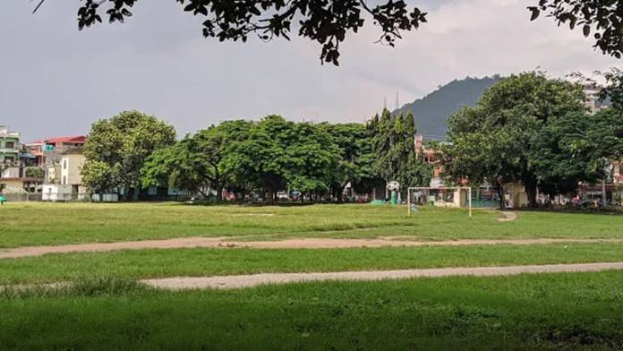

Truth seekers, peace-lovers and dharma followers from all paths and walks of life are lovingly invited to the divinely blessed and joyous event of the 21st Maha Mai Maitri Divas World Peace Puja.

The five-day-long puja with prayers and meditation will take place from the 9th to 13th of April 2026 in Hetauda, Makwanpur district of Nepal, this year converging the birthday celebrations of our most revered, supreme Maha Sambodhi Maitri Nath and Lopam Shronyang together with traditional Maitri Divas into a single sacred event.

To nurture loving friendship among all living beings including humans, plants and animals on Earth and beyond, the puja focuses on peaceful support and empathetic protection of all Life on Earth.

Location of the puja will be Hupra Chaur, Hetauda, Makwanpur, Nepal: https://maps.app.goo.gl/oBxWQuycTSU77PCM9?g_st=aw

https://bsds.org/en/news/223/maitri-puja-2026

