**Three-Day World Peace Maitri Puja 8-10 January 2025**

December 9, 2024

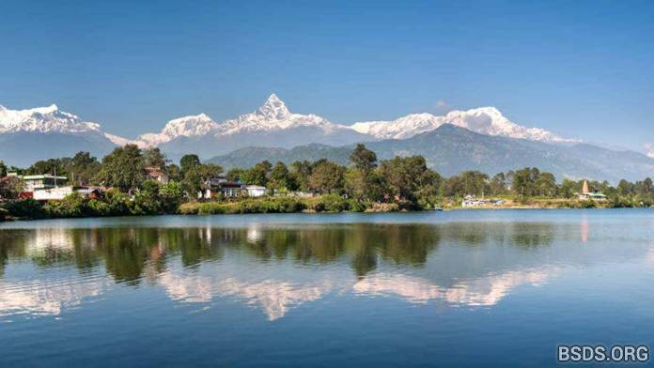

A World Peace Maitri Puja will be held in **Pokhara, Nepal on January 8-10, 2025**. Dharma followers, peace lovers and truth seekers from all over the world are invited.

Location of the puja place: [28.2118852,83.9895022,13](https://bsds.org/https://www.google.com/maps/@28.2116818,83.989653,197m/data=!3m1!1e3?hl=en-np&amp;entry=ttu&amp;g_ep=EgoyMDI0MTIwNC4wIKXMDSoASAFQAw%3D%3D)

There are no sleeping facilities on site, so it is recommended to bring a tent or organise accommodation nearby by yourself. Also please read the [Memo to Visitors](https://bsds.org/https://bsds.org/en/news/153/memo-to-visitors-arriving-for-guru-s-blessing-from).

For contact please use: [office@bsds.org](https://bsds.org/mailto:office@bsds.org)

[https://bsds.org/en/news/220/world-peace-maitri-puja-8-10-january-2025](https://bsds.org/https://bsds.org/en/news/220/world-peace-maitri-puja-8-10-january-2025)