2024 World Peace Walk and Maha MaiMaitri Puja in Patharkot

March 1, 2024

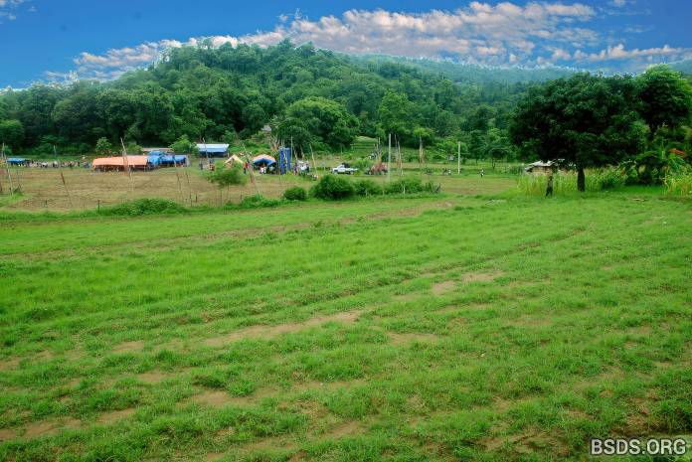

Blessed by the most venerable omniscient supreme Mahasambodhi Guru Dharmasangha, the central Board Committee of the Bodhi Shrawan Dharma Sangha Association joyfully announce the Maitri Walk for World Peace together with the 19th Maitri Divas celebration for the year 2024 including Bodhimarga Darshan, Bhagawan-marga Maitri Dharma Puja prayers, from the 21st through the 25th March 2024 in Patharkot, Lalbandi Municipality, Sarlahi District, Nepal. All faithful sangha devotees worldwide, all followers, dharma lovers, truth seekers, as well as all gurus of all the dharmas with their devotees and well-wishers are respectfully invited to come together to gain and to share divine punya, to offer countless lights to all the transcended Paramatma Bhagawan existing lovingly in this and all other Realms, with the fervent wish for world peace, protection of all the universe’s living beings, of all existence, of living together in co-existence and cohabitation on Earth, and for mukti-moksha liberation of all the innocent creatures as well as all the uncountable wandering souls in the great space above.

We humbly offer this Maitri announcement to all human societies with unending reverence to the supreme omniscient Mahasambodhi Guru Dharmasangha of the true eternal maitribhav heartset, compassion and peace, the protector of existence, living together,co-existence and cohabitation on Earth.

We lovingly invite all faithful sangha devotees worldwide, all followers, all dharma lovers, truth seekers, as well as all gurus of all the dharmas and their devotees and well-wishers to gather together and launch the 19th Maitri Divas Puja this year with the great Peace Walk at 08:00 AM on the morning of the 19th March, beginning by the Bagmati Bridge, Bagmati Forest, Rautahat District, Nepal, going through New Road, Hariwan, Nawalpur, Lalbandi Bazaar up to Patharkot and the sacred Kadjukpa of the Maitri Precinct, and to gain further immense dharma punya at the 2024 World Peace Maha MaiMaitri Puja celebrations.

Day 1 – Peace Walk – Shanti Padh Yatra – 19th March 2024

08:00 AM, beginning by the Bagmati Bridge, Bagmati Forest, Rautahat District, Nepal, going through the east-west Mahendra Highway, to New Road, Hariwan, Nawalpur, Lalbandi Bazaar up to Patharkot and the sacred Kadjukpa of the Maitri Precinct, Sarlahi district.

Day 2 – Rest and Preparations for the Puja – 20th March 2024

Patharkot Maitri Precinct, Sarlahi district, Nepal

Days 3,4,5,6,7 – Maha MaiMaitri Puja prayers and chanting programme – Maitri Diwas 2024 -21st -25th March 2024 (Tentative schedule, to be confirmed in the coming days)

Just as the wheel of time is continuously moving and turning everything, all living beings including humans and all existence are conditioned accordingly. Let us all, dear precious friends, joyfully accept and appreciate the presence of the most revered omniscient supreme Mahasambodhi Guru Dharmasangha in our midst and, in grateful awareness of this golden moment, let the entire world move forward together as one on the true margapath.

Shaigi Wayinkhya,
Bodhi Shrawan Dharma Sangha

https://bsds.org/en/news/219/world-peace-maitri-diwas-puja-2024

