Growth of Maitri in Nepal

January 28, 2022

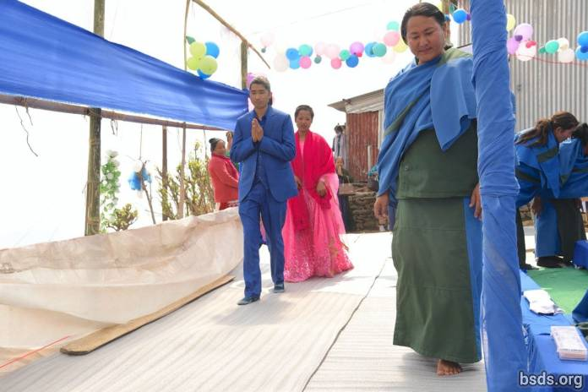

Since Dharmasangha Guru’s magnificent proclamation of Maitri Dharma at His last Mahā Puja for World Peace of 2017 at Bungamati in the Kathmandu Valley, permanent local Maitri Centres have been springing up in one district after another, like a field of flowers opening their bright colours and gentle fragrance in Spring, spreading the typical maitri inner joy over all Nepal. New branches of the Bodhi Shrawan Dharma Sangha (BSDS) Association are being registered all across Nepal, including remote areas in the Himalayas, and all the places that Guru had visited in Person to give blessings, hold World Peace Pujas and deliver Teachings. These new BSDS Chapters have been building new centres as puja meditation halls to hold regular monthly gatherings for all the districts’ maitri sangha members, devotees and followers, under the wise and compassionate guidance of Mātma Gurumārga female Thapowa and male Athoahas gurus.

They worship together at least one day each month, beginning with offering of the five elemental Gifts of divine Creation (water, flowers, fruits, light and incense), and follow with prayers, doing mantra-mala meditations and silent tap-meditations. At each meeting, the groups also study readings from the Maitri Dharma Pustak (Book of Maitri Dharma) in loving fellowship, probing from the heart in reverence and gratitude, gradually realising the living qualities of dharma wisdom that lead to everlasting universal liberation. In receiving the teachings, and in the question-and-answer sessions with Mātma Gurumarga gurus as directed by Guru, communities have been steadily deepening their inner grasp of maitri dharma whilst building up strong community bonds. Devotees identify themselves and each other by their maitriness, by their maitri life-style, and these regular meetings are strengthening their collective identity as one cohesive Maitri Family. In this light, a glowing new socio-spiritual dimension has been added to the geospiritual fabric of Nepal.

Groups of Mātma Gurumārga gurus have been officiating in their respective Districts at various major rites of passage for sangha members, devotees and followers. These important occasions include nativities where new born babies receive their Maitri names bestowed by Guru; at weddings where a puja is held to join the two souls of bride and groom into one. This requires the respect and support of both families who must recognise, support and not impede the conjugal life of maitri dharma chosen by the new couple. In this light, some families new to Maitri Dharma, eventually ended up following the lifestyle that their child has married into, and began renouncing all meat and alcohol from then on as well.

Then there is the great send-off of the soul newly freed from its mortal body as it begins its 75-day journey to a heavenly realm with Mātma Gurumārga gurus’ guidance so as not to get lost along the way. For this event all family, relatives and friends gather at the cremation place and watch or joining in respectful silence as the Mātma Guramārga Athoahas and Thapowa say the prayers of the Twenty-One Realms, enjoining the soul to stay strictly on the path. In Nepal, these simple funerary procedures are among the least costly and often very beautiful. For example a family may decide to cremate their beloved departed by the side of a rapidly flowing river, and following incineration of the whole body, disperse the ashes into the swift currents.

All attendees at such events share in the maitri practice of purity and non-violence, which means total abstinence from any meats, fish or alcohol, no matter what their usual diets entail. For this day of Maitri send-off celebration, everyone is willing to go vegan all day long, for love of their maitri hosts. In the past, many traditional Nepali rites of passage used to involve slaughter of live animals for the meat-based banquets.

In Maitri Dharma, the wedding of man and woman, too, has radically transformed past practices common in Nepal. Instantly noticeable is the total absence of the glitter and rustling of gold and silver jewellery like earrings, noserings, necklaces, bracelets and bangles. There is no gift-giving of any jewellery whatsoever from anyone to anyone else. The bride is freed of the usual elaborate make-up with heavy cosmetics, and wears a simple gown of light pink and the groom an outfit of maitri blue. The assembled guests in maitri coloured outfits of blue, green, pink and purple, are seated in the community maitri hall, facing the three officiating Mātma Gurumārga gurus at the front by a low table. Most of the other Mātma Gurumārga gurus are seated in front along the left wall, opposite the newly weds along the right wall, seated by a low table with two large vessels with beautiful white flowers.

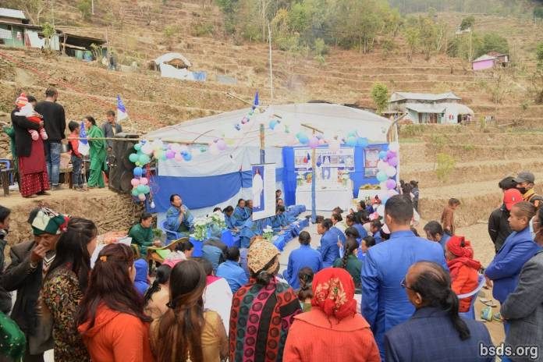

In Maitri the bride and groom are equal, and bygone traditions of the bride prostrating in total surrender to the groom or to his parents is replaced by her joining her beloved as an equal partner, with equal responsibilities and privileges, to share the rest of their conjoined life as one united single soul, to work with the greatest dedication for the benefit of Earth and the moksha-liberation of all living beings. At the request of the leading Mātma Gurumārga guru, they light the two oil lamps in front of them. All the guests, along with the new couple, reverently follow the Mātma Gurumārga gurus in chanting the prayers and mantras. Everyone having lit a lamp at the entrance and kindled the heartsoul for this auspicious union, is deeply immersed in the pervasive presence of Paramātma Gurunature in the hall. The entire wedding is one continuous worshipful celebration, and participants are immersed in maitribhav throughout. Although of immense social significance, maitri weddings are primarily a spiritual experience.

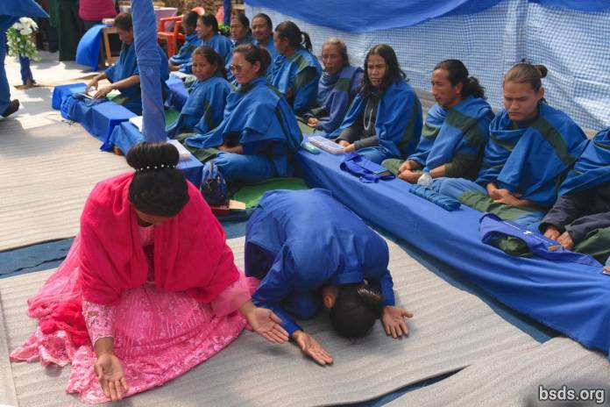

The significance of a maitri wedding is not rings, bangles, fancy dresses or decoration, but the intimate, strong and lasting bond with Paramātma as two souls are joined into one, from which point the bond becomes ever stronger. And for this purpose these two souls need Paramātma blessing to make the union fruitful. The wedding takes place as a full puja, with each partner helping the other strengthen their new common life-bond. This is how people in Nepal are coming to understand the real, internal meaning of marriage.

A remarkable development is seen in weddings where one of the partners comes into Maitri Dharma from a different background. The bride or groom may be from another religious background, but is here surrendering heart, soul and body to Maitri Dharma in order to be one with the partner. And for this the family too, takes on Maitri behaviour – at least for the day of the wedding celebration. Over the years it has become clear that in time, all the “new” families of the bride or groom coming into Maitri for the first time, have one after another decided to join the simple and pure life of Maitri Dharma where direct divine connection is unhampered by any extraneous material considerations.

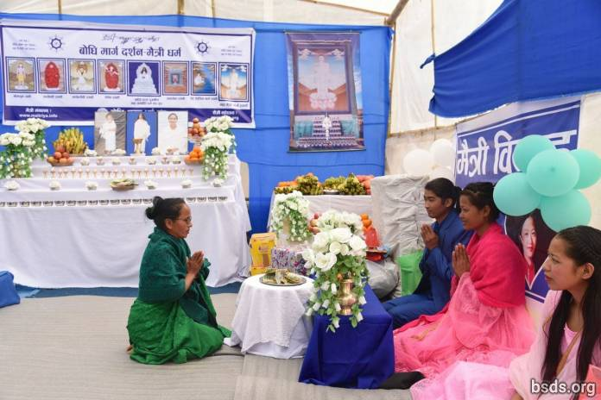

Regarding births, Maitri names are given to new borns by Mātma Gurumārga gurus after consulting with the parents beforehand. Maitri names often carry dharma significance, with meanings like transcendent, dharma, cool breeze, fulfilled, perfected, or elemental meanings like earth, light, or sunshine. Maitri nativity rituals are performed on the 9th, 11th, or 21st day after the baby’s birth. This is a more private event. Mātma Gurumārga gurus begin the day at the home of the newborn early in the morning, chanting general prayers. After brunch, prayers are specified for the particular new life ritual. For nativity, this is the time the infant is officially blessed by Paramātma. The Mātma Gurumārga gurus are praying for the baby to grow and thrive free of obstacles and to enjoy a long and healthy life. After this, Mātma Gurumārga gurus announce the name of the blessed new soul. With this everyone learns a new Maitri word as source for a new dimension of maitri meditation.

Mātma Gurumārga gurus are intimately involved in all communities, and visit each household for blessings at least once a year. They are ever ready to clarify questions regarding dharma principles, rules and regulations, give guidance and solve spiritual problems. They have become an immense foundation for devotees’ confidence, faith and spiritual uplift.

In short, every aspect of life in Maitri is a manifestation of dharma karma in its highest level. All celebrations are in reality part of humanity’s mukti-moksha mārgapath for the collective transformation of the world and all living beings, each with profound joy, as celebration of living existence. Devotees ignite maitri sparks in each other, and all gatherings are filled with the typical gentle serenity and quiet gladness of open and inclusive maitri loving friendship. Maitri devotees advance more deeply into the infinite light of dharma that now illuminates life more and more. For here in Nepal, Maitri dharma has sunk its deep roots and is spreading wide and steadily, transforming life from its very core.

https://bsds.org/en/news/216/growth-of-maitri-in-nepal

