Maitri to Become a Worldwide Language

August 15, 2019

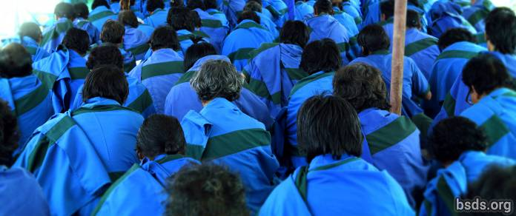

The Maitri Dharma Centre Office wishes to announce the happy news that shortly after Maha Sambodhi Dharma Sangha Guru began His Three-Year solitary MahaDhyan Supreme meditation practice in the Sindhuli mountain jungle on the 16th of June, some two hundred Maatma GuruMarga Tapowa and Athoahas gathered for concentrated intense training in the Maitri Language on the 5th of July under Sanyasi GuruMarga gurus where, after six months by the end of the year, major communications with the Paramatma Gurus for the welfare of this world, the uplift of all living beings as well as for peace on earth, will be expressed entirely in Maitri. It is the first time this Maitri group will have learned not only to pray and chant in the language, but their thinking in Maitri will cause internal transformation that will make Maitribhav a natural part of their everyday living. The spread of this unprecedented and divine language among all devotees in Nepal and eventually around the world, will be realised through these Maatma GuruMarga gurus. Here we pray for the joyful completion of this difficult and unique task, and look forward to the new Pujas and Sangha-training programs scheduled for the year 2020.

Sarva Maitri Mangalam

https://bsds.org/en/news/209/maitri-to-become-a-worldwide-language

