Supreme Meditation for Peace on Earth

July 5, 2019

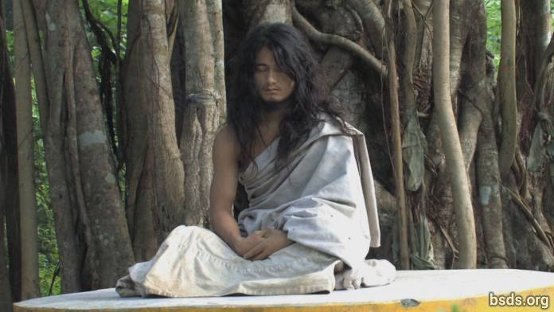

A major press conference was organized by the Nepali sangha Bodhi Shrawan Dharma Sangha at the press club in Kathmandu on the 4th of July 2019, to deliver the unprecedented and joyful message to all peoples of Nepal and the entire World, disciples, sangha, devotees, followers, Dharma-lovers and Truth-seekers that, as of the 16th June 2019, our most revered Guru, Mahasambodhi Dharmasangha, has once again entered Mahadhyan or Supreme Meditation in the dharma forest of Sindhuli for three years, and that during this time major Pujas and training programs will be conducted by the Sanyasi and Maatma Guru Marga gurus.

Through this media conference, we wish to appeal to the Government of Nepal for basic support and for maintenance of peace and protection of this sacred Dharma Land of Nepal to ensure the success of this arduous, glorious undertaking. We are all praying for the joyful completion of Mahasambodhi Dharmasangha Guru's unique 3-year Mahadhyan Supreme Meditation, and hereby share our Maitri-filled wishes for all living beings of the universe, the entire plant kingdom, and all existence to absorb new inner wisdom, punya karmafruits, and boundless gains of Mukti Moksha liberation for all.

Sarva Maitri Mangalam

https://bsds.org/en/news/208/supreme-meditation-for-peace-on-earth

