MaatmaGurus Complete 3-Month Austerities

January 21, 2019

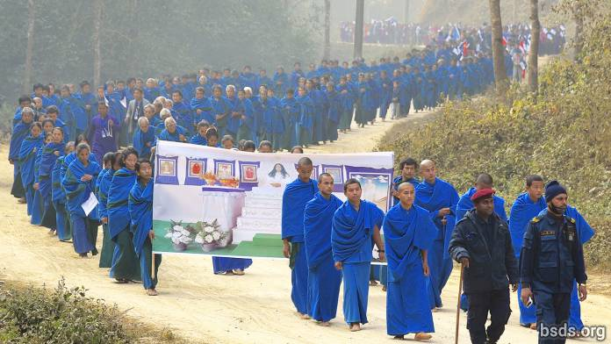

It was well past midnight early on the 16th of January when the jungle around the sacred Maitri precinct in Sindhuli began to stir. One by one, around 200 male and female Maatma GuruMarga gurus emerged from his and her tent, dressed in blue-and-green robes, to return to worldly life anew as fully accomplished Maatma GuruMarga gurus with full Mukti-Moksha wisdom gained over their arduous three-month meditation in silence and isolation. They are the first messengers to spread Maitri dharma in Nepal and, eventually, throughout the world. Including householders as well as single men and women, the new gurus will serve in towns and villages to perform various life-functions abiding strictly by Maitri guidelines: they will not demand exorbitant fees, they will teach people not to eat or sacrifice any living being from sky, land or water; not to cut down trees in acquisitive greed, but only as needed. They will launch reforestation wherever and whenever possible, planting trees in all districts. In rituals and ceremonies, the new gurus will abolish erroneous, wasteful or harmful beliefs and practices accumulated over past millennia for mourning or for celebration. Two years ago, their robes had red and yellow stripes, now further advanced, the stripes have given way to green panels, highlighting the ecological glow of their mission: to avoid any and all killing, to protect all life, to sustain and support Earth as a whole.

In the Maitreyan language, these secular teachers are called MaatmaGuru Athoahas for men, and the MaatmaGuru Tapowa for women. They have worked hard to gain the wisdom for bestowing Mukti-Moksha, showing the steps we must take to attain liberation from cyclical rebirths. This seemingly miraculous feat used to take many lifetimes of continual, arduous, dedicated spiritual practice. And many were the holy souls who have returned to the world lifetime after lifetime to practice meditations for this liberation again and again but, ignorant of the true Path, had repeatedly failed in this quest. Now, by the grace of the Maatma Guru Athoahas and Maatma Guru Tapowa, there is no more mystery about direct ascension or liberation. In ordinary parlance, the Maatma Athoahas and Maatma Tapowa are now here to lead souls directly to bliss in eternal life.

By Nepali calendar reckoning, they began this arduous course on the 18th of October, 2018, and completed it three Nepali months later at the end of the 15th January, 2019. Finally they have finished their deep-searching and far-reaching Maitri Meditation in total uninterrupted silence, absorbing Guru’s blessing and attendant inward spiritual growth. Inside each of their simple huts dotted over the hilly jungle of the Sindhuli Maitri Dharma Centre, they had sat in meditation through the cold winter months in silent burning practice, enduring all sorts of inclement weather, physical discomfort and spiritual challenge, gradually to settle into increasingly profound upward extension of the soul’s quickened evolution to realise direct connection with Paramatma Gurus. During this time, Mahasambodhi Dharmasangha Guru Himself had been giving them sacred Teachings in the woods, dispensing Maitri wisdom. They return to the world empowered with deep punya blessings accumulated through their intense practice, and broadly expanded in awareness to serve their respective communities as teachers of Maitri Dharma, to conduct rites of passage including births, weddings and funerals, to give comfort and life-guidance to all people, bringing about the state of inner peace and wholeness wherever they may happen to be.

The 30-40 women include mothers, grandmothers as well as single women; the men include fathers, grandfathers in their 80s as well as young men in their twenties. One after the other, at last emerging from their simple isolated meditation huts, they were guided by GuruMarga Gurus holding torches, up the winding mountain paths to the gathering place in the open space of worship above. Meanwhile their waiting families had set up long tables filled with hundreds of oil lamps now glowing and waving in the soft night air. Tears flowing with joy and throat choking with months of longing finally assuaged, family members stood waiting for the first glimpse of their beloved heroes and heroines returning from the long gruelling practice, their hearts are now full of reverence and gratitude. The meditators, some with beards and mustaches grown long, slowly walked up to the open space, their legs and feet adjusting once more to physical movement returning to full circulation. At the sight of the Maatmas, family members knelt in joyful reverence and performed prostrations to the Paramatma Gurus in gratitude and welcome.

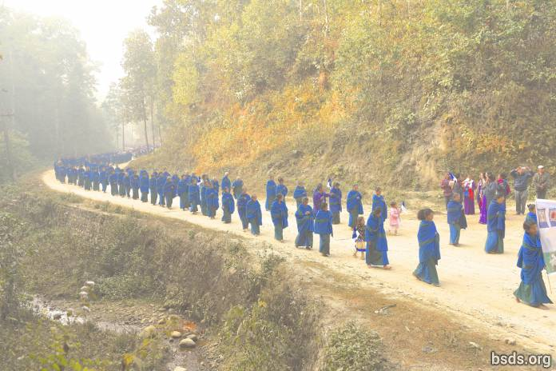

This soft and gentle energy emerging in the jungle night was Mahasambodhi Dharmasangha Guru quietly unleashing a brilliant light onto the world. These men and women, now fully functional Maatma Athoahas and Maatma Tapowa, will transform Nepali society in every sector from the very grassroots up. The blessing of Maitri will thence spread throughout the world with the punya being offered up from all Nepal for all living beings everywhere.

Powerful punya was spread forth, both by the Maatma Gurus through their profound meditations and prayers, and by the Sangha through their self-forgetting efforts of labour in erecting the altar and in creating a place of beauty and offering to the Paramatma Gurus.

The glowing Maatmas came forward and greeted their families, but still in training, retired into waiting monastic dormitories for the rest of the night. In the morning after sunrise, they rose for a day of cleansing, shaving and washing, remaining essentially in silence for a few more days till their full release back into the world after completion of the World Peace Puja.

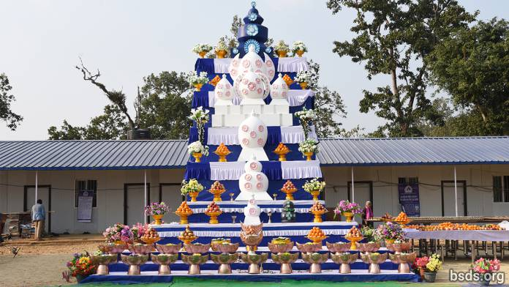

The Precinct however was abuzz with secular activity as the Nepali Sangha, having erected the brick altar once more, spent much time and effort hoisting up gigantic heavy rounded wooden forms of offering, pulling them up over a long smooth bridge made of strong shiny bamboo poles, to the very top of the high brick altar. The base of the main blue MaiMaitri form has already been hoisted atop the high, layered brick altar. The job now was to hoist the rounded chief Offering up above the base without breaking the large wooden flower at the front that reached above the base. Here ingenuity combined with strength had to work in concert to achieve total union of all participants so that all function and feel as one, a basic Maitri attribute. Here local and international sangha watching the activities learned a lesson in full cooperation, that state of being where individual egos dissolve to immerse as part of the greater oneness. This self-losing to the whole illustrated what our daily prayers seek: the ascension and liberation from cyclical rebirths of all living beings (of which the self or ego is inalienably a part, albeit an infinitesimal part). When the infinitesimal ego fully realises the oneness and infinity of monolithic Creation, it dissolves in total bliss, secure in the light of the whole.

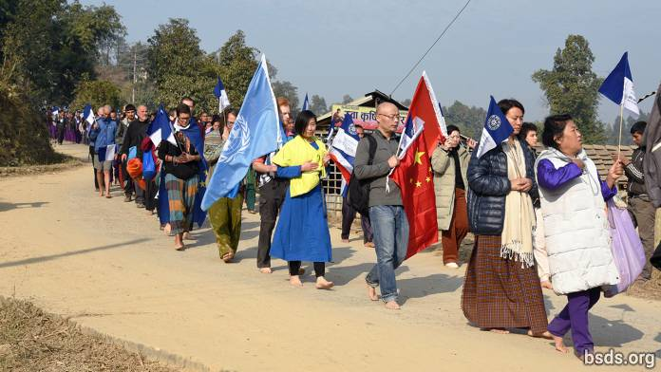

Next morning on the 17th, all gathered at the open space, local and international sangha, the Maatma Athoahas and Maatma Tapowa and their families around 06:30 and began forming lines for the celebratory march into Sindhuli township toward Guru’s Kadjokpa there beneath the site of the Autumn World Peace Puja of 2012. Heading the whole procession was the motorcade of some 20 motorcycles, each fluttering with twin blue-and-white Maitri banners. Next came the 200 odd celebrants, the Maatma Guru Athoahas and Maatma Guru Tapowa, with the women in the lead, a few walking together with their little daughters hopping proudly by their moms. Then came the men, some with young sons running alongside, also in silence. Everyone walked barefoot on the rocky stony paths leading to the town some eleven kilometres down the hill. Everyone held a Maitri flag, some couples hoisted up two ends of large horizontal banners with photos of Guru, name of the organiSation Bodhi Shrawan Dharma Sangha, and emblazoned with the words Bodhi Margadarshan – Maitri Dharma (Bodhi Path-Revealed Maitri Dharma).

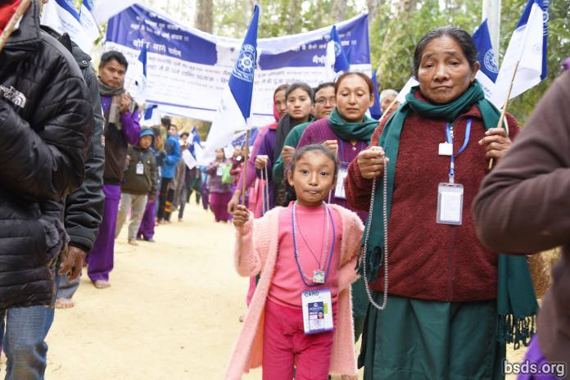

Following the Maatma Gurus came the international sangha headed by Chinese devotees followed by Western groups, with the immense Nepali sangha bringing up the end. Notable among foreign banners were huge flags of the United Nations, Switzerland and the People’s Republic of China. There were around 50 foreign devotees, many also attempting to walk bare foot over the stony rocky thorny paths. An Ambulance from the Chitwan Hospital took up the end, ready to pick up the elderly, unwell or injured along the 11-kilometre walk. Many Maatmas as well as sarva sadharan lay devotees were holding mala strings and doing mantra meditation as they walked. The sight of the dozens upon dozens of blue-and green Maatma Gurus walking in deep meditation was an amasing sight, and triggered profound reverence among townsfolks standing with joined palms on both sides of the roads. In deep silence the long files of Maatmas moved up and down the hilly paths beneath the giant trees that seemed to respond in a cool, blue and green light. The whole group seemed weighty, or rather more grounded, more steady, more at one with Earth than other walkers. After three months drenched in silent meditation their entire being has become transformed. One older Maatma Guru Tapowa is now decades younger than when she first started her tapas. Her bent form is now straightened, her wrinkles gone, her laboured movement now agile and lively. It will take some time for all transformations to be noted.

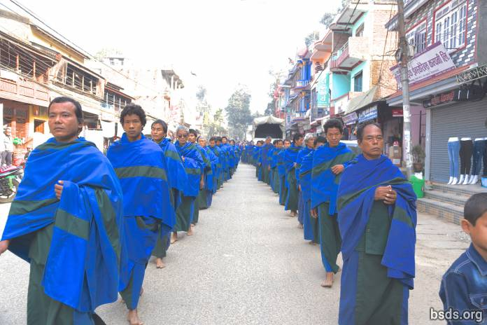

One observer remarked, that watching them moving barefoot in silent files felt like watching Truth on the March. Another observed was amazed by the tremendous sense of unity of the group, sensing how they were united in spirit even though they are of such differences in age and background. As their fleshy, gentle blessed bare feet touched the ground, profound punya of their acquired blessing was imprinted onto Sindhuli soil. The paths being travelled lit up in joy as they passed. The warmth and reverence of the towns people’s reception, too, was palpable. They lined the streets, with hands joined in reverence, and, moved by the peace-filled glow on the face of each Maatma Guru, their hearts felt deep and warm blessing in return. Profound gratitude and a cool refreshing awareness of the divine filled the mountain air, enveloping all trees, walkers, and observers. It felt as if all living beings had entered a new dimension, drawn deep into the peace of heaven now radiating from the Sindhuli earth.

The whole phalanx walked four hours each way during which the only sound heard was that of the Maitreyan Mantras broadcast from the leading van. Otherwise it was the swishing of the Maatmas’ blue and green robes, rising and falling in time with their neighbours’ as strong bare feet sank and rose among the grass stubble or jagged stones. Even though among the tall conifers and deciduous mountain trees the Maatmas’ robes seemed on the dark side, the effect of their unified walk was as if Guru had unleashed a stream of compassionate light upon the earth, to move in slow motion. The light of their collective progress through the mountains was amazing and unearthly. Like a new River, Guru had unleashed upon Nepal a flow of Maitribhav that would grow and expand, that would heal this ancient land and bring eternal bliss to its people, ushering in the Golden Age in its full glory. These men and women, unlike most of us, are perfectly clear about their life, their life purpose, and fully know the path toward their life goal. There is not a shred of doubt in their enlarged souls, about how to deploy every minute of the rest of their mortal lives. They are firmly rooted in Maitribhav, that all-encompassing love that knows no division or discord, no bias and no greed, no jealousy or want, but only the profound peace and serenity at the core of Creation, the heart of the Paramatma Gurus. They are here to take our hand when we flounder on our life’s path, wondering what to “choose,” how to “get it” or “get there,” mired in whirlpools of self-centered concerns. They have come to help us uphold Maitri rules and regulations in order to blossom in Maitri, so that eventually, like them, we will be rooted, deeply grounded and firmly set on the Maitri Path to blossom fully in eternal peace and joy.

https://bsds.org/en/news/200/maatmagurus-complete-3-month-austerities

