Welcome to the World Peace Maha Darshan Maitri Puja and Blessing Programme 2017

December 6, 2016

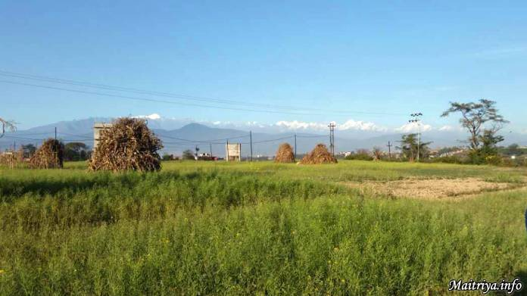

Welcome to the 13-Day World Peace Maha Darshan Maitri Puja and Blessing Programme (21st March to 2nd April 2017) to be held in Chunikhel, Bugal, Bungamati Township Ward No.7, Lalitpur District, Kathmandu Valley, Nepal.

When your travel plans are set, please kindly fill out and send this Puja registration form. The Google co-ordinates are: 27°37'25.8" 85°18’23.5" (27.6238333, -85.30652777) as shown by the red marker on the map below.

Within the Sacred Precincts
Since Maha Sambodhi Dharma Sangha Guru stepped on this land, it has become sacred. Benefiting yourself and all world-wide devotees, visitors and Truth-seekers are invited to:

● Come and go with a sincere and open heart, with kindness, compassion, friendship and Dharma Peace as our highest intention.
● Respect each and every Dharma-friend, knowing we are ONE with everyone else, sharing in absorption of Maitribhav that binds us happily without boundary or caste.
● Refrain from any activities obstructive to Dharma, Dharma-followers or against the rules of Dharma.
● Refrain from meat or fish products, tobacco, alcohol or drugs (except personal medication).
● Leave cameras, smartphones and video recorders outside the precinct (there will be official photographers whose photos will be online for downloading).
● Restrict phone calls to emergencies only.
● Remove sandals before entering sacred precincts for meditation and Blessing.
● Remove all leather and silk wear, jewellery as well as glasses when coming up to Guru for Blessing (a handy pocket helps).
● Remove any head wear (scarves, hats etc) and other personal decorations (necklace, rings, hat etc) before coming up for blessing.
● We are here to receive Guru’s Maitri blessing, to deepen our Dharma and our direct link with Guru. It is best to increase our inward alertness, listening for the inner light even when back in our tents. Going inwards, we come closer to Guru, to Dharma and to each other.

Accommodation During Puja
With the blessings of Maha Sambodhi Dharma Sangha, all international guests & devotees are invited to bring our own tents and live at the peaceful Maitri camping site for free, including our two daily meals for the duration of the Puja. It is a most rare and precious occasion when we sleep in nature to stay immersed in Maitri and loving kindness to gain Dharma punya-merit for all living beings including ourselves.

The Puja site is no five-starred hotel but unadorned Nature above terraced farming fields. It may help for urbanized Sangha to prepare for a camping experience with a totally open heart and mind. In this space we offer the information regarding on-site outdoors facilities that are being constructed as we write.

The Puja site provides free accommodation and two healthy samyak ahar vegan meals per day. Toilets and drinking water for refills will be available on site.

Sleeping is organised in two areas covered with huge overhead tarpaulins, separate for men and women, (regardless of marital status) as in spiritual centres where one’s entire day — and night — is subsumed under the overall spiritual ambience of being absorbed in contemplation, here in Maitri Dharma.

Keeping in mind that we are on Sacred Ground including our camping site, we will remember to refrain from eating meat, smoking and consuming alcohol or drugs during the 13 day Puja period. This is not only beneficial for your Dharma punya-merits, but it will also help to uphold the integrity and purity of the Puja on a grander scale.

Other Accommodation
As in the past, devotees seeking more urban accommodation outside the sacred Puja Precincts are asked to search for these on their own to ensure that they can find something which suits their own personal preferences.

Volunteering
Many have asked to join any volunteer work that may be needed close to the time of the Puja and during the Puja. There is indeed very much work and one is usually short-handed. So, all those wishing to become volunteers please be sure to tick the "volunteer" checkbox on the Puja registration form and/or make yourself known to the Bodhi Shrawan Dharma Sangha office upon your arrival to the Puja site stating any expertise that might be relevant for various Puja activities i.e. helping in the kitchen, in construction, in sweeping the ground, in ushering devotees to their seats inside the Puja Tent, in handing water to people standing long hours in queues for blessing, etc.

Note on BSDS and Commercial Activities
Bodhi Shrawan Dharma Sangha (BSDS) is a non-profit organisation under Maha Sambodhi Guru Dharma Sangha that aims to help spread true Dharma, helping all beings attain freedom from ignorance, suffering and rebirths. It is not connected with any enterprise around the world or outside the Sacred Precincts whether lodging, healing, blessing, guide / transport, selling of religious artefacts or other services in the Name of Guru. No claims of this kind are genuine. If ever any commercial activity be authorized it will be announced in this space. If you have questions regarding any particular agency or enterprise, feel free to contact us at contact@bsds.maitriya.info

You are all welcome, Sisters and Brothers!

More information on the upcoming Puja can be found at http://us.bsds.maitriya.info/world-peace-maitri-puja-2017-info/

http://maitriya.info/en/news/195/welcome-to-the-world-peace-maitri-puja-2017

