Kathmandhu Welcomes New Maatma Marga Gurus

26 April 2016 / Updated on 27 April 2016

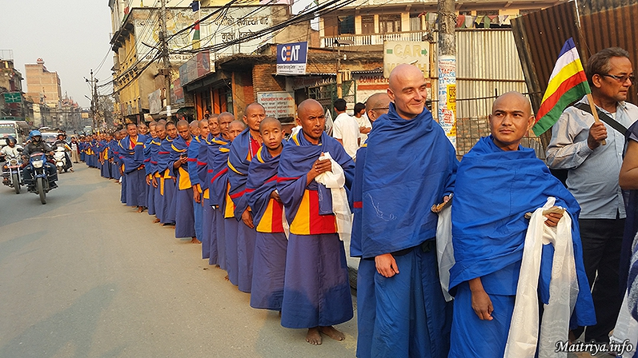

As the more than hundred new Maatma Marga Gurus arrived today in Kathmandhu having finished their five-week intensive training under Maha Sambodhi Dharma Sangha Guru at the Maitri Dharma Centre in Badegaun, Sindupalchowk, the streets in Kathmandu were lined with well-wishers cheering their achievement. Offering khatas, water and biscuits, families, friends and devotees were on hand to express their shining joy now that Maitribhav has been launched in these embodied gurus who will uplift and transform towns and villages throughout Nepal, practicing and teaching compassionate love and Maitri Peace.

http://maitriya.info/en/news/190/kathmandhu-welcomes-new-maatma-marga-gurus

