New Maatma Marga Gurus Usher in the New Year

March 21, 2016

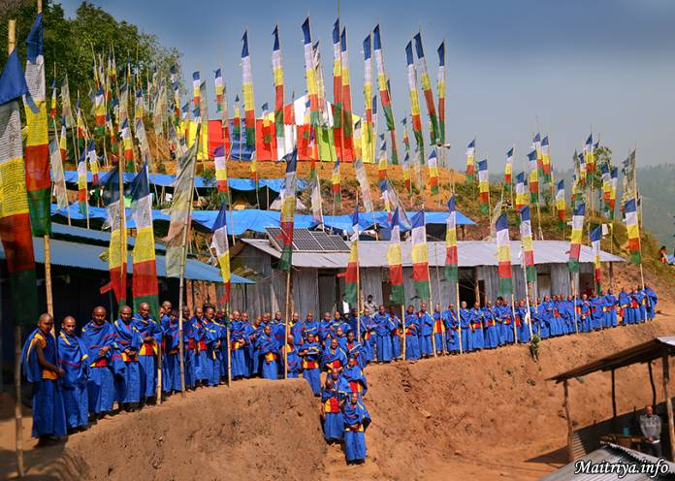

Todhkebari 5, Badegaun, Sindhupalchowk

In this eleventh year of Maha Sambodhi Dharma Sangha’s unceasing Offerings for the Liberation and Salvation of all beings in the universe, the Guru launches during the Maitri Divas celebrations over a hundred new gurus on the Maatma Marga (Primordial Earthly Path) of Maitri Dharma. They shall serve communities throughout Nepal and, eventually, throughout the world.

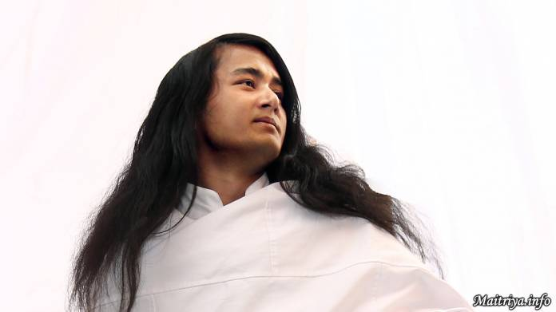

The Maatma Marga Path teaches entirely new wisdom gained during Guru’s solitary six-year penitential meditation without eating or drinking in the jungle under many extreme conditions. Entirely from first hand experience, Guru’s Bodhi Maitri wisdom offers precious new truths long since forgotten. On this historic occasion the new Maatma Marga gurus accepted offerings of blue Maitri robes with distinctive colour stripes, the newly printed blue book of Maitri wisdom, and five weeks of intensive personal training at the mountain Dharma Centre. They work directly under Guru and, in time as the inner wisdom of the Primordial Earthly Path grows and matures, these wonderfully blessed Maatma Marga trainees shall dedicate their life serving as gurus to all peoples, and to shine the light of wisdom in their respective communities, forming the first wave of official Maitreyan Messengers of Peace and Loving Compassion that will spread throughout the world.

http://maitriya.info/en/news/189/new-maatma-marga-gurus-usher-in-the-new-year

