The Earthquake in Badegaon, Sindhupalchok

April 28, 2015

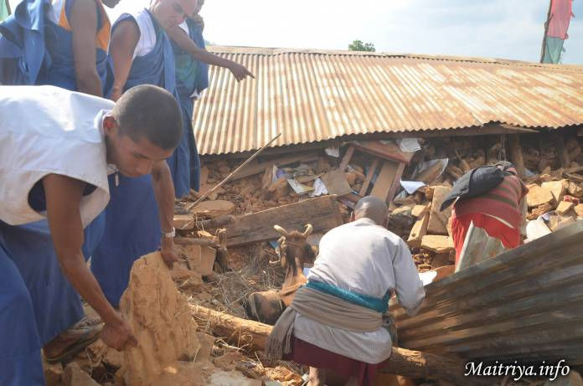

On April 25th and 26th there was a strong earthquake in Nepal measuring 7.9 in magnitude. The earthquake aftershocks are still taking place in Sindhupalchok district. All of the Maitri disciples in the Maitri Dharma Centre are alive and safe including all international devotees. However surrounding villages of Badegaon, Apchaur, Sivapokhare-vdc, Jhamire, Archale, Salle, Milanchowk, Narawalpur-vdc, Padamaruwa, Kareltol, Bhattaraitol, Dandatol, Shresthatol, Thapatol, Bismuretar, Amaldong, Basanpur, Dhusine, Piughar, each with approximately 50 houses, are either severely damaged or completely destroyed and their communities are suffering a lot. Casualties confirmed to date are more than 50, with the count continuing.

On a daily basis, Maha Sambodhi Dharma Sangha Guru is sending Maitri disciples to the nearby villages to provide first aid and to help in the rescue of people and animals. Bodhi Shrawan Dharma Sangha is giving villagers its own food, medical supplies and tarpaulins (for building temporary shelters) and is going to buy more supplies for further distribution to up to 3000 villagers for at least a month.

Contact e-mails:
— Kim: jyampakidwen@gmail.com (for donations inquires)
— Maha Sambodhi Dharma Sangha office on the site: dharmasangha.office@gmail.com

http://maitriya.info/en/news/183/the-earthquake-in-badegaon-sindhupalchok

