February 22-27, 2014, Lamjung Maitri Puja for World Peace

April 16, 2014

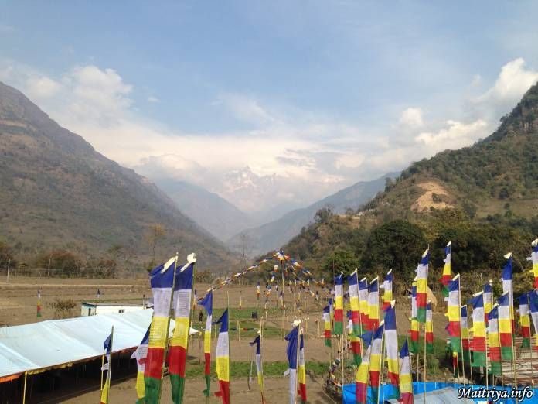

From the village of Khudi, at the foot of the Himalayas, the eye can reach directly onto the snowcapped peaks of Manasulu, towering 8163 meters above sea level, giving the illusion of being only three or four kilometers away. This is the view from the site of the last puja of the Nepali year 2070, held in the District of Lamjung in northwest Nepal, on the border of Tibet. Devotees had gathered from everywhere. Nepalese devotees had arrived from Manang, Pokhara Lake, Kaski, Gorkha, Tanau, Dading, Kathmandu, Kirtipur, Lalitpur, Bhaktapur, Kavry, Nuwakot, Sindupalchowk, Ramechhap, Makwanpur, Chitwan, Parsa, Bara, Sarlahi, Sindhuli, and those from the far distant mountain region of Mustang had to travel across the great ranges, taking more than three days for their journey. There were also Indian devotees from Sikkim and Darjeeling, among other places.

The air throughout the highlands of Nepal is cold in the morning and evening, with sun during the day, warming the breeze. Here in Khudi, the air seems especially fresh, brushing down from the highest peaks of the world, and quickening the heart with a strong feeling of being in the presence of the divine. Devotees who have attended many of the Maha Sambodhi Dharma Sangha Guru’s Puja agree that there was something rather special about the Lamjung Puja.

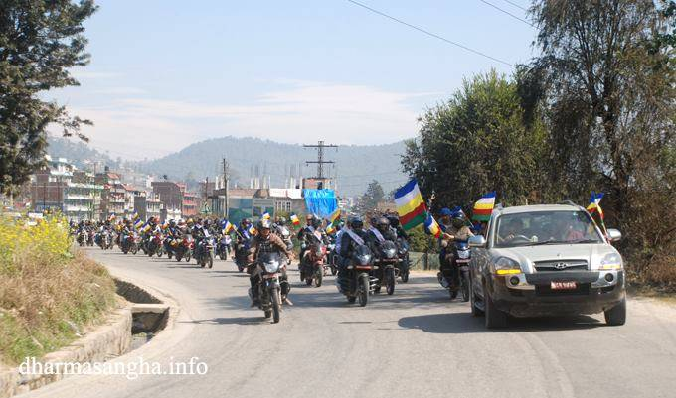

The Maha Sambodhi Dharma Sangha Guru had left his mountain retreat in Thodkhebari of Badegaun Township in Sindhupalchok District, on the morning of February 19th, to travel with his immediate entourage for ten hours by jeep to Lamjung. From the very beginning atop the tiny mountain village, there were already twenty cars of local devotees waiting to join the convoy and, when they reached the town of Sipaghad below, thirty more cars were waiting, along with untold numbers of motorcycles, ready to brave the long journey over the bumpy and dusty Nepali roads.

Along the way, motorcycles and private cars, seemingly out of nowhere, continued to join the motorcade, their numbers growing at an alarming rate, with offerings of flowers, candles and incense, khatas and fruit, waiting patiently for the Guru. At times, in certain populated towns, the road ahead became completely blocked by devotees to the point that nothing could pass, often requiring the gentle assistance of the local police. The vehicles continued to multiply as the day wore on. The roaring wheeled assemblage came to stretch long and wide for kilometers, creating a memorable sight along the roads leading to the large town of Chabel where an additional 700 devotees were waiting. There was a joyous celebratory mood among them, one and all. Whenever the caravan passed villages and towns, there were groups of devotees gathered along the road with flowers and other offerings to greet Guru’s passage, hoping for a glimpse of the beloved face, and possibly even a blessing.

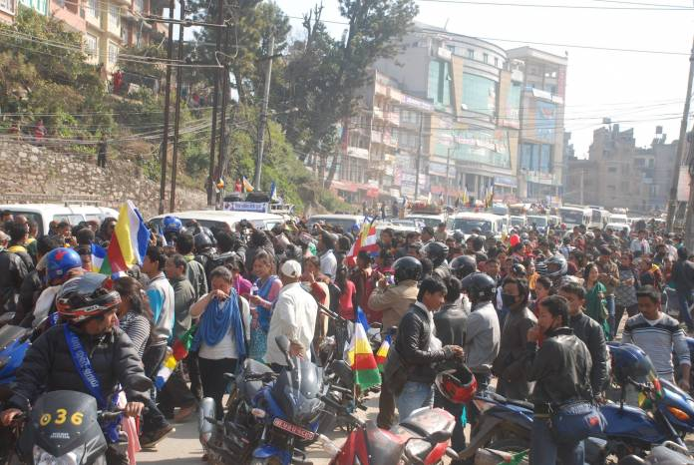

Throughout the day, devotees continued to appear along the 180 kilometers between the districts of Sindhupalchowk and Lamjung. In the darkness past sunset, they stood on the roads holding offerings of flowers, incense, khatas, and now also flickering candles. The reverent devotion shown by the tens of thousands of devotees was overwhelming to observers. There were spontaneous local receptions all along the way during the ten hours of travel, giving the travellers an unforgettable sight. Guru’s journey was attended throughout by waiting devotees from town to town, and in between. There seemed to be more people, more new faces, and more crowds than ever before.

By nightfall when the convoy reached Besishsahar, the largest town at the foothills, devotees stood there still, holding lights or candles in the darkness, their hearts kindled like their flames, eyes glistening for a glimpse of the Maha Sambodhi Dharma Sangha Guru. Already for some years, he has ruled their hearts in loving compassion. But now was the chance for them to be there, even for a fleeting moment, close to Guru’s actual aura, to feel the Maitri Presence.

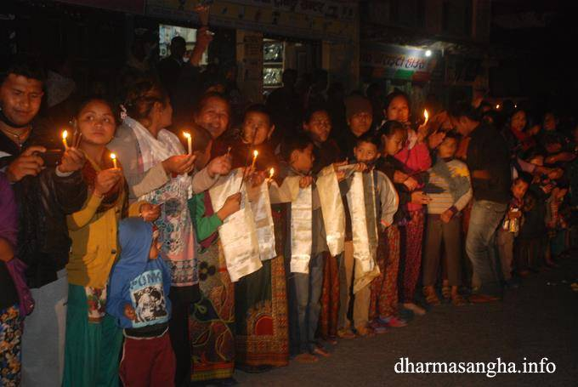

Ten hours after setting out, Guru’s party finally arrived at the Lamjung site where accommodations had been prepared by the local Sangha. And the next morning after a good night’s sleep, everyone rose to work on additional preparations for the puja itself. The great tarps were laid over bamboo foundations, and flags in the Maitri order of blue, white, yellow, red and green were stretched in long strings in all eight directions from the pole-top, announcing the event. On the newly made platform, the Maha Sambodhi Dharma Sangha Guru’s dais was placed, and on the surrounding fabric walls were hung thangkas of the Great Deities uniquely related to Maitriya. For two days feverish work joined all the fervent devotees into one large workforce, as people hitherto unknown to each other worked side by side for the same purpose. and with the same joyous dedication.

“Rain blesses the beginning and the end of the Maha Sambodhi Dharma Sangha’s every puja,” said a long-time assistant of Guru. “It will always rain when Guru arrives, and again when Guru leaves. Sometimes the rain may be big, sometimes so subtle that people may not be aware of it, while at other times it is loud and wet. But for sure there will always be rain…. followed by the rainbow.” This time the rainbow was unmistakable for all to see and marvel. A huge ring of a rainbow appeared around the sun, glowing in the mid-heavens and forming a complete and perfect circle. There was a smaller ring immediately around the sun, a rim of red and yellow filaments surrounding a relatively bluish sun in the middle, much like the pupil of a huge round eye. This phenomenon hovered continuously, suspended exactly above the puja mandala holding the tent and blessing program. The rainbow was so large, so clear, and so perfectly centered overhead that onlookers were awestruck with wonder at the surprising and inspiring manifestation.

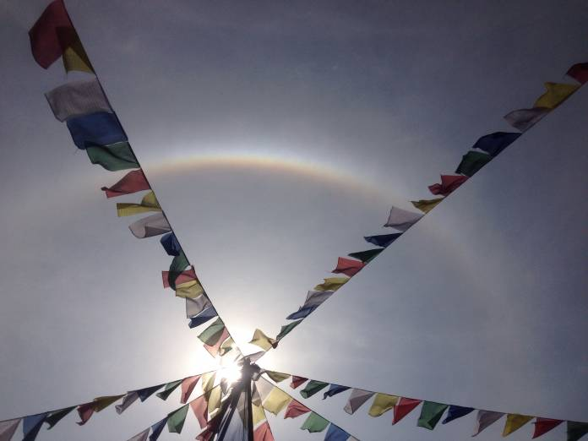

For three days the haloed sun-eye hovered overhead, enveloping the sacred precinct. Passersby and devotees both were awed at the sight of such auspiciousness and benevolence. And for the last three days, many devotees saw a bright light emanating from the middle of the Maha Sambodhi Dharma Sangha’s forehead, with a startlingly warm and gentle glow. Many such unforgettable manifestations around the Maha Sambodhi Dharma Sangha Guru were recounted by eye-witnesses and spread across the world.

The Lamjung site is situated at the base of the famous trekking paths leading up to Annapurna in the Himalayas. It is a stop for mountaineers. During those days many hikers passing by were drawn irresistibly to the puja. Here they received unexpected blessing of unbounded love and compassion that flowed unceasingly from the Maha Sambodhi Dharma Sangha Guru for more than eight hours each day. It has been estimated that several hundred thousand people received Guru’s blessing during the six days.

There were many familiar faces among the foreign sangha, as well as new ones here for the first time, together representing more than thirty nations. There were two Italian couples, one having brought along their children. Many Buddhist and Chan monks came from monasteries in Korea and Thailand, among others. About seventy Nepali Buddhist monks from diverse monasteries, dressed in crimson and orange, came to join the chanting of prayers and mantras and to participate proactively in all proceedings.

When devotees saw the Maha Sambodhi Dharma Sangha Guru in a white robe with blue trim coming with his monks in blue robes and white tops, there was a gasp of surprise and awe.

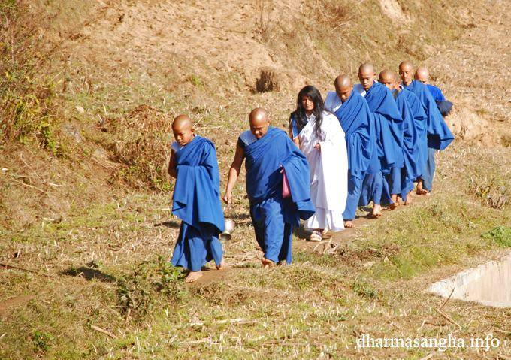

This was the first time that Guru’s Maitri colors were worn at a public event, and they presented a startling contrast to the traditional clerical colors of crimson and orange, brown, black or grey. Gradually, devotees began to realize that something was rather different about this timespace. They found themselves under a new banner, witnessing a new Order and, in their hearts, many knew that the world would be listening to a new language and hearing a new Message.

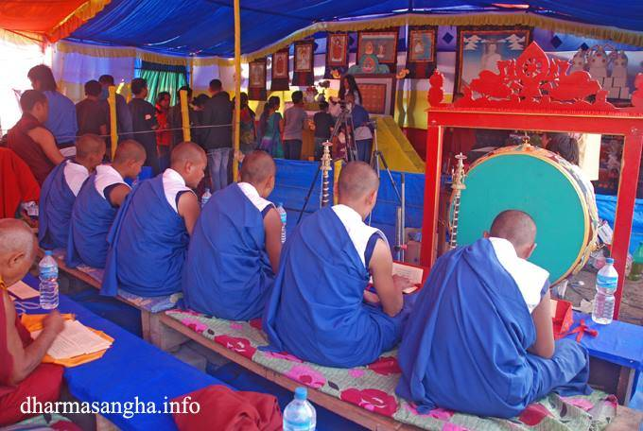

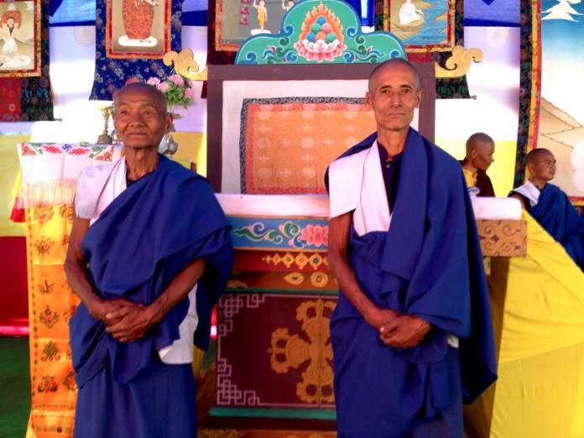

Guru ascended his dais and dropped into lotus position in one graceful move. In due course, he gave his Teaching. Marking the Fourth Year of Maitriya, the New Age following upon the long preceding Kali Yuga or Age of Darkness, the Maha Sambodhi Dharma Sangha Guru revealed yet a little more of the special attributes of the world to come, providing a hint of the peace and happiness that shall bloom forth, once the basic precepts of universal respect, compassion, equality and true faith are revived in our hearts.

On the morning of departure, rain began to fall gently over the land, smiling on the convoy like a blessing. Again, villagers from nearby stood along the streets in the morning sprinkle to bid Guru farewell. But, once the motorcade left the district of Lamjung, the rain intensified, falling loudly, and soon the streets were filled with small rivulets. By the time they reached the Naubisey highway going to Kathmandu, the road was congested for a full kilometer with cars that had been there for nearly ten hours. The passage became inundated and water covered the tires of Guru’s Jeep. Motorcyclists had water coming up to their waists.

Miraculously, local sangha members appeared, and managed in groups to open up a pass way for Guru’s convoy of about thirty cars, busses and cyclists to go through. Curiously, throughout this stretch, the towns to the left or right of their journey remained dry, without the least rain. By this time, close followers have become used to certain manifestations of the unusual.

http://maitriya.info/en/news/172/february-22-27-2014-lamjung-maitri-puja-for-world

