Mahasambodhi Dharmasangha Guru's Message in Lamjung of February 22, 2014

February 22, 2014

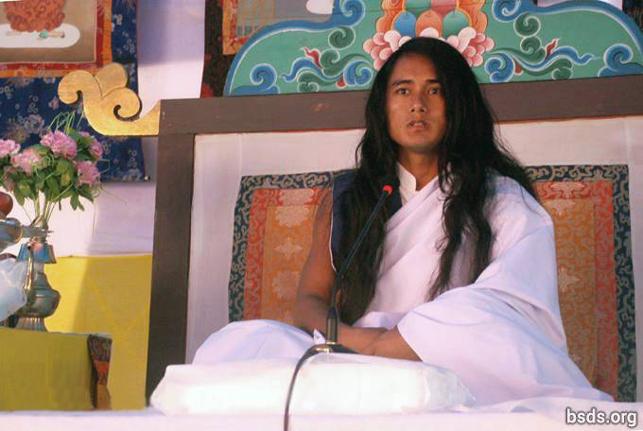

Dharma Sangha
Bodhi Shravan Guru Sanghaya
Namo Maitri Sarva Dharma Sanghaya

1. Following the Great Maitri Marga Guru, the GuruMarga and the Bhagvan Marga, absorbed in forgotten feelings, making Maitri Mangal (lovingly fulfilled) all Sangha friends, Dharma-lovers and followers that come and go; and, remembering this present Guru’s moment together, may all tormented souls on the Marga of the Maitri Dharma have refreshing realization. Dharma is the only element that can support a platform built to be directly with the Paramatma.

2. And, may the suffering wandering souls being without feeling or direction be free from bondage as soon as possible by heeding the fulfilling sound of Great Maitri.

3. Just as the value of water corresponds to the degree of thirst; the value of the Dharma is assessed by kindness, compassion, nonviolence, trust, belief, devotion, faith and an unwavering human life regarding the Marga.

4. To enter into the Dharma means to be absorbed in the path of mukti (freedom after death) and moksha (liberation from the cycle of rebirth).

5. That marga which does not have the element forming mukti and moksha can never even be accepted in the true Dharma as being called a marga, and the Dharma not being in divided civilisations, is obtained in the perfection of the Maitri knowledge, the bridge between the soul and the Paramatma.

6. It is impossible for humans remaining far from the knowledge of Maitri to attain true enlightenment no matter what one is practicing.

7. In the end, all that may have appeared to be beneficial in this transient world will prove futile.

8. There is no separation in the lifecycles of countless beings and their coming and going, in the order of the lokas (worlds), and in between the atma, anatma, and the Paramatma.

9. The Dharma is the rising and setting sun, the sky in which the stars shine, and the flowers blossoming in nature.

10. In the end, the Dharma is to understand the transience of the moment of this passing world as though waking up from a nightmare to find that in reality one is safe.

11. Rather than asking such questions as to what attributes a contemplative and intelligent person skillful in the Dharma has, and what the role of religion is in the Dharma; why doesn’t a person make the inquiry as to what one has given oneself through passion and attachments to worldly things?

12. Whether or not the way a person is following possesses the Tatva forming mukti and moksha is the person’s own very personal internal quest.

13. Guru is fulfilling the Dharma: He is giving the Marga to the world, but the person must make the journey on the Marga by oneself.

14. Whether or not one is enlightened and what one has to bear is justly determined according to the accumulated merit and other karma of the souls traveling on the Marga being shown by Guru.

15. Even though it is natural for various pains and sorrows to occur on the Path, the crucial matter is the reverence and faith towards the Guru Marga.

16. So be it, continue! The great realization of the omniscient wisdom of this Great Maitri Marga is perfect being filled with the precious jewels of the Dharma Tatva (essence).

17. However people store empty words used in their past life, otherwise the Path of Enlightenment would be realised very quickly by following the Guru Marga.

18. To stand on the Earth while resting in the sky remaining in human form together with the realisation of the Maitri Tatva of the pure appearance of the Paramatma’s own form – realizing including self all the mysteries of the universe – is to be freed from the mind’s countless oceans of illusion having evaporated like water into the open sky.

19. That which leads to the highest qualities of tatvas among all religions and Guru knowledge, having the ability to extinguish former confusion throughout the world, is called the Maitri Dharma. In this way, the primordial existence of all religions would all be on the Marga of Maitri Dharma itself.

20. On the Maitri Marga, only by doing true practice of the Dharma until the last moment of life does a person benefit the Dharma.

21. And with this Maitri message, I am giving (you) the 11 precepts to be free from all the defilements within the whole human world.

1) Never break oneness and equality on account of name, appearance, ethnicity, tribe, religion, colour, class, gender, belief, community, nation, power, position, ability and so forth; this means, give up all discord, be it worldly or spiritual.

2) Having found the eternal Dharma, Margapath and the Guru, remain respectful to all religions and beliefs.

3) Never cause rifts or doubts with untruths, accusations and counter-accusations, belittling or meaningless talk.

4) Resist all teachings and paths that lead to separation, rifts or boundaries; stay steadfast in the true marga-practice.

5) Resist doing even the least harmful karma-actions throughout life in true Gurumarga practice, melt totally into Guru’s truth-nature, becoming part of it.

6) Before being truly merged in the essential realities and practices of Gurunature and Dharmanature, refrain from expounding it with clever words; while still mired in hearsay, rumour, and propaganda, do not draw others into delusion.

7) Avoid any and all demonic behaviour: violence, killing, harming or hurting living beings; choose only pure wholesome nourishment.

8) Do not think less of people or countries on account of national identity.

9) Rooted in true Gurumarga practices, dedicate all karma-actions, thought and speech to the uplift of the whole world, including ourselves.

10) When searching for Truth, the Gurumarga path begins to take form within the heart and merges with Gurunature for the wellbeing of all life in the universe.

11) Remain always in the highest and deepest awareness, realising the various precepts in the soul, gaining freedom from all bygone bondage and constraints.

22. Together with these 11 precepts being internalized by all the Sanghas, liberate all living beings including self, and; may all realize this Satya Marga Gyan – the Wisdom of the True Path.

23. Never lingering in the ego, running after worldly name and fame; humans should stay resolute in the remembrance of the Paramatma always keeping the feeling of Maitri in the heart (atma).

24. The GuruMarga has descended to re-establish the true Dharma on the Earth after an interval of ages.

25. As this golden moment has been realized by beings and plant-life (the eco-system); may humans also be without defilements and take virtuous benefit from this Maha Maitri Marga at the earliest!

May all beings be lovingly fulfilled.
So be it!

https://bsds.org/en/news/170/dharmasangha-guru-lamjung-message-2014

