Maha Sambodhi Dharma Sangha Guru's Message in Chitwan of June 8, 2013

June 8, 2013

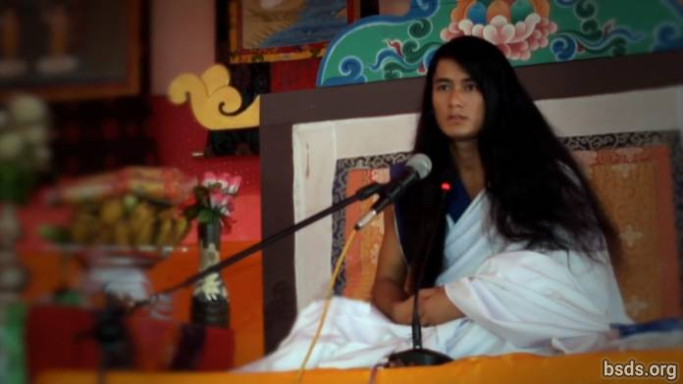

Dharma Sangha

Bodhi Shravan Guru Sanghaya

Namo Maitri Sarva Dharma Sanghaya

1. Being in unison with the True Dharma, Guru, and the Way; may the world realize the Dharma Tattva [1]. And, may all the world’s beings be contented by the Supreme Wisdom of this Great Maitri Way having the form of Mukti and Moksha.

2. The science of the Dharma Tattva is very deep and limitless.

3. In order to realise the True Dharma and Tattva, it is necessary to embody the Tattva oneself.

4. And the Dharma Tattva is not limited to this world alone, but resides in all existence.

5. May humans realise that this world is only one opportunity.

6. In order to realize the Tattva, in some trees, even though countless blossoms bud, only a limited number of fruit reach their natural form; thus only a few humans achieve the Dharma.

7. Even so, the flowers fallen on the Way of the True Dharma also have existence and greatness.

8. And each one of the fruit is being made to have its own distinct specialty and Dharma Virtue.

9. The main purpose of the human world and life is to be in adherence of the True Dharma and, achieving the Dharma Tattva, to be absorbed in Mukti and Moksha alone.

10. The Guru fulfills His own Dharma.

11. The Way is being given to the world, yet even so, the responsibility for taking each step forward on the way is the human’s own individual quest [2].

12. Whether or not the way one is following has the form of the Mukti and Moksha Tattva is another extremely personal quest of the human.

13. For a human remaining far from the wisdom of Maitri, no matter what kind of practice is done in one’s life in the name of Dharma, attainment of the True Tattva based in existence is impossible.

14. And those on a way not allowing the formation of Mukti and Moksha, can never call that "the Way."

15. That would be just a mere amusement of the temporary world.

16. In the worldly ways, the ego and desires of humans are upheld as usual, and the various paltry remedies being applied are distancing the desirous humans from the True Guru and the Way.

17. The Path which does not accept egoism and desires — that Path humans don’t want to walk.

18. But, ironically, each human has the understanding in the inner voice of the conscience [3] of which way is leading where.

19. Whether or not one is enlightened and what one has to bear is justly determined according to the accumulated merit of each soul traveling on the Way being shown by Guru.

20. Yet so be it, continue, the journey is yours alone.

21. Having been absorbed by the attributes of the Dharma Tattva; realising the defects of egoism and desires, one can be freed from the world. In order to do this, a human needs to strive continuously in the Dharma until the final moment of life.

22. May the whole world take this Maitri wisdom to heart and awaken.

Sarva Maitri Mangalam Astu Tathaastu (May all beings be lovingly peaceful. So be it.)

______________________

Notes:

[1] Tattva तत्व (n.)

[2] This word was written by Guru as "nirnaya," meaning "decision," however, in the speech, Guru says "khoj", meaning "search/quest."

[3] Nep. Chitta

https://bsds.org/en/news/158/maha-sambodhi-dharma-sangha-guru-s-message-in

