Maha Sambodhi Dharma Sangha Guru's Message in Patharkot of April 9, 2013

April 9, 2013

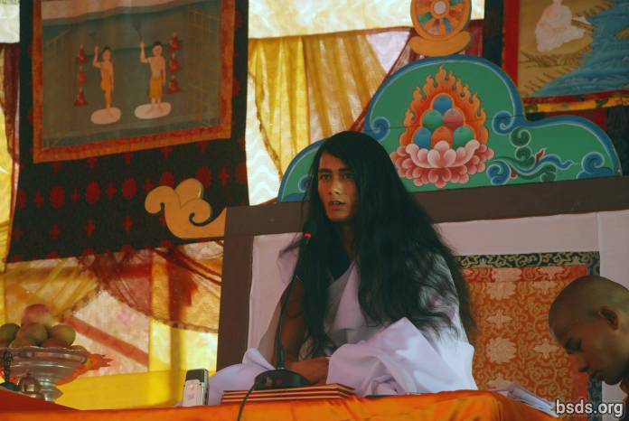

Dharma Sangha
Bodhi Shravan Guru Sanghaya
Namo Maitri Sarva Dharma Sanghaya [1]

1. Adhering to the Maha Maitriya Marga (the Great Loving Way), being Marga Guru (Guru of the Path), the Guru Marga (the Master Path) up until the Bhagwan Marga (the God Path), remaining in the presence of countless feelings, may the entire world of living beings take in the Amrita of Great Wisdom.

2. And may the blessings of the the Great Maitriya Guru and the Path always remain in the world.

3. Although countless stars are being seen, the sky is one; in the same way, the main source of all religions and paths seen in the world is ultimately one.

4. That is the wisdom that has been gained in the different ages of the world, moreover, the paths that have been rendered in auspicious times by the enlightened Gurus for the welfare of the world have been colored with the colors of various religions, teachings, paths and cultures in modern times.

5. I have been seeing humans, in the name of religion and path, gradually being separated from the True Essence, either unable or unwilling to distinguish right, wrong, sin, the Dharma, the Guru and the Path, carelessly moving towards darkness and lacking essence.

6. In the past, being of ek bhavana [2] (one focus/path) the enlightened Buddha is only a Marga Guru who points out the Path; however in the present time there is the illusion in the world that the previous Buddha did not have a teacher, nevertheless, the question of who the teacher of this Marga Guru is and the fact exist thus.

7. In this existence there are various thoughts, gurus, and paths that are still mysterious in this world.

8. According to the extreme importance of time, I have been showing the Guru Marga (the Master Path).

9. Even though the Path of all Gurus is the same, each one [Guru] makes their own rule and position, and in accordance with the rule the results are reaped.

10. The Guru Marga is that Path on which the whole world, living beings and plant life, by following Maitri Marga (the Path of Loving Kindness), achieve mukti (liberation after death) and moksha (Iiberation from rebirth).

11. In the human world, humans have freedom: they concentrate on the Path of Dharma or spend their lives in sinful acts.

12. The meaning of this world is to distinguish between Dharma and sin.

13. But the result is determined according to the good or bad karma of what humans have done on their own.

14. After ages, the Guru Marga has descended in the world.

15. Quenching the thirsty world by the nectar of understanding non-violence, kindness, compassion, love and Maitri Bhaav (the feeling of loving kindness) is the way to establish the Rule of Maitri, but, having feelings of omniscience, the egoistic humans cannot always properly accept the situation of the present Guru.

16. If humans take a moment to hold the soul in awareness and contemplate: why this penance of the Guru?

17. In the end it would only be for the sake of the mukti and moksha of the world, living beings and plant life.

18. There are those who have the hope to benefit from the Guru in another worldly way, but Guru can only give Dharma, Marga, Mukti, and Moksha.

19. But ironically since times past the polluted state of the human mind has instead been giving Guru accusations, disbelief, violence and obstructive behavior.

20. This human society, including the management, makes the need of Dharma and Marga for this entire world imperative.

21. Not just the Dharma, but may this truth be understood by humans.

22. And may life be spent in the search of the essence of Maitri Bhaav.

23. Also, in the coming days, Guru will definitely travel in order to give the darshan of the True Path throughout the world.

24. May all beings be lovingly peaceful. So be it.

______________________

Notes:

[1] To the Sangha of the Dharma Sangha Bodhi Shravan Guru (Wisdom Heeding Dharma Sangha Guru) I bow to all Loving Dharma Sanghas.

[2] Bhāvanā (Pali; Sanskrit, also bhāvana) literally means "development" or "cultivating" or "producing" in the sense of "calling into existence." The word bhavana normally appears in conjunction with another word forming a compound phrase such as citta-bhavana (the development or cultivation of the heart/mind) or metta/maitri-bhavana (the development/cultivation of lovingkindness). When used on its own bhavana signifies 'spiritual cultivation' generally. (Wikipedia)

https://bsds.org/en/news/148/maha-sambodhi-dharma-sangha-guru-s-message-in

