Mahasambodhi Dharmasangha’s Message in Sindhuli of September 10, 2012

September 10, 2012

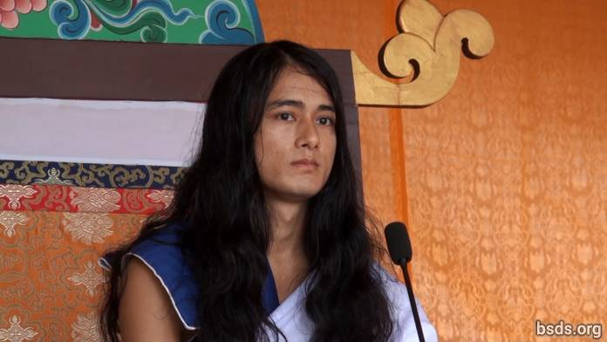

1. Following the True Dharma and the Guru in this current time, making all the meritorious souls present and absent here Maitri Mangalam (Lovingly Peaceful); remaining on this great Maitri Marga (Loving Way) of welfare and praanidhaan (prayers/life bestowing) for the world; atma (soul), body, and speech being under the witness of the Guru, I am proclaiming The Eternal Dharma.

2. Being Eternal Breath in order to know the Tattva (Essence) which is without decay, death, or destruction, one must have a life practice which single-mindedly takes up only the Dharma.

3. Moreover, the word Dharma is not sufficient in itself.

4. How can the Dharma come (be defined) in only one word when all Lokas (realms/worlds/universes) are in that Dharma Tattva (Essence)!

5. Dharma is not something to be understood but the truth to be realised.

6. If one is able to establish kindness, compassion, love, and friendship not only among human beings but also the world’s movable and immovable living beings and vegetation with unity; being able to drink the nectar of friendship; being able to keep one’s life routine in incomparable loving kindness; as a result, after this life, one attains Mukti (liberation after death) and Moksha (liberation from rebirth).

7. Murdering beings, displaying miraculous activities, and doing tantra-mantra (magic) in the name of the Dharma is only a way of temporary selfish fulfillment. Dharma is only that which provides the sentient beings the Path of freedom and liberation without discrimination according to karma (causes and conditions).

8. Since ancient times on Earth, human beings have been drifting about in the ocean of illusion. Having taken on a meaningful human life [1], one continues to wander on meaningless substances and paths, knowingly and unknowingly throughout the Kalpas (ages).

9. Blessed are these saintly souls, who are adhering to the Path of the Truth being in the refuge of the Guru. And also the Guru Himself, remaining under the Rule of Dharma of the highest of the Gurus beyond thousands of past Buddhas, has come.

10. In the coming days, I will be showing Teachings of the Guru and the Dharma. I am always doing so.

11. In order to eradicate karma accumulated under the influence of the passion of desires wandering into countless emotions; being in the Rule of the Dharma, one has to take up the Guru Marga, feeling reverence of mind in an undivided form, never being diverted in the least.

12. Sacrificing attachment, overcoming saying “me” and “mine,” greed and ego; only by living a life with an indestructible feeling for all living beings will human life be successful.

13. Finally what is the objective of coming to the world? Which essence is the search? What are the duties and the Dharma for oneself including the whole existence? What is the relationship between the atma (self/soul), anatma (non-self/non-soul), and Parmatma (the Great Soul)?

14. One must spend the Kalachakra (period of life) on life’s inner search for the boundless and minute, not just momentary sensual gratification and material bonds. Finally, establishing One Being, One World, One Dharma and the feeling of Maitri (Loving Kindness) without discrimination, having decorated the world in the sound of the Dharma, the Guru will travel satisfying the world’s countless perplexed beings throughout with the nectar of Maitri, giving Marga Darshan (guidance) in the coming time.

15. Guru is True since Guru is in the Dharma. It’s just that spreading the Rule of the Dharma by Guru has been misunderstood in a material world, though this is what it is, and it’s true.

16. May all beings be lovingly peaceful.

______________________

Notes:

[1] Tatvarupi manushya cholaa (meaningful human life) – note that cholaa means ‘cloth’ and has been used to indicate the human body. Manav chola means human body.

https://bsds.org/en/news/137/mahasambodhi-dharmasangha-s-message-in-sindhuli-of

