Birthday Speech in Halkhoriya in 2012

April 11, 2012

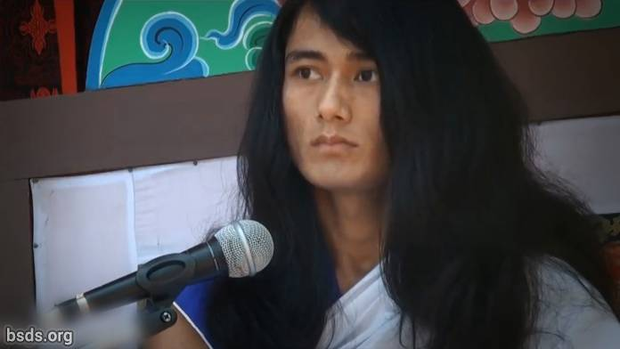

1. Benefiting all Sanghas and followers with Loving Kindness, today’s Yuga (age) is not only a time for festivity, it is for imparting the Path of Freedom and Liberation to the sentient beings of the world in following the Path of Truth and spreading the Law of Dharma, establishing Dharma, Peace, Understanding and the Maitri (Loving Kindness) feeling in the world.

2. It is difficult to find fulfillment unless one realizes the Tattva (Essence) of the True Guru in order to follow the Path of Truth.

3. The human life can be fruitful if one is able to search for and know the Tattvas (Elements) hidden in Guru’s words.

4. Guru, having been freed from worldly restraints, although seen in the world yet not being a worldly Guru, is the Pure Dharma Guru.

5. In order to establish the Law of the Dharma in the world, it is important to be completely faithful and dedicated to the Guru and equally so to the Sanghas as well.

6. And the fragrance of the moral excellence of the Sanghas must be in the spirit of mutual loving kindness and togetherness.

7. Interfering and placing obstacles in the work of the Guru means interfering with Dharma and the Path.

8. However, it is natural that many obstacles and interference occur in the spreading of the Law of Dharma.

9. But to face or overcome those Dharma-opposing Tattvas by being truthful with mind, body and speech is another personal dharma and duty of each of the Sanghas.

10. Guru, himself remaining, let all the Sanghas, absorbed in these invaluable moments by being engrossed in the Dharma-Sound, always utilize every Guru-Moment proving their own extreme intellectual abilities.

May all beings be loving and peaceful. So be it.

https://bsds.org/en/news/127/birthday-speech-in-halkhoriya-in-2012

