Closing Speech for The World Loving Peace Puja on March 26, 2012

March 26, 2012

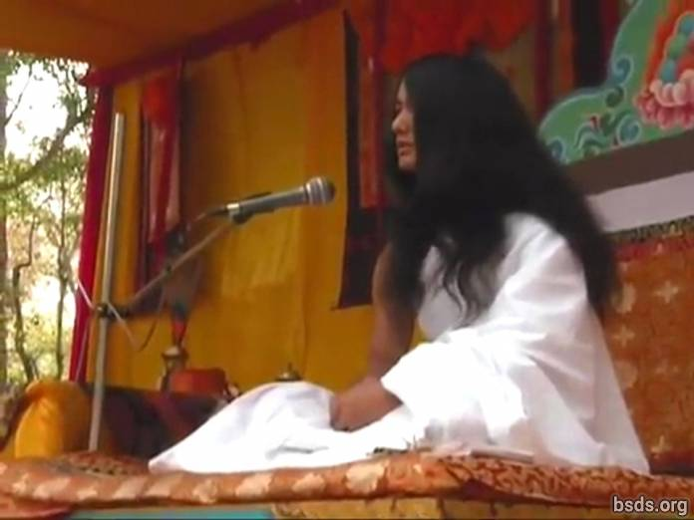

1. May all Sanghas [1] keeping the discipline of the Dharma [2] gathered at the World Loving Peace Puja [3] show unification to the world uniting all sentient beings within the perimeters of the power of the Dharma overcoming all illusions and obstacles of the past, present and coming days.

2. The way on the path of the True Dharma being followed, perfect enlightenment being accomplished, the understanding of world peace and the feeling of Maitri (Loving Kindness) being established, may the acquisition of the Dharma World be made manifest.

May all beings be happy. So be it.

________________________________

Notes:

1) Sangha – assembly/group with common goal, vision, purpose.

2) Dharma – Universal and Cosmic Truth, righteous duty, virtuous path, liberating law.

3) Puja – ritual, worship, ceremony, prayers.

https://bsds.org/en/news/125/closing-speech-for-the-world-loving-peace-puja-on

