Maha Sambodhi Dharma Sangha Accepts Food and Drink

April 11, 2012

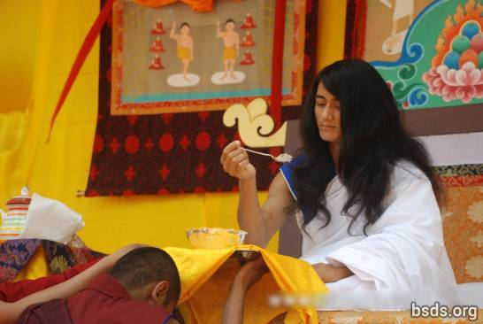

On April 11, 2012, at 1:30 PM (29 Chaitra 2068 in the Nepali calendar), Maha Sambodhi Dharma Sangha took food (rice) from the hands of his close assistant, monk named Buddha, and drink from the hands of Khenpo Dawa in front of the sangha, a group of the devotees and international guests, who were gathered in Halkhoria.

Bodhi Shravan Dharma Sangha,
Central office, Halkhoria, Bara, Nepal.

http://maitriya.info/en/news/123/maha-sambodhi-dharma-sangha-accepts-food-and-drink

