04.06.2011

जेठ २१, २०६८ (04.06.2011)

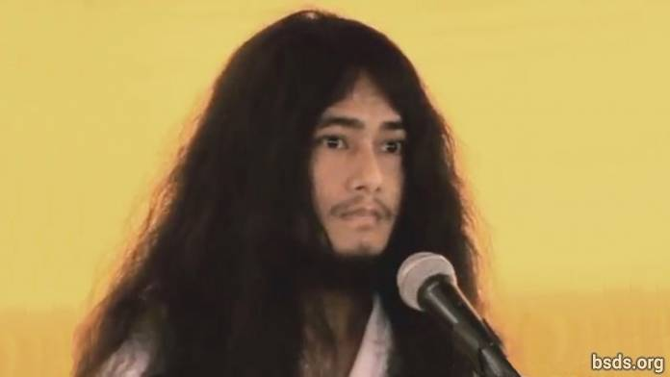

1. Amarvati bhuvan rup jastei sunyata ra moksha ma leen hona sakosh sansar.

2. Chandrama ko mahur jyotirmaye prakash jaste siddhanta chhaye raho sansar.

3. Surya ko tejasvi-jyotirmaya prakash jaste nipurn bhayi gyan laye chhao sansar.

4. sankhako dhvani jaste gunchi rah dharma ko sansar.

5. Bajradaar jaste kathor hosh atma paratma, anatma maitreya ko sansar.

6. Ashtakamal ko phul jaste prativimbit ruple chhao sila, pragya, samadhi ko sansar.

7. Yas vishudda margadarshan khojma sakshat Maitreya Nath ra AryaTara ko sil, samadhi, pragyama nirantar bhayi Sansara bhari mukti ra mokshya ko margadarshan garirahanechhu.

8. Yadi sansar ma mukti ra Mokshya ko margadarshan garaunda lok-hitartha ra parivartan nabhaema, dharma sansar matra nabhayi jiv praakirtik manav bich samma parivartit parivartanko huri aunechha.

9. Chhingur sansar ma jaba dharmako chhya hundai janncha, taba sansarle ashanti, kalaha, samudayik beechma sampradaya ko rupale dharma ko naam line, jaati-paati ko naamle nichhbebahar garne, muktiko marga bata banchit garaune, yasta dharma shanti haruko pacchi lagnu tyo dharma hoina.

10. Tyesta dharma sampadayeko ruple byektitva swartha pura garne dharma ho.

11. Aaja yas punit karyale hami dharma sanghaharu ati khushi chhaun [].

12. Tyesari nai, Maitreya sadhbhav rakhi yashlai bevaharikta ma parivartan ra parimaarjan [] garaune chhu.

13. Ra Namo Buddha Tapoban Samrakshyan sangha, Bodhi Shravan Dharma Sanghaka Sangha Mitra ra Kalyan Mitraharule vabya swaagat ra khata arpan garaidinu hola.

14. Yesarinai Dharma Sangha, Sangha Mitra, Kalyan Mitra, sanghalai eutai... eutai bhavana gari dharmako samrakshyan garnu, bhandai dharmik bidaeka saathai dhammik dhanyavad didai.

15. Bhavatu sarva mangalam. Bhava astu tatastu.

https://bsds.org/ne/news/103/04-06-2011

