Dharmasangha's Message in Ratanpur of June 4, 2011

June 4, 2011

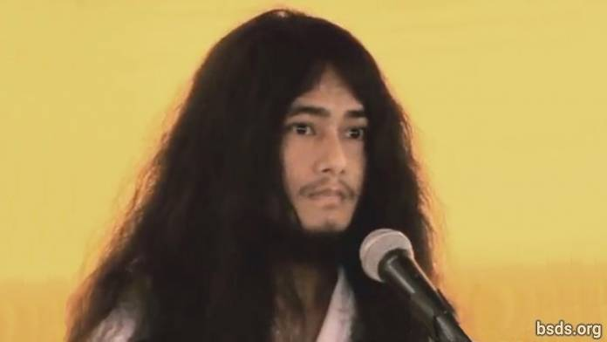

1. May the eternal sky acquire the form of the Earth, absorbing Sansara into the empty field of absolute potential (shunyata) and freedom (moksha).

2. Just as the Moon’s great illumined radiance may the world be enveloped by faith.

3. Just as the Sun’s glorious illumined radiance may the world be surrounded by perfect wisdom.

4. Just as the conch’s sound may the world resonate with the Dharma.

5. Just as the holder of the dorje (vajradhara), may the world be adamant with the love of the soul, the supreme soul (paratma) and the non-self (anatma).

6. Just as the eight-petalled lotus carries forms as the reflection, may the world be enveloped in morality, wisdom and meditation.

7. In search of this pure guidance (margadarshan), directly being steadfast in the precepts, meditational states, and wisdom (sheel, samadhi, pragya) of Noble Maitriya Nath and Noble Tara, I will be giving the guidance of freedom (mukti) and liberation (moksha) in the whole world.

8. If in the world Dharma guidance (margadarshan) for freedom and liberation (mukti and moksha) is given, (but) benefit for the earth and changes do not happen, not just the Dharma world (but) among each and every sentient being and human a storm of uncertain change will come.

9. In the impermanent world, when Dharma decays, then the world becomes unpeaceful, confrontational; a form of sectarianism is taken up among societies in the name of religion – mean behavior is practiced in the name of caste and creed – being deprived from the path of freedom. That is not Dharma to go about religions and peace in such a way.

10. By this communal form of religion, it is a religion made to fulfill personal interest.

11. Today we the Dharma Sanghas are in extreme happiness with the pious work.

12. Thus, let us keep the Maitriyan harmony. For this, I am assimilating and modifying in practice.

13. And, a splendid welcome and Khata may be tributed by the Namo Buddha Tapoban Samarakshyan Sangha and Bodhi Shravan Dharma Sangha’s Sangha Mitra and Kalyan Mitra.

14. In this way by the unification of the the sangha, let the Sangha Mitra and Kalyan Mitra of Dharma Sangha, maintain the Dharma having the same feeling. Also along with bidding a religious farewell, lets give religious thanks.

15. May all beings be tranquil. May they be happy. So be it...

https://bsds.org/en/news/103/speech-of-dharmasangha-on-june-4-2011

